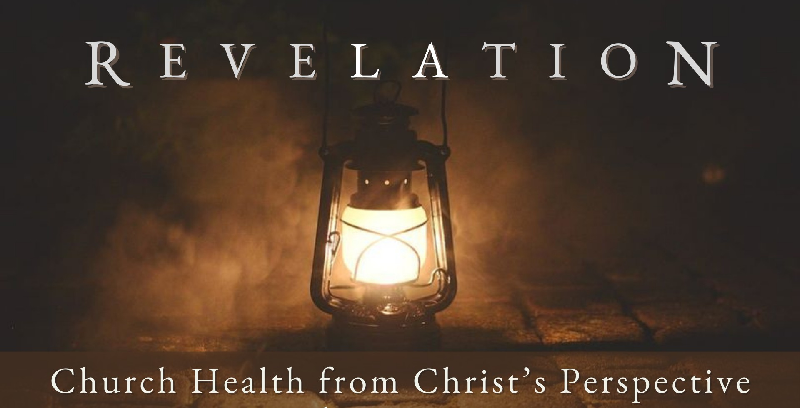
Good Morning Fellowship,

F e b r u a r y 1 1 , 2 0 2 4
Are you getting ready for the return of Jesus Christ? Before you answer, take a close look at Revelation 1:1-8. As we will discover this morning, the introduction to the
fascinating final book of the Bible shows us exactly what we need to know and do as we live for Christ and await His coming.
~Grant

A r e Y o u R e a d y ? R e v e l a t i o n 1 : 1 - 8

How do we know if we are ready for Christ’s return?
Four main perspectives have been taken to interpret Revelation:

The preterist approach views Revelation not as future prophecy, but as a historical record of events in the first-century Roman Empire.

The historicist approach portrays Revelation as a record of the sweep of church history from apostolic times to the present.

The idealist approach views Revelation as the timeless struggle between good and evil that is played out in every age.

The futurist approach sees chapters 4–22 as predictions of people and events yet to come in the future.

Are you ready for Christ’s return?
As Christians we are preparing for Christ’s return when we…
- Know what is to come 1:1-2

“But do not let this one fact escape your notice, beloved, that with the Lord one day is like a thousand years, and a thousand years like one day. The Lord is not slow about His promise, as some count slowness, but is patient toward you, not wishing for any to perish but for all to come to repentance.”
2 Peter 3:8–9
- Follow what He has said 1:3

F E B R U A R Y 1 1 , 2 02 4

Page 2

- Worship Him for who He is 1:4-8

Are you ready for Christ’s return?

When Christ is reigning in our hearts, we are ready for His return.

My personal application of this passage:

Page 3
F E B R U A R Y 1 1 , 2 02 4

Questions for individual study and LIFE Groups:

- Why do you think God wants His people to understand what will take place in the end (see Rev. 1:1)?

- How did this understanding benefit the original recipients of this letter 1900 years ago?

- How can knowing what will come in the future affect the way we live today?

- Why are believers blessed by “reading, hearing, and heeding” what is to come (see Rev. 1:3)?

- Why does Jesus Christ desire that His disciples follow and keep what He has said?

- Can you share a practical example of how God’s truth shapes your convictions?

- Can you share a practical example of how God’s truth shapes your behavior?

- What can we learn about Jesus Christ from Rev. 1:4-8?

- What can we learn about who Christians are in a relationship with Him?

Page 4
F E B R U A R Y 1 1 , 2 02 4

