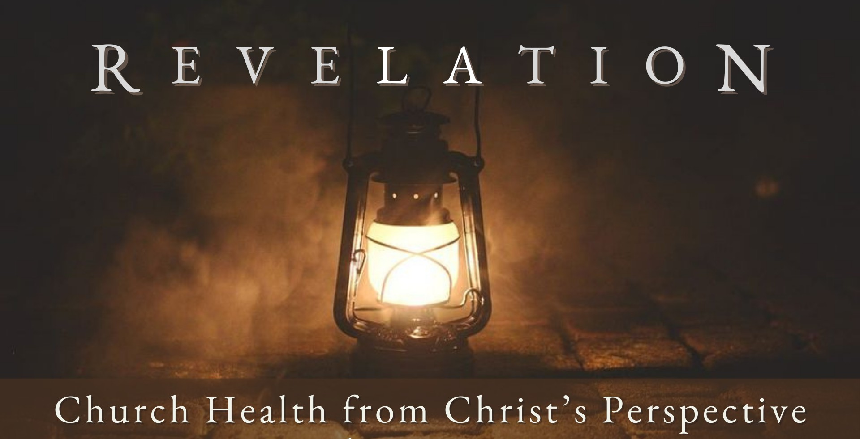
Good Morning Fellowship,

F e b r u a r y 1 8 , 2 0 2 4
Who is Jesus, and what is His ministry today? Recent research shows that most
people, including many Christians, are confused when it comes to these essential matters. As we will discover this morning, Revelation 1:9-20 gives us the clarity we so desperately need.
~Grant

W h o i s J e s u s , a n d W h a t i s H i s M i n i s t r y T o d a y ?
R e v e l a t i o n 1 : 9 - 2 0
Who is Jesus, and what is His ministry today?
- Jesus reveals His will in His written word 1:9-11
The Lord shepherds His people through His Scriptures. The written word reveals Christ for our salvation.

“...and that from childhood you have known the sacred writings which are able to give you the wisdom that leads to salvation through faith which is in Christ Jesus.”
2 Timothy 3:15

The written word develops our sanctification.

“All Scripture is inspired by God and profitable for teaching, for reproof, for correction, for training in righteousness; so that the man of God may be adequate, equipped for
every good work.”
2 Timothy 3:16-17

The written word is to be the source of our proclamation.

“I solemnly charge you in the presence of God and of Christ Jesus, who is to judge the living and the dead, and by His appearing and His kingdom: preach the word; be
ready in season and out of season; reprove, rebuke, exhort, with great patience and instruction. For the time will come when they will not endure sound doctrine; but
wanting to have their ears tickled, they will accumulate for themselves teachers in
accordance to their own desires, and will turn away their ears from the truth and will turn aside to myths. But you, be sober in all things, endure hardship, do the work of an evangelist, fulfill your ministry.”

F E B R U A R Y 1 8 , 2 02 4
2 Timothy 4:1-5

Page 2

- Jesus reigns eternally as the Sovereign Lord 1:12-20
Jesus is the epicenter of His churches vv. 12-13a

Jesus is the embodiment of deity vv. 13-16

Jesus is the encourager of His people v. 17a

Jesus is the self-existent source of eternal vv. 17-20
life and truth

The written word reveals Jesus reigning as the Sovereign Lord.

Page 3
F E B R U A R Y 1 8 , 2 02 4

My personal application of this passage:

Questions for individual study and LIFE Groups:

- Why do you think Jesus chooses to communicate to His people and churches through the written word?

- What are some ways in which you regularly receive the word of God?

- How have you learned to apply God’s word to how you think, in what you believe, and how you behave?

- Why is Jesus Christ so concerned we worship Him for who He is?

- What are some ways you worship Jesus Christ?

- How does the detailed picture of Jesus Christ in Rev. 1:12-18 develop the confidence and convictions of those who follow Him?

- Why is this presentation of Christ especially beneficial to believers who are facing hardships and suffering persecutions?

- Are you ready for Christ’s return? How could our study of the Book of Revelation aid you in living in light of His return?

Page 4
F E B R U A R Y 1 8 , 2 02 4

