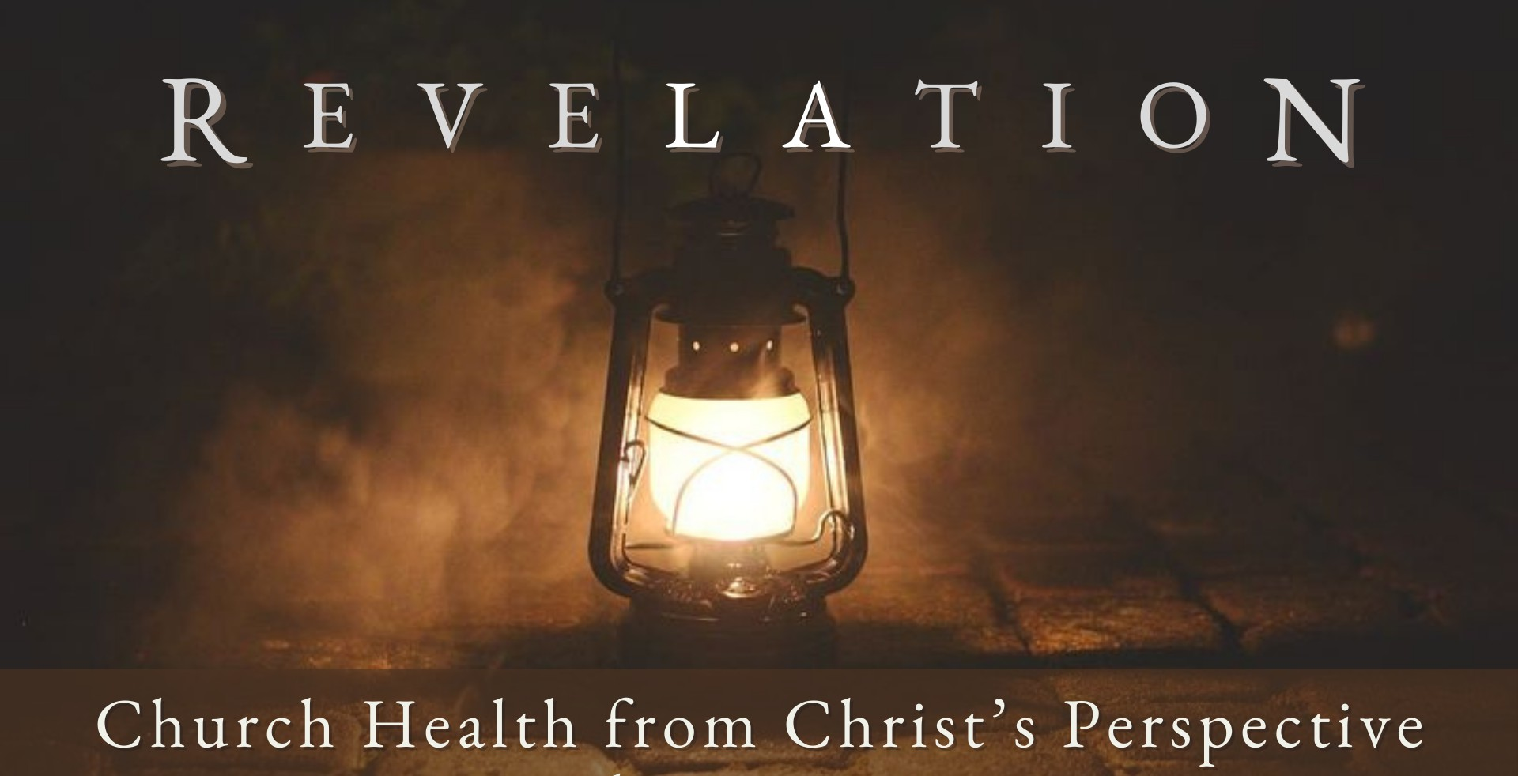
Good Morning Fellowship,

F e b r u a r y 2 5 , 2 0 2 4
What is the ultimate priority of the church? In Revelation 2:1-7, Jesus focuses on this paramount priority as He directs every church to keep and cultivate what is central
to their existence.
~Grant

T h e C h u r c h ’ s U l t i m a t e P r i o r i t y R e v e l a t i o n 2 : 1 - 7

What is God’s ultimate priority for His people?

“One of the scribes came and heard them arguing, and recognizing that He had answered them well, asked Him, ’What commandment is the foremost of all?’
Jesus answered, ‘The foremost is, ”Hear, O Israel! The Lord our God is one Lord; and you shall love the Lord your God with all your heart, and with all your soul,
and with all your mind, and with all your strength.” The second is this, “You shall love your neighbor as yourself.” There is no other commandment greater than
these.’”
Mark 12:28–31

How do we regain our first love for Christ and others when we become aware that we have left it?

We regain our first love for Christ and people when we…

- Recognize the severity of our condition 2:1-4

- Remember the love we once had 2:5a

- Repent of our sin 2:5b

F E B R U A R Y 2 5 , 2 02 4
Page 2

- Return to the love and deeds we did at first 2:5c-7

“For whatever is born of God overcomes the world; and this is the victory that has overcome the world—our faith. Who is the one who overcomes the world, but he who believes that Jesus is the Son of God?”
1 John 5:4–5

Loving Christ, His truth, and people are the ultimate priorities for a church.

My personal application of this passage:

Page 3
F E B R U A R Y 2 5 , 2 02 4

Questions for individual study and LIFE Groups:

- Why is Jesus Christ so concerned with the health of His churches? Why is it somewhat difficult for us to gauge the spiritual vitality of a church? Why is it easy for the Son of God to do so?

- Why are the churches pictured as lampstands (Rev. 1:11-13, 20, 2:1)?

- What does Jesus Christ commend about the church in Ephesus? What does a church look like today that would receive a similar commendation as found in verses 2-3?

- Why do you think Christ draws attention to the fact that they had lost their “first love”? What might this look like among the individuals in the church? How would such a loss of love for God be manifested in a church as a whole?

- How can believers respond if they realize that loving Christ and people is no longer their top priority?

- How would you describe a believer cultivating a “first love” for God?

- What are the various means God has given believers to sustain and strengthen their love for God and others? How can we encourage one another to love the Lord our God with all of our heart, soul, mind, and strength and to love our neighbors?

- How do you see God developing your heart to love Him? Love others?

- What do you think would be important that we do, as a church, in response to Christ’s letter to the Ephesians?

Page 4
F E B R U A R Y 2 5 , 2 02 4

