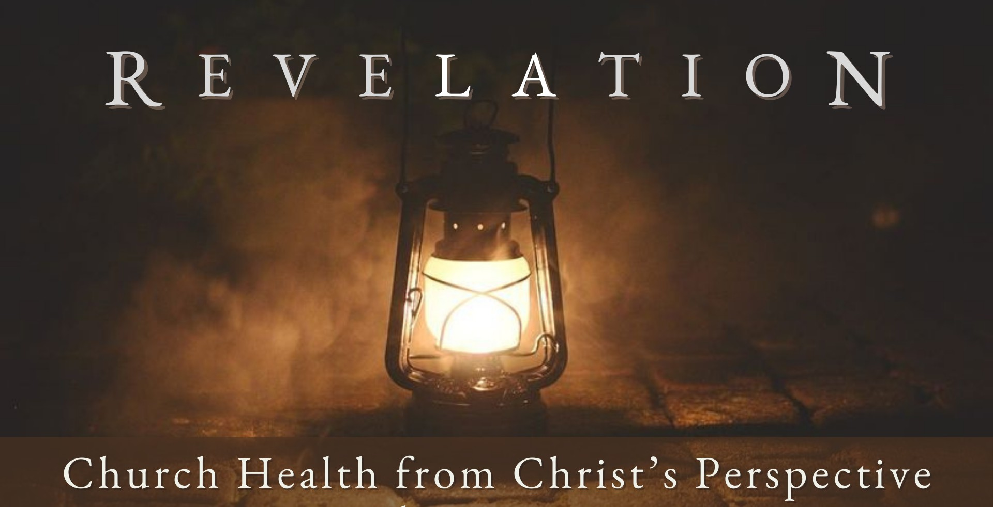
Good Morning Fellowship,

M a r c h 1 7 , 2 0 2 4
What does it look like for a church to be spiritually compromised, and how serious
is the issue? Jesus’s letter to the church at Pergamum answers these questions and reveals how Christians are to respond when compromises with the world have taken root in the church.
~Grant

T h e H i g h C o s t o f a C o m p r o m i s e d F a i t h R e v e l a t i o n 2 : 1 2 - 1 7
How do you respond when compromises with the world have contaminated your faith?
- Recall past faithfulness 2:12-13

- Recognize and repent of present sinfulness 2:14-16

- Refocus on Christ and His future promises 2:17

Compromises with our world lead to a contamination of our faith.

M A R C H 1 7 , 2 02 4
Page 2

My personal application of this passage:

Questions for individual study and LIFE Groups:
- Why is it important to recall past faithfulness as individual believers and collectively as a local church?
- What are some possible reasons Jesus mentions Antipas in 2:13? Why is he a noteworthy individual? How does God develop a person like this?
- Why do you think Jesus Christ does not want the people in His church to compromise with the world?
- What were some of the compromises that were being made in Pergamum?
- How do people try to modify their faith in Christ to be more accommodating to the world?
- Why would people be tempted to do this?
- What is Jesus’s direction to those who have made compromises with the world regarding their doctrine, morals, or lifestyle?
- Who and what influences how you live out your faith in these present times?
- How does Jesus Christ enable us to walk with Him without drifting into compromise?
- How does focusing on Christ and His future promises influence how you live?

Page 3
M A R C H 1 7 , 2 02 4

