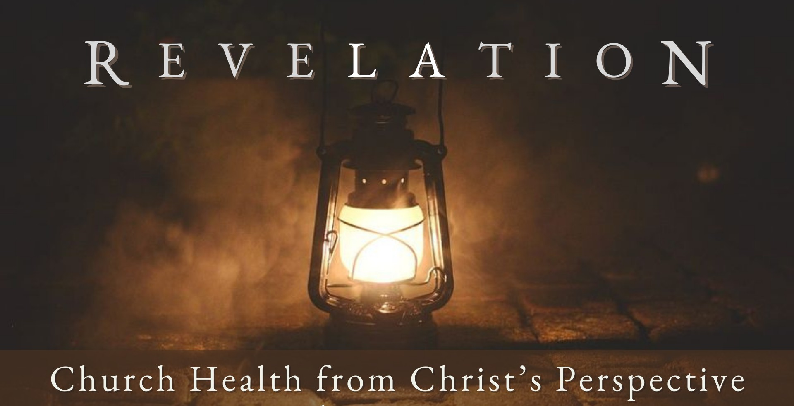
Good Morning Fellowship,

M a r c h 2 4 , 2 0 2 4
What happens when a church sacrifices truth in the name of tolerance? In
Revelation 2:18-29, Jesus sends a letter to the church at Thyatira on how to address the cancerous problem of tolerating sinful beliefs and behavior.
~Grant

W h e n T r u t h i s S a c r i f i c e d f o r T o l e r a n c e R e v e l a t i o n 2 : 1 8 - 2 9
How does a church treasure God’s truth
and not sacrifice it in the name of tolerance?
- Delight in the deeds Christ loves 2:18-19

- Discern and deny the sins that Christ hates 2:20-23

- Devote yourself to Christ’s word and the
kingdom He rules 2:24-29

A church that treasures God’s truth
will not sacrifice it in the name of tolerance.

Page 2
M A R C H 2 4 , 2 02 4

My personal application of this passage:

Questions for individual study and LIFE Groups:
- Why do you think Jesus describes Himself as He does in Revelation 2:18?

- What qualities are found in the church of Thyatira that Jesus commends?
- Why is Jesus so gravely concerned about the presence of this false teacher who calls herself a “prophetess”? What does she do that is so destructive?
- How is the grace of God seen in how Jesus deals with this false teacher and those who have followed her?
- How does Jesus know what someone really believes (2:23)? How do people’s beliefs affect their behavior?
- How should we respond if God brings about a realization that we are syncretizing biblical faith with false teaching?
- How have you seen God develop purity as you matured in your relationship with Christ?
- How does eternal reality for the faithful motivate your behavior in this present time, as highlighted by Jesus in Revelation 2:24-29?

Page 3
M A R C H 2 4 , 2 02 4

