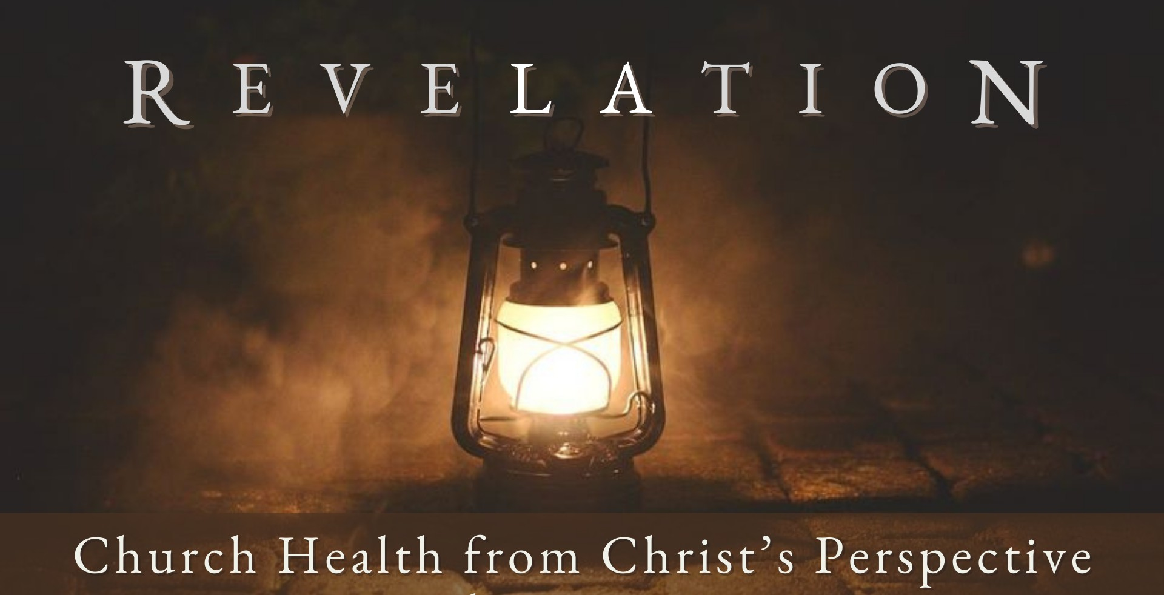
Good Morning Fellowship,

M a r c h 3 , 2 0 2 4
Who or what are you living for? In Revelation 2:8-11 we discover a letter Jesus wrote to a church living under immense pressure that reveals how to live for Christ for a
lifetime.
~Grant

T h e K e y s t o a L i f e t i m e o f F a i t h f u l n e s s R e v e l a t i o n 2 : 8 - 1 1
How can followers of Christ be faithful for a lifetime, even when facing suffering?
What are the keys God gives believers for a lifetime of faithfulness?
- Think upon Christ’s deity 2:8

“Therefore, since we have a great high priest who has passed through the heavens,
Jesus the Son of God, let us hold fast our confession. For we do not have a high
priest who cannot sympathize with our weaknesses, but One who has been tempted in all things as we are, yet without sin. Therefore let us draw near with confidence
to the throne of grace, so that we may receive mercy and find grace to help in time of need.”
Hebrews 4:14-16

- Trust in Christ’s sovereignty 2:9-10a

- Triumph through Christ’s life 2:10b-11

In the world you have tribulation, but take courage; I have overcome the world.”
John 16:33
The Person of Christ and the promises of God fuel the perseverance of His people.

M A R C H 3 , 2 02 4
Page 2

My personal application of this passage:

Questions for individual study and LIFE Groups:

- Why would it be difficult for the saints in Smyrna to remain faithful to the Lord?
- What role did the devil have in these saints' difficulties? How does this give us insight into the spiritual warfare that believers in Christ face? (See also Eph. 6:10-20 for more insight.)
- How does it affect you to realize that God knows the troubles and difficulties that you are facing?
- In what ways were these impoverished believers in Christ rich (2:9)? What particulars does our relationship with Christ provide to us who believe?
- What are some ways people face persecution and suffering today because of their faith in Jesus Christ? Why do you think God allows suffering and persecution in the life of the believer?
- Why does Jesus Christ emphasize in the introduction of this letter that He is "The first and the last, who was dead, and has come to life" ?
- How does knowing Christ and who He is help us in the challenges in our lives?
- What is Christ's promise to those whose faith is in Him?

Page 3
M A R C H 3 , 2 02 4

