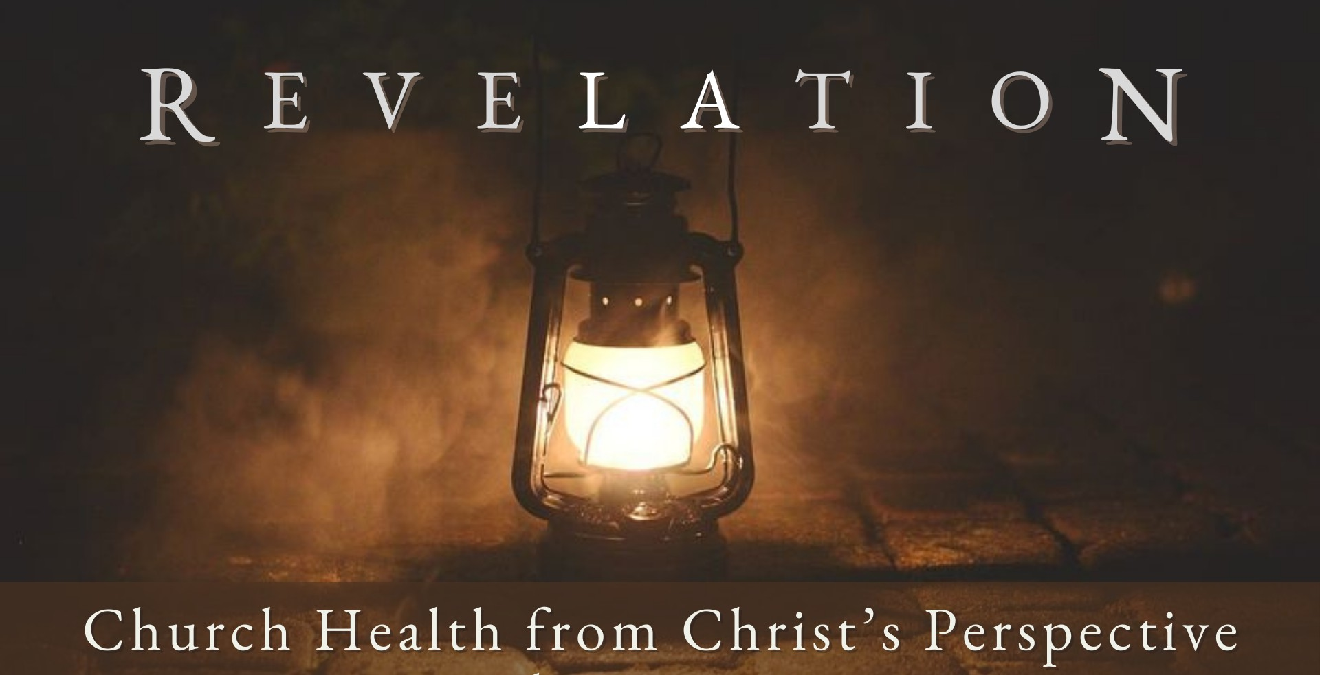
Good Morning Fellowship,

A p r i l 1 4 , 2 0 2 4
“Code Blue” is a life-threatening situation for both your body and a body of local
believers. This morning, we will discover what Jesus calls a spiritually dying church to do, based on His letter in Revelation 3:1-6.
~Grant

C o d e B l u e
R e v e l a t i o n 3 : 1 - 6
What does Christ call a spiritually dying church to do?
The life-saving measures Christ calls for to resuscitate a spiritually dying church:
- Revive what remains 3:2

- Remember what you have received 3:3a

- Repent of your sin 3:3b

Distinguishing characteristics of a dying church:

Live in the past

Lost their purpose in the present

Lack vision for their future

Page 2
A P R I L 1 4 , 2 02 4

- Refocus your hearts back on Christ 3:4-6

"Therefore everyone who confesses Me before men, I will also confess him before My Father who is in heaven. But whoever denies Me before men, I will also deny him before My Father who is in heaven.”
Matthew 10:32-33

Focusing on our LIFE in Christ keeps us from the deadening effects of sin.

My personal application of this passage:

Page 3 A P R I L 1 4 , 2 02 4

Questions for individual study and LIFE Groups:

- How would you describe a church needing a “wake-up call” like the church in Sardis?

- What would be some contributing factors that would cause a church to go from having a name that it was alive to coming to a point where it was dying?

- What does Jesus Christ call the people in a church to do if they have become spiritually lethargic and complacent?

- Based on verse 4, what was a significant problem for the church in Sardis? How would this problem be manifested today?

- How is it that a few people in Sardis had not contaminated and defiled their lives and character? How can we walk paths of purity amid a defiling world?

- What does it mean to be an “overcomer” (3:5)? How is it possible to be such a person? What does Jesus Christ promise to those who are overcomers?

- How has your walk with God been going lately? How can this letter encourage your development as one who is “in Christ”?

Page 4
A P R I L 1 4 , 2 02 4

