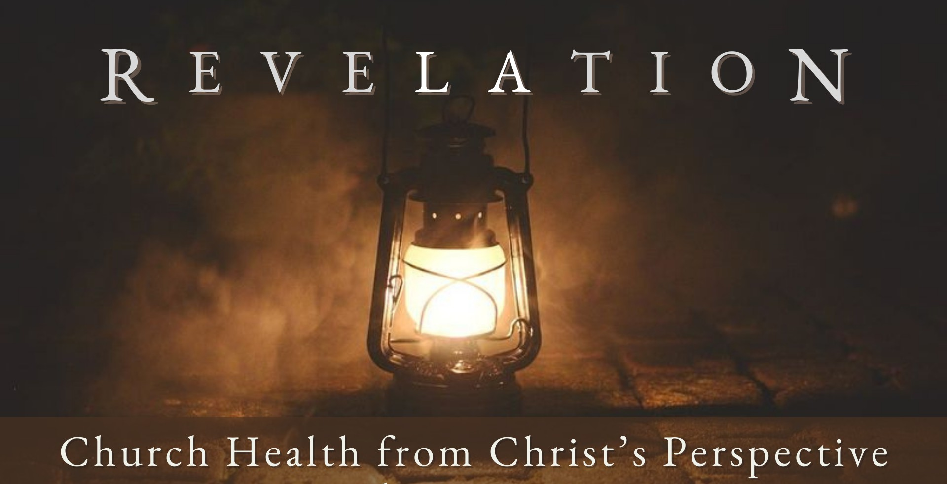
Good Morning Fellowship,

A p r i l 2 1 , 2 0 2 4
How do believers in a church thrive in the love of Christ? In the fascinating letter to the church at Philadelphia recorded in Revelation 3:7-13, Jesus outlines how
Christians live well in His love.
~Grant

H o w T o T h r i v e i n t h e L o v e o f C h r i s t
R e v e l a t i o n 3 : 7 - 1 3
How do believers in a church thrive in the love of Christ?

- Engage in Christ’s work 3:8a

What to consider to discover the open “DOORS” that God provides:

D: Direction God has given you O: Opportunity before you
O: Orientation of the opportunity and alignment with who God has called you to be

R: Resources available

S: Supplication in asking God to guide your desires and decision

- Keep Christ’s word 3:8b

“Why do you call Me, ‘Lord, Lord,’ and do not do what I say? Everyone who comes to Me and hears My words and acts on them, I will show you whom he is like: he is like a man building a house, who dug deep and laid a
foundation on the rock; and when a flood occurred, the torrent burst
against that house and could not shake it, because it had been well built. But the one who has heard and has not acted accordingly, is like a man who built a house on the ground without any foundation; and the torrent burst against it and immediately it collapsed, and the ruin of that house was great.”
Luke 6:46–49

Page 2
A P R I L 2 1 , 2 02 4

- Honor Christ’s name 3:8c

- Believe in Christ’s promises 3:9-13

The purpose of our lives is to reveal the love of Christ.

My personal application of this passage:

Page 3 A P R I L 2 1 , 2 02 4

Questions for individual study and LIFE Groups:

- Why is it important that each of us know our purpose in life? What are some of the results of not knowing our reason for being?

- What is the church and its purpose (see Eph. 4:11-16; Col. 1:18, 24-29)?

- Why would the people in the church of Philadelphia be greatly encouraged by this letter?

- What were some of the noteworthy characteristics of this church? How are these characteristics manifested in the lives of believers you know?

- What does Jesus promise to believers in Rev. 3:10? Why would this be encouraging to the saints then and to Christians today?

- Why does Jesus emphasize the reality of future glory with Him?

- What are some of the promises Christ gives His church in Revelation 3:9-13?

- How does knowing our future give us hope in our present circumstances?

- What is one principle or point of application that you can take away and weave into the fabric of your life this week?

Page 4
A P R I L 2 1 , 2 02 4

