**June 16, 2024**

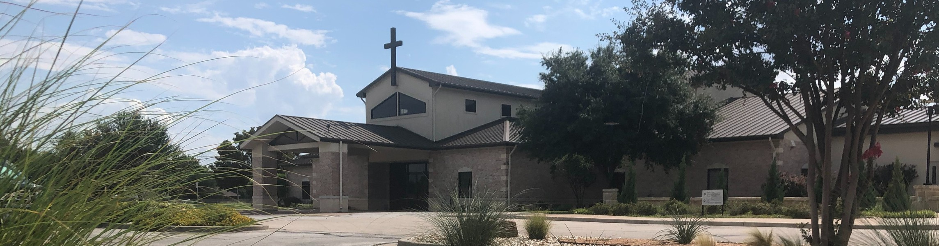

Welcome to Fellowship!

Thank you for joining us for worship today! If you are a first-time visitor, please visit our Welcome Desk in the foyer or scan the QR code at right to complete a Guest Connect form.

# J U N E A T A G L A N C E :



**Need Assistance?**

Visit the South Foyer Welcome Desk and our friendly Welcome Team will be glad to answer any questions or help you find the information you’re looking for!

**Need Coffee?**

Visit our Café in the North Foyer. Our Hospitality Team is ready to serve you!

**Need Prayer?**

If you would like someone to pray with you, our Prayer Team is available at the back of the Worship Center after each service.

Visit our website:

fellowshipwaco.org

Email us: [office@fellowshipwaco.org](mailto:office@fellowshipwaco.org)

Read and subscribe to our weekly newsletter: fellowshipwaco.org

Download our church app: fellowshipwaco.org/app

Telephone: 254.848.7200

Follow Us On Social Media

*@fellowshipwaco*

June 18

June 19

June 21

June 30

June 30

MomLIFE Play Date LiveWires Pool Party Student Event Night Student Event Night

Watermelon Sale for GBBMI

# O T H E R U P C O M I N G E V E N T S :

July 6-10

July 11

July 13

July 14

July 19

July 20

July 24

July 21-26

July 25

Student Summer Camp ForeRunners Luncheon MomLIFE Moms’ Breakfast

Stephen Ministry Interest Meeting Student Worship Night

Men’s Breakfast LiveWires Pool Party Student Mission Trip MomLIFE Play Date

*For complete event details and registration, visit our website: fellowshipwaco.org/events*

*or scan the QR code at right.*

Good Morning Fellowship,

This week at our FX Camp, we have

focused on being "all in for Jesus." To make this journey our reality, we must each learn to live by faith. In Revelation 10, we will uncover some surprising

insights about how God nurtures our faith in Him and His word.

*~Grant*

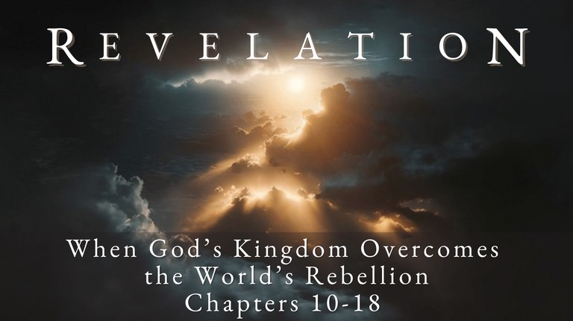**H o w G o d D e v e l o p s t h e F a i t h o f H i s P e o p l e**

**R e v e l a t i o n 1 0 : 1 - 1 1**

To be “all in for Jesus” we must learn how to live by faith in Him.

***How does God develop the faith of His people?***

## What we need to know to live by faith:

1. **God conceals some of what could be known 10:1-4**

My thoughts are not your thoughts, nor are your ways My ways,

declares the LORD. For as the heavens are higher than the earth, so are My ways higher than your ways and My thoughts than your

thoughts.

Isaiah 55:8-9

The secret things belong to the LORD.

Deuteronomy 29:29

4 Ways

to Give **In Service**

*Boxes in Worship Center*

**Online**

*fellowshipwaco.org/giving*

**App**



*fellowshipwaco.org/app*

**Mail**

*P.O. Box 21655*

*Waco, TX 76702*

## CIAG Grid: Control - Influence - Accept - Grateful for

1. **God reveals what must be known through His word 10:5-11**

**How to live by faith in God and His word:**

## Receive the word

So faith comes from hearing, and hearing by the word of Christ.

Romans 10:17

## Internalize the word

* + **Communicate the word**

***What we need to walk by faith God has given to us in His word.***

Take Next

Steps **Membership**

*fellowshipwaco.org/membership*



**Serve**

*fellowshipwaco.org/serve*



**Small Groups**

*fellowshipwaco.org/groups*

***My personal application of this passage:***



**Video from previous messages: youtube.com/fellowshipwaco Audio from previous messages: fellowshipwaco.org/podcasts Sermon notes online: fellowshipwaco.org/sermon-notes**

***Questions for individual study and LIFE Groups:***

1. Why does God intentionally not reveal all that He could make known?
2. What is an “unknown” in your life that you have had to accept and move forward “by faith?”
3. What does this passage teach us about God and His word?
4. What does this passage teach us about God’s sovereign control of the future?
5. What helpful practices have you employed in your study and application of God’s word?