**June 23, 2024**

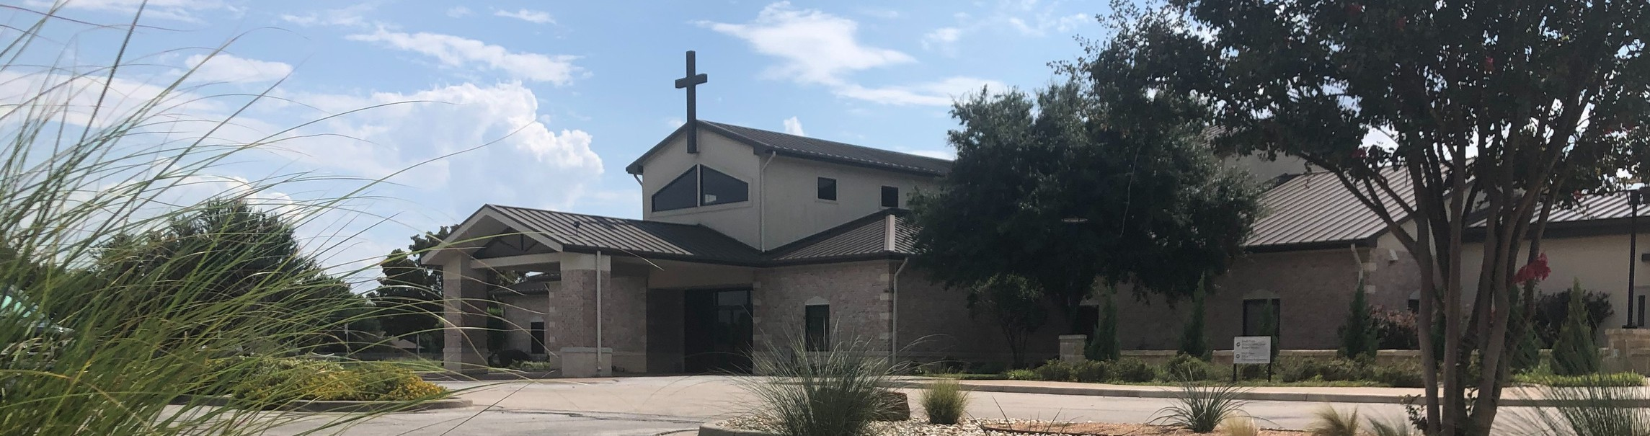

Welcome to Fellowship!

# Thank you for joining us for worship today! If you are a first-time visitor, please visit our Welcome Desk in the foyer or scan the QR code at right to complete a Guest Connect form.

U P C O M I N G E V E N T S



**Need Assistance?**

Visit the South Foyer Welcome Desk and our friendly Welcome Team will be glad to answer any questions or help you find the information you’re looking for!

**Need Coffee?**

Visit our Café in the North Foyer. Our Hospitality Team is ready to serve you!

**Need Prayer?**

If you would like someone to pray with you, our Prayer Team is available at the back of the Worship Center after each service.

Visit our website:

fellowshipwaco.org

Email us: [office@fellowshipwaco.org](mailto:office@fellowshipwaco.org)

Read and subscribe to our weekly newsletter: fellowshipwaco.org

Download our church app: fellowshipwaco.org/app

Telephone: 254.848.7200

Follow Us On Social Media

*@fellowshipwaco*

June 30

June 30

July 6-10

July 11

July 13

July 14

July 19

July 20

July 24

July 21-26

July 25

Aug. 18

Student Event Night Watermelon Sale for GBBMI

Student Summer Camp ForeRunners Luncheon MomLIFE Moms’ Breakfast

Stephen Ministry Interest Meeting Student Worship Night

Men’s Breakfast LiveWires Pool Party Student Mission Trip MomLIFE Play Date

Discover LIFE Membership Class

*For complete event details and registration, visit our website: fellowshipwaco.org/events*

*or scan the QR code at right.*

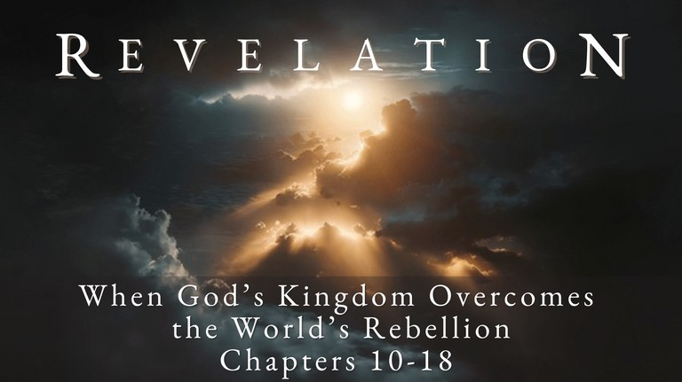

Good Morning Fellowship,

God always has a witness in the world. You are a Christian who worships today because of this reality. Revelation 11

highlights the unique testimonies God will manifest in the end times to bear witness of His sovereign character and power.

*Grant Kaul, Senior Pastor*

**N e v e r W i t h o u t a W i t n e s s**

**R e v e l a t i o n 1 1 : 1 - 1 9**

God’s present witness to the world: Creation, Communication, Conscience, Christ, Christians

The Almighty God always has a witness to the world.

**God’s future additional testimony to the world in the end-time:**

1. **The restoration of God’s temple on earth 11:1-2**

4 Ways

to Give **In Service**

*Boxes in Worship Center*

**Online**

*fellowshipwaco.org/giving*

**App**



*fellowshipwaco.org/app*

**Mail**

*P.O. Box 21655*

*Waco, TX 76702*

1. **The revelation of God’s final two prophets on earth 11:3-14**
2. **The realization of Christ’s kingdom triumph is declared in heaven**

**11:15-19**

***Believing the testimonies of God brings transformation to our lives.***

Take Next

Steps **Membership**

*fellowshipwaco.org/membership*



**Serve**

*fellowshipwaco.org/serve*



**Small Groups**

*fellowshipwaco.org/groups*

***My personal application of this passage:***



**Video from previous messages: youtube.com/fellowshipwaco Audio from previous messages: fellowshipwaco.org/podcasts Sermon notes online: fellowshipwaco.org/sermon-notes**

***Questions for individual study and LIFE Groups:***

* 1. What are different ways God continues to give testimony to His existence today? How would you respond if someone asked, “Why do you believe there really is a God?”
  2. Who are some of the Christians God has placed in your life who have been instrumental in your knowing Jesus Christ and growing as a Christian?
  3. What are some of the different ways God will give testimony of Himself in the end times, as revealed in Rev. 11?
  4. Why do you think God always has a witness to the people in the world?
  5. How would you explain the significance of the statement made in Revelation 11:15? In what ways is “our Lord and His Christ” reigning today? How could this verse be used in your private worship of God this week?