**June 30, 2024**

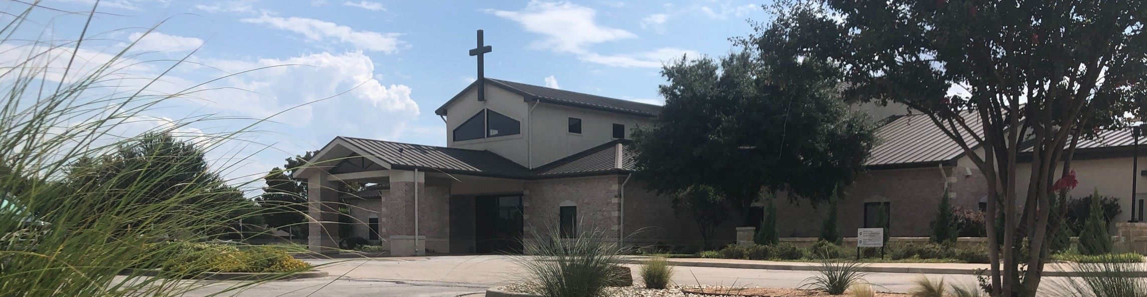

Welcome to Fellowship!

# Thank you for joining us for worship today! If you are a first-time visitor, please visit our Welcome Desk in the foyer or scan the QR code at right to complete a Guest Connect form.

U P C O M I N G E V E N T S



**Need Assistance?**

Visit the South Foyer Welcome Desk and our friendly Welcome Team will be glad to answer any questions or help you find the information you’re looking for!

**Need Coffee?**

Visit our Café in the North Foyer. Our Hospitality Team is ready to serve you!

**Need Prayer?**

If you would like someone to pray with you, our Prayer Team is available at the back of the Worship Center after each service.

Visit our website:

fellowshipwaco.org

Email us: [office@fellowshipwaco.org](mailto:office@fellowshipwaco.org)

Read and subscribe to our weekly newsletter: fellowshipwaco.org

Download our church app: fellowshipwaco.org/app

Telephone: 254.848.7200

Follow Us On Social Media

*@fellowshipwaco*

July 4

July 5

July 5-10

July 7

July 11

July 13

July 14

July 14

July 19

July 20

July 24

July 21-26

July 25

Aug. 18

Independence Day - Office Closed Office Closed

Student Summer Camp ForeRunners Connection ForeRunners Luncheon MomLIFE Moms’ Breakfast

Stephen Ministry Interest Meeting Isaiah 117 House Lemonade Stand Student Worship Night

Men’s Breakfast LiveWires Pool Party Student Mission Trip MomLIFE Play Date

Discover LIFE Membership Class

Special Note: During the month of July, Kids’ Ministry and Early Childhood Classes will meet during 2nd service only.

*For complete event details and registration, visit our website: fellowshipwaco.org/events*

*or scan the QR code at right.*

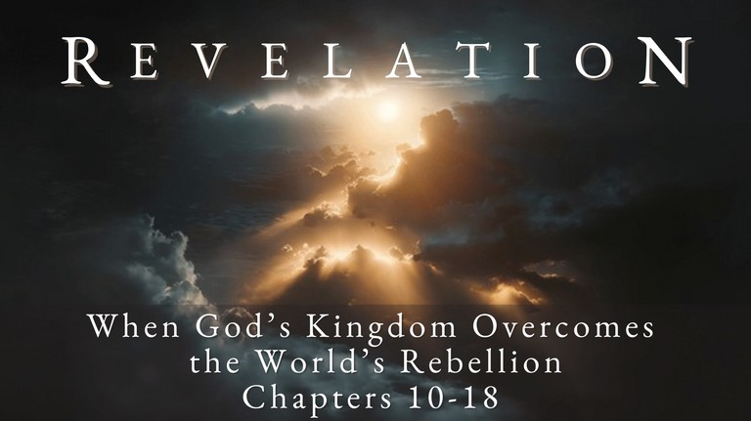

Good Morning Fellowship,

There is much more than meets the eye when it comes to the spiritual war

between God and Satan. Revelation 12

gives us a fascinating look into the nature of the war and how believers today and in the future become overcomers in Christ.

*Grant Kaul, Senior Pastor*

**T h e O v e r c o m e r ’ s G u i d e t o S a t a n ’ s W a r w i t h G o d a n d H i s P e o p l e**

**R e v e l a t i o n 1 2**

**What do overcomers in Christ need to know about Satan’s war with God and His people?**

**The key characters and events 12:1-9**

1. **The woman: Israel vv. 1-2**
2. **The dragon: Satan vv. 3-4**
3. **The male child: Christ vv. 5-6**
4. **The archangel: Michael vv. 7-9**

So Jesus was saying to those Jews who had believed Him, “If you continue in My word, then you are truly disciples of Mine; and you will know the

truth, and the truth will make you free.”

John 8:31–32

4 Ways

to Give **In Service**

*Boxes in Worship Center*

**Online**



*fellowshipwaco.org/giving*

**App**



*fellowshipwaco.org/app*

**Mail**

*P.O. Box 21655*

*Waco, TX 76702*

**The Christians’ core characteristics 12:10-12**

* **They celebrate God’s salvation and His Kingdom v. 10a**
* **They are cognizant of the enemy’s schemes v. 10b**
* **They are completely committed to Christ vv. 11-12**

**The culminating conflict 12:13-17**

***The enemy of God is only overcome by trusting the Lord of life.***

**What is your story that you are sharing?**

Take Next



Steps **Membership**

*fellowshipwaco.org/membership*



**Serve**

*fellowshipwaco.org/serve*



**Small Groups**

*fellowshipwaco.org/groups*

***My personal application of this passage:***



**Video from previous messages: youtube.com/fellowshipwaco Audio from previous messages: fellowshipwaco.org/podcasts Sermon notes online: fellowshipwaco.org/sermon-notes**

***Questions for individual study and LIFE Groups:***

1. Why do you think God gives us some of the big picture details of the war that Satan is waging?
2. What does Revelation 12 teach us about the identity of the enemy of God?
3. What can we learn about Satan’s strategy in his war against God’s people? What are some ways you see this manifested today?
4. What are some of the characteristics of overcomers identified in Revelation 12:11, 17? How can these characteristics be cultivated in our lives?
5. What are some of the biggest deceptions Satan places in front of you? How can you, through Christ, overcome these?