**June 9, 2024**

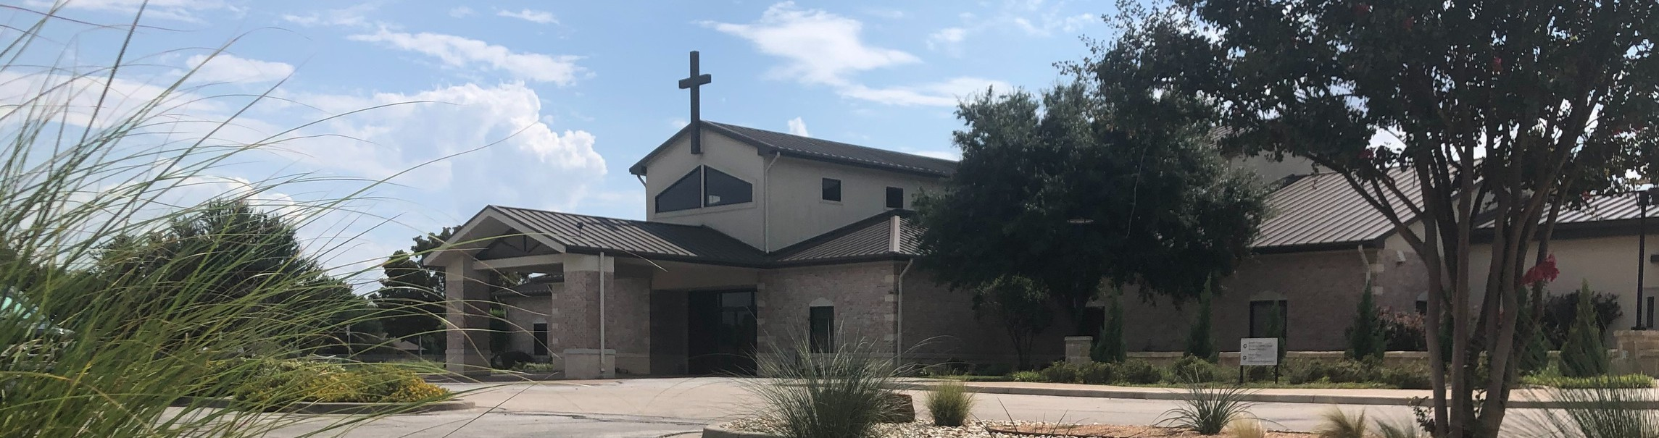

Welcome to Fellowship!

Thank you for joining us for worship today! If you are a first-time visitor, please visit our Welcome Desk in the foyer or scan the QR code at right to complete a Guest Connect form.

# J U N E A T A G L A N C E :



**Need Assistance?**

Visit the South Foyer Welcome Desk and our friendly Welcome Team will be glad to answer any questions or help you find the information you’re looking for!

**Need Coffee?**

Visit our Café in the North Foyer. Our Hospitality Team is ready to serve you!

**Need Prayer?**

If you would like someone to pray with you, our Prayer Team is available at the back of the Worship Center after each service.

Visit our website:

fellowshipwaco.org

Email us: [office@fellowshipwaco.org](mailto:office@fellowshipwaco.org)

Read and subscribe to our weekly newsletter: fellowshipwaco.org

Download our church app: fellowshipwaco.org/app

Telephone: 254.848.7200

Follow Us On Social Media

*@fellowshipwaco*

June 10

June 15

June 16

June 18

June 19

June 21

June 30

FX Camp Begins Men’s Breakfast

Father’s Day/Family Sunday MomLIFE Play Date LiveWires Pool Party

Student Event Night Student Event Night

# O T H E R U P C O M I N G E V E N T S :

July 6-10

July 11

July 13

July 14

July 19

July 20

July 24

July 21-26

July 25

Student Summer Camp ForeRunners Luncheon MomLIFE Moms’ Breakfast

Stephen Ministry Interest Meeting Student Worship Night

Men’s Breakfast LiveWires Pool Party Student Mission Trip MomLIFE Play Date

*For complete event details and registration, visit our website: fellowshipwaco.org/events*

*or scan the QR code at right.*

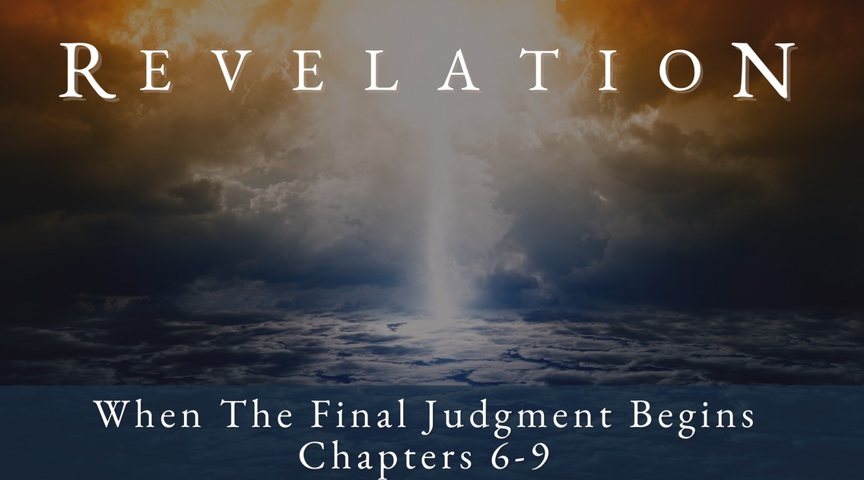

Good Morning Fellowship,

In a rarely taught section of Revelation, we discover just how deep the problem of human depravity is. Chapters 8 and 9

vividly show how great our need is for God's mercy in the midst of His

judgments.

*~Grant*

**D e p r a v i t y R u n s D e e p**

**R e v e l a t i o n 8 - 9**

Everyone is a worshipper

***Everyone who will not worship the one true God***

***will face judgment for what they choose to worship.***

**Depravity:** a term that refers to the corruption of sin extending to all people and affecting the entire person, intellect, emotions, and will.

How big a problem is human depravity?

The coming trumpet judgments reveal how great an offense our depravity is to God 8:1-9:19

1. **First trumpet: desolation of one-third of the earth’s vegetation**

8:7

1. **Second trumpet: desolation of one-third of the sea, its creatures, and its ships 8:8-9**
2. **Third trumpet: desolation of one-third of the earth’s fresh water**

8:10-11

4 Ways

to Give **In Service**

*Boxes in Worship Center*

**Online**

*fellowshipwaco.org/giving*

**App**



*fellowshipwaco.org/app*

**Mail**

*P.O. Box 21655*

*Waco, TX 76702*

1. **Fourth trumpet: disruption of one-third of the heavens 8:12**
2. **Fifth trumpet: demonic invasion 9:1-12**
3. **Sixth trumpet: deadly attack of the massive army from the East**

9:13-19

The coming trumpet judgments reveal how greatly depravity affects us 9:20-21

***Everyone who will not worship the one true God***

***will face judgment for what they choose to worship.***

***The Lord is not slow about His promise, as some count slowness, but is patient toward you, not wishing for any to perish but for all to come to repentance.*** 2 Peter 3:9

Take Next

Steps **Membership**

*fellowshipwaco.org/membership*



**Serve**

*fellowshipwaco.org/serve*



**Small Groups**

*fellowshipwaco.org/groups*

***My personal application of this passage:***



**Video from previous messages: youtube.com/fellowshipwaco Audio from previous messages: fellowshipwaco.org/podcasts Sermon notes online: fellowshipwaco.org/sermon-notes**

***Questions for individual study and LIFE Groups:***

* 1. What are some practical ways we see Jesus Christ worshipped by those trusting in Him as their Savior and Lord of their lives?
  2. Why does God bring judgment upon the earth and its inhabitants as portrayed in Revelation 8-9?
  3. What can we learn about human nature from Revelation 9:20-21?
  4. How would you define depravity, and how is it displayed in these verses?
  5. Reflecting on the impending events in Revelation, how do you find it influencing your daily life? How does it alter the way you allocate your time, manage your finances, or nurture your relationships with family and friends?