**July 21, 2024**

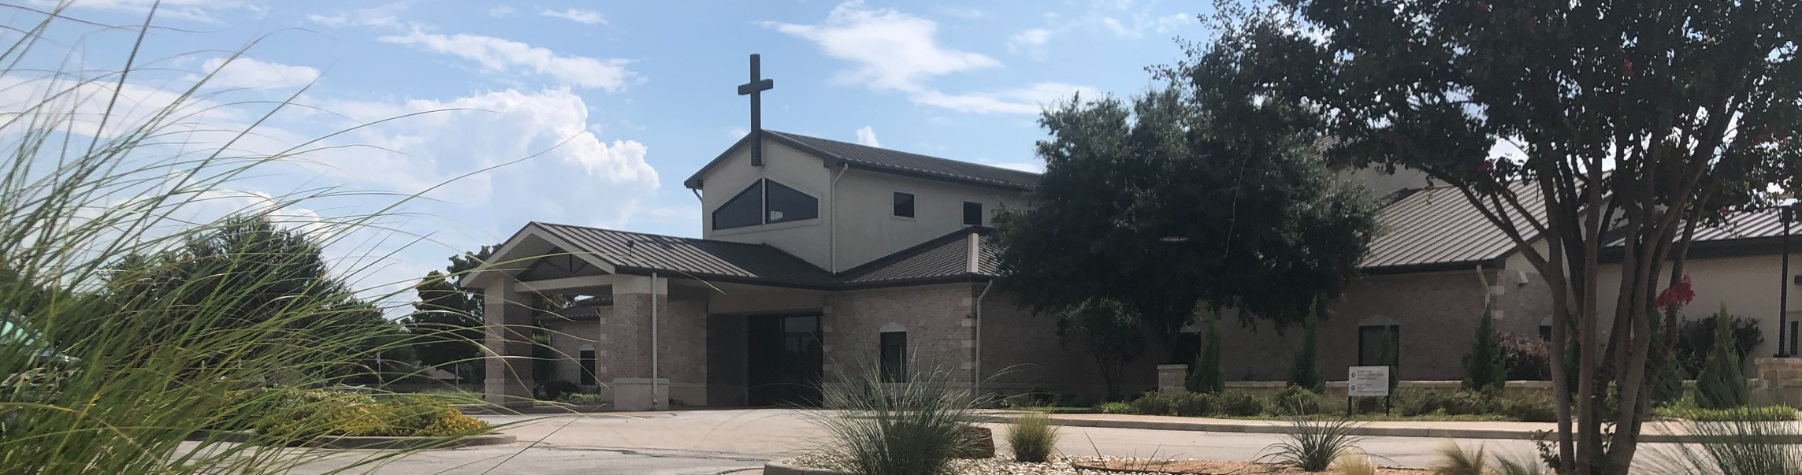

Welcome to Fellowship!

# Thank you for joining us for worship today! If you are a first-time visitor, please visit our Welcome Desk in the foyer or scan the QR code at right to complete a Guest Connect form.

U P C O M I N G E V E N T S



**Need Assistance?**

Visit the South Foyer Welcome Desk and our friendly Welcome Team will be glad to answer any questions or help you find the information you’re looking for!

**Need Coffee?**

Visit our Café in the North Foyer. Our Hospitality Team is ready to serve you!

**Need Prayer?**

If you would like someone to pray with you, our Prayer Team is available at the back of the Worship Center after each service.

Visit our website:

fellowshipwaco.org

Email us: [office@fellowshipwaco.org](mailto:office@fellowshipwaco.org)

Read and subscribe to our weekly newsletter: fellowshipwaco.org

Download our church app: fellowshipwaco.org/app

Telephone: 254.848.7200

Follow Us On Social Media

*@fellowshipwaco*

July 21-26

July 24

July 25

Aug. 4

Aug. 8

Aug. 10

Aug. 11

Aug. 17

Aug. 18

Student Mission Trip LiveWires Pool Party MomLIFE Play Date

ForeRunners Connection ForeRunners Ice Cream Social LiveWires Pool Party Promotion Sunday

Men’s Breakfast

Discover LIFE Membership Class

Special Note: During the month of July, Kids’ Ministry and Early Childhood Classes will meet during 2nd service only.

*For complete event details and registration, visit our website: fellowshipwaco.org/events*

*or scan the QR code at right.*

Good Morning Fellowship!

The world around us is roaring and chaotic. The natural world and nations of the world appear out of control. Psalm 46 tells us this is not new. Do you

want to know how to have deep peace and serenity in a world that doesn’t

provide either of those? Psalm 46 provides the key to finding and knowing the refuge that can only come from knowing God.

Brian Davis, Elder

**T h e R e f u g e a n d T h e R o a r**

**P s a l m 4 6**

**The refuge of the Lord silences the roar of the world.**

**Refuge in the Natural World vs. 1-3**

4 Ways

to Give **In Service**

*Boxes in Worship Center*

**Online**



*fellowshipwaco.org/giving*

**App**



*fellowshipwaco.org/app*

**Mail**

*P.O. Box 21655*

*Waco, TX 76702*

**Refuge in the Nations of the World vs. 4-7**

 **Exaltation of the Lord Almighty vs. 8-11**

***You can be still, knowing that the refuge of the exalted Lord Almighty silences the roar of the world.***

Take Next



Steps **Membership**

*fellowshipwaco.org/membership*



**Serve**

*fellowshipwaco.org/serve*



**Small Groups**

*fellowshipwaco.org/groups*

***My personal application of this passage:***



**Video from previous messages: youtube.com/fellowshipwaco Audio from previous messages: fellowshipwaco.org/podcasts Sermon notes online: fellowshipwaco.org/sermon-notes**

***Questions for individual study and LIFE Groups:***

1. Do you find God to be a refuge and source of strength in times of trouble? Why or why not?
2. What can aid or facilitate you experiencing these streams that make you glad (v. 4)?
3. We are told to “come and see the works of the Lord” in the world around us. What are some works you can clearly attribute to Him?
4. What does it look like for you to cease striving, to “Be still and know that I am God”?
5. God says, “I will be exalted among the nations, I will be exalted in the earth.” How does that provide peace to you in times of trouble?