**July 28, 2024**

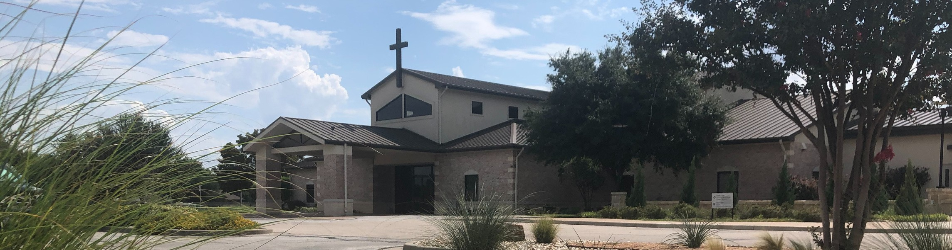

Welcome to Fellowship!

# Thank you for joining us for worship today! If you are a first-time visitor, please visit our Welcome Desk in the foyer or scan the QR code at right to complete a Guest Connect form.

U P C O M I N G E V E N T S



**Need Assistance?**

Visit the South Foyer Welcome Desk and our friendly Welcome Team will be glad to answer any questions or help you find the information you’re looking for!

**Need Coffee?**

Visit our Café in the North Foyer. Our Hospitality Team is ready to serve you!

**Need Prayer?**

If you would like someone to pray with you, our Prayer Team is available at the back of the Worship Center after each service.

Visit our website:

fellowshipwaco.org

Email us: [office@fellowshipwaco.org](mailto:office@fellowshipwaco.org)

Read and subscribe to our weekly newsletter: fellowshipwaco.org

Download our church app: fellowshipwaco.org/app

Telephone: 254.848.7200

Follow Us On Social Media

*@fellowshipwaco*

Aug. 4

Aug. 8

Aug. 10

Aug. 11

Aug. 17

Aug. 18

Aug. 21

Sept. 10

Sept. 11

Sept. 12

Sept. 13

ForeRunners Connection ForeRunners Ice Cream Social LiveWires Pool Party Promotion Sunday

Men’s Breakfast

Discover LIFE Membership Class Student Ministry Fall Kick-Off

Tues. Morning Bible Studies begin Wed. Night Activities begin MomLIFE begins

Women’s Worship Night

Special Note: During the month of July, Kids’ Ministry and Early Childhood Classes will meet during 2nd service only.

*For complete event details and registration, visit our website: fellowshipwaco.org/events*

*or scan the QR code at right.*

Good Morning Fellowship!

Many times, when we face troubling situations or seasons in life, we are

tempted to feel like we are lost and alone with no real hope. As we continue our sermon series Summer in the Psalms, we are encouraged by Asaph in

Psalm 77 to remember the past faithfulness of the Lord. Let’s worship Jesus together and find comfort in recalling His faithfulness!

George Ohmstede, Associate Pastor

**R e m e m b e r i n g t h e F a i t h f u l W o r k s o f t h e L o r d**

**P s a l m 7 7**

**Comprehension *(observation, interpretation, application)***

4 Ways

to Give **In Service**

*Boxes in Worship Center*

**Online**



*fellowshipwaco.org/giving*

**App**



*fellowshipwaco.org/app*

**Mail**

*P.O. Box 21655*

*Waco, TX 76702*

**Conviction**

**Conduct**

Take Next



Steps **Membership**

*fellowshipwaco.org/membership*



**Serve**

*fellowshipwaco.org/serve*



**Small Groups**

*fellowshipwaco.org/groups*

***My personal application of this passage:***



**Video from previous messages: youtube.com/fellowshipwaco Audio from previous messages: fellowshipwaco.org/podcasts Sermon notes online: fellowshipwaco.org/sermon-notes**

***Questions for individual study and LIFE Groups:***

1. Which attributes of God bring you comfort when you find yourself troubled?
2. Recall and read a passage in the Old Testament that allows you to be reminded of the faithfulness of God. (Noah and the ark, Daniel and the lion’s den, the story of Ruth, etc.).
3. Take verses 7-9 in Psalm 77 and answer Asaph’s questions with scripture that speaks to God’s faithfulness to never leave us nor forsake us.
4. Make a list of God’s works of wonder found in scripture, then take time to meditate upon and praise Him for them.
5. How would you use God’s faithfulness of the past to express your certainty of His faithfulness in the present and the future? For example, if you were in a gospel conversation how would God’s faithfulness (past, present, future) be incorporated?