**August 18, 2024**

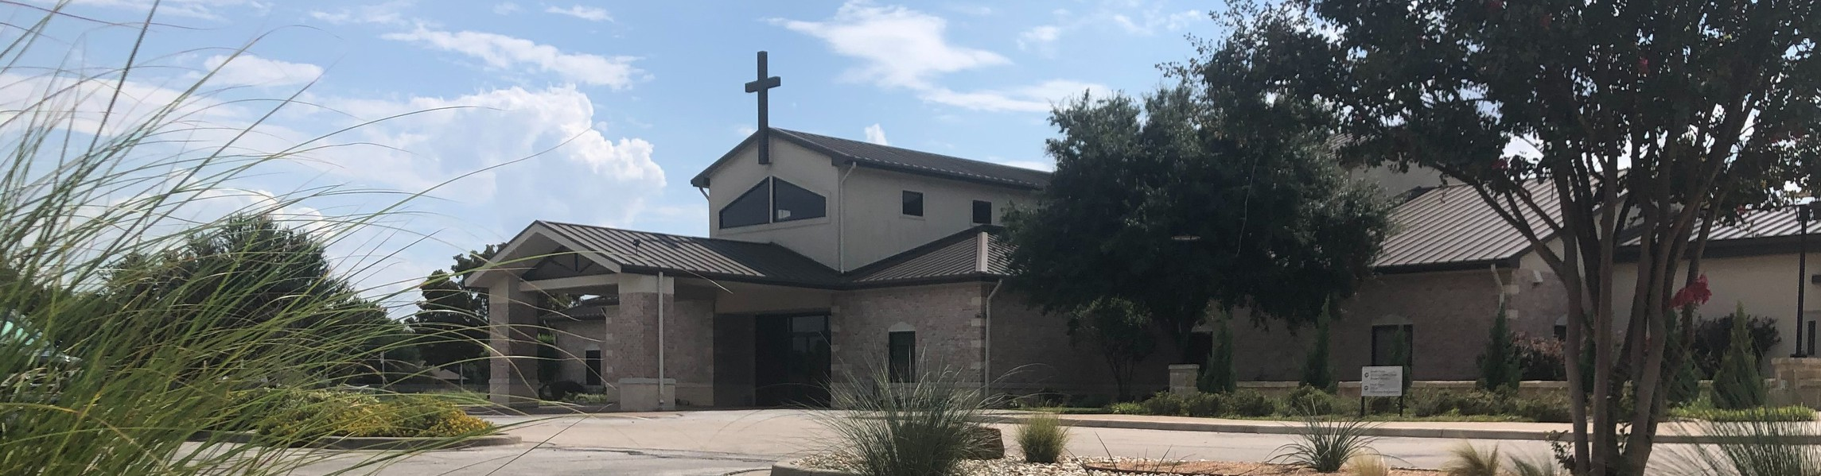

Welcome to Fellowship!

# Thank you for joining us for worship today! If you are a first-time visitor, please visit our Welcome Desk in the foyer or scan the QR code at right to complete a Guest Connect form.

U P C O M I N G E V E N T S



**Need Assistance?**

Visit the South Foyer Welcome Desk and our friendly Welcome Team will be glad to answer any questions or help you find the information you’re looking for!

**Need Coffee?**

Visit our Café in the North Foyer. Our Hospitality Team is ready to serve you!

**Need Prayer?**

If you would like someone to pray with you, our Prayer Team is available at the back of the Worship Center after each service.

Visit our website:

fellowshipwaco.org

Email us: [office@fellowshipwaco.org](mailto:office@fellowshipwaco.org)

Read and subscribe to our weekly newsletter: fellowshipwaco.org

Download our church app: fellowshipwaco.org/app

Telephone: 254.848.7200

Follow Us On Social Media

*@fellowshipwaco*

Aug. 18

Aug. 21

Aug. 21

Aug. 25

Sept. 1

Sept. 2

Sept. 10

Sept. 11

Sept. 12

Sept. 12

Sept. 15

Sept. 21

Sept. 28

Discover LIFE Membership Class Student Ministry Fall Kick-Off Student Ministry Parent Meeting Student Worship Team Meeting for Students & Parents

ForeRunners Connection Labor Day - Office Closed

Tues. Morning Bible Studies begin Wed. Night Activities begin MomLIFE begins

ForeRunners Event

Stephen Ministry Interest Meeting Men’s Breakfast

Share Your Faith Workshop

*For complete event details and registration, visit our website: fellowshipwaco.org/events*

*or scan the QR code at right.*

Good Morning Fellowship!

What you don't know really can hurt you when it comes to God and what will happen in the end times. This morning, we will walk through Revelation 14 and discover what every person must know about God.

Grant Kaul, Senior Pastor

**T h e U l t i m a t e R e a l i t y**

**R e v e l a t i o n 1 4**

**What does every person need to know about God?**

**What every person must know about God:**

1. **God redeems His people 14:1-5**

4 Ways

to Give **In Service**

*Boxes in Worship Center*

**Online**



*fellowshipwaco.org/giving*

**App**



*fellowshipwaco.org/app*

**Mail**

*P.O. Box 21655*

*Waco, TX 76702*

1. **God reveals His gospel 14:6-7**

**the gospel:** the “good news” that by grace God forgives and redeems all who are broken over their sin, believe in the perfect life, substitutionary death, and resurrection of Jesus Christ, and receive eternal life as a disciple in His kingdom

1. **God renders judgment on His enemies 14:8-20**

You adulteresses, do you not know that friendship with the world is hostility toward God? Therefore whoever wishes to be a friend of the world makes himself an enemy of God.

James 4:4

**Those redeemed by Christ's sacrifice will never face God's wrath.**

Take Next



Steps **Membership**

*fellowshipwaco.org/membership*



**Serve**

*fellowshipwaco.org/serve*



**Small Groups**

*fellowshipwaco.org/groups*

***My personal application of this passage:***



**Video from previous messages: youtube.com/fellowshipwaco Audio from previous messages: fellowshipwaco.org/podcasts Sermon notes online: fellowshipwaco.org/sermon-notes**

***Questions for individual study and LIFE Groups:***

* 1. How are the redeemed in the tribulation described in Rev. 14:1-5? In what ways should those who are redeemed reflect the character of the Redeemer?
  2. Why does God have His gospel proclaimed both today and in the end times before His Son’s return?
  3. Why does God bring about judgment upon those who reject Him?
  4. What role does the gospel have in your life? How have you grown in understanding of the gospel and love for Christ in the past year?
  5. Who is someone who does not truly know the Savior for whom you have been praying or with whom you have been seeking to share the love of Christ? How has our study of Revelation influenced your behavior in this regard?