**August 25, 2024**

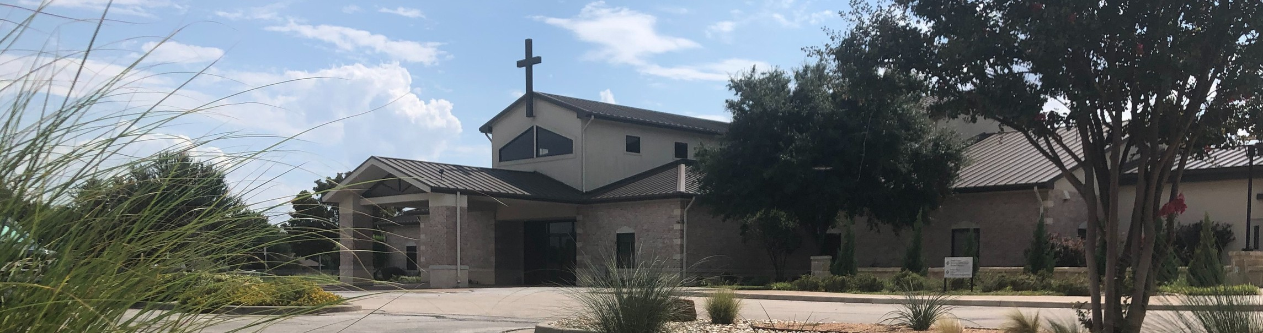

Welcome to Fellowship!

# Thank you for joining us for worship today! If you are a first-time visitor, please visit our Welcome Desk in the foyer or scan the QR code at right to complete a Guest Connect form.

U P C O M I N G E V E N T S



**Need Assistance?**

Visit the South Foyer Welcome Desk and our friendly Welcome Team will be glad to answer any questions or help you find the information you’re looking for!

**Need Coffee?**

Visit our Café in the North Foyer. Our Hospitality Team is ready to serve you!

**Need Prayer?**

If you would like someone to pray with you, our Prayer Team is available at the back of the Worship Center after each service.

Visit our website:

fellowshipwaco.org

Email us: [office@fellowshipwaco.org](mailto:office@fellowshipwaco.org)

Read and subscribe to our weekly newsletter: fellowshipwaco.org

Download our church app: fellowshipwaco.org/app

Telephone: 254.848.7200

Follow Us On Social Media

*@fellowshipwaco*

Aug. 25

Sept. 1

Sept. 2

Sept. 10

Sept. 11

Sept. 12

Sept. 12

Sept. 15

Sept. 21

Sept. 28

Student Worship Team Meeting for Students & Parents

ForeRunners Connection Labor Day - Office Closed

Tues. Morning Bible Studies begin Wed. Night Activities begin MomLIFE begins

ForeRunners Event

Stephen Ministry Interest Meeting Men’s Breakfast

Share Your Faith Workshop

*For complete event details and registration, visit our website: fellowshipwaco.org/events*

*or scan the QR code at right.*

Good Morning Fellowship!

Believers have experienced it, the lost are in need of it, many will reject it. What is “it”? The eternal gospel! This morning, we will look at how Saul of

Tarsus allowed the eternal gospel to not only save him, but to stir a passion within him to make sure the whole world knew about IT!

George Ohmstede Associate Pastor

**T h e E t e r n a l G o s p e l i n A c t i o n :**

***S a u l o f T a r s u s ’ J o u r n e y o f S a l v a t i o n !***

**A c t s 9**

**Comprehension**

1. **Saul before he professed Christ (1-2)**
2. **Saul’s conversion in professing Christ (3-9)**
3. **Saul after he professed Christ (10-31)**

**Conviction**

**The eternal Gospel should stir up a passion within the believer to share the good news of Jesus at every opportunity.**

4 Ways

to Give **In Service**

*Boxes in Worship Center*

**Online**



*fellowshipwaco.org/giving*

**App**



*fellowshipwaco.org/app*

**Mail**

*P.O. Box 21655*

*Waco, TX 76702*

**Conduct**

***Put together a plan, practice the plan, put the plan into action!***

**Practice example of a plan:**

***Paul’s Story:***

**Acts 9**

***Personal story:***

**Who you were before Jesus**

**How you surrendered to Jesus**

**Who you are since trusting Jesus**

***Pathway of scripture:***

**Romans Road and/or Ephesians 2 Romans 3:10**

**Romans 3:23 Romans 6:23 Romans 5:8**

**Romans 10:9-13 Ephesians 2:8-9**

***Let us be moved with urgency to share the eternal gospel to those around us. Let IT bring truth to the lost and let IT bring power, peace,***

***and poise to the believer!***

Take Next



Steps **Membership**

*fellowshipwaco.org/membership*



**Serve**

*fellowshipwaco.org/serve*



**Small Groups**

*fellowshipwaco.org/groups*

***My personal application of this passage:***



**Video from previous messages: youtube.com/fellowshipwaco Audio from previous messages: fellowshipwaco.org/podcasts Sermon notes online: fellowshipwaco.org/sermon-notes**

***Questions for individual study and LIFE Groups:***

1. Who was Saul of Tarsus and what did we find him doing in the beginning of Acts 9?
2. How did Saul know to address the voice as Lord?
3. How do we protect ourselves against having the initial attitude of Ananias when we meet a new convert?
4. How did the eternal gospel change Saul? Spend time digging deep here. We know he was saved. How did his salvation change him into who he became?
5. Spend time crafting your personal plan to share the eternal gospel with others. Practice the plan and put it into action!