**August 4, 2024**

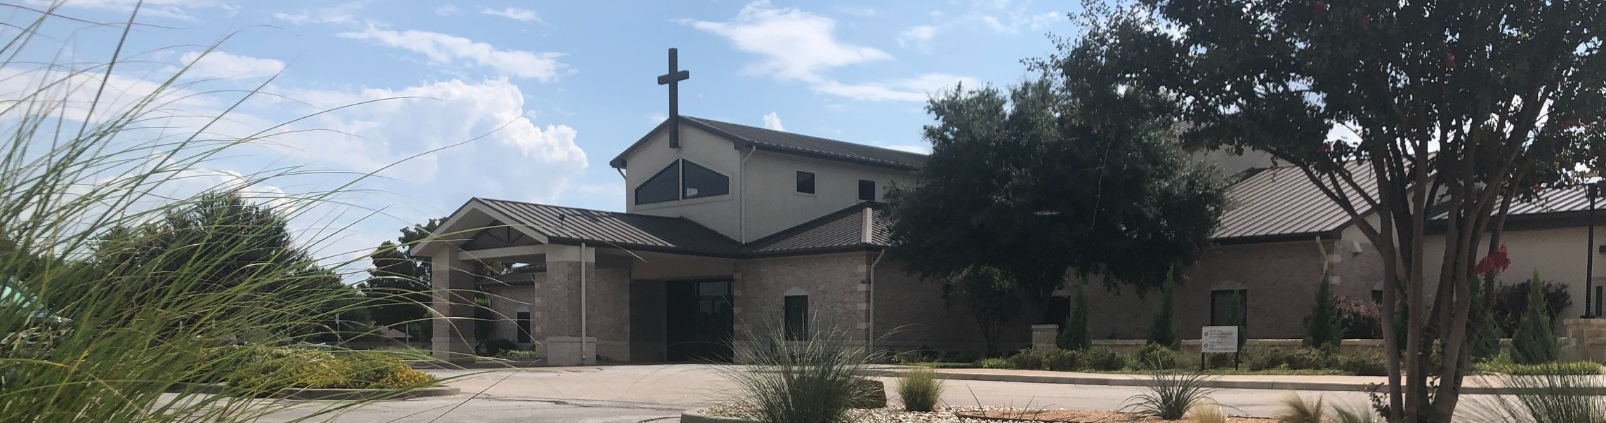

Welcome to Fellowship!

# Thank you for joining us for worship today! If you are a first-time visitor, please visit our Welcome Desk in the foyer or scan the QR code at right to complete a Guest Connect form.

U P C O M I N G E V E N T S



**Need Assistance?**

Visit the South Foyer Welcome Desk and our friendly Welcome Team will be glad to answer any questions or help you find the information you’re looking for!

**Need Coffee?**

Visit our Café in the North Foyer. Our Hospitality Team is ready to serve you!

**Need Prayer?**

If you would like someone to pray with you, our Prayer Team is available at the back of the Worship Center after each service.

Visit our website:

fellowshipwaco.org

Email us: [office@fellowshipwaco.org](mailto:office@fellowshipwaco.org)

Read and subscribe to our weekly newsletter: fellowshipwaco.org

Download our church app: fellowshipwaco.org/app

Telephone: 254.848.7200

Follow Us On Social Media

*@fellowshipwaco*

Aug. 4

Aug. 8

Aug. 10

Aug. 11

Aug. 17

Aug. 18

Aug. 21

Sept. 10

Sept. 11

Sept. 12

Sept. 13

ForeRunners Connection ForeRunners Ice Cream Social LiveWires Pool Party Promotion Sunday

Men’s Breakfast

Discover LIFE Membership Class Student Ministry Fall Kick-Off

Tues. Morning Bible Studies begin Wed. Night Activities begin MomLIFE begins

Women’s Worship Night

*For complete event details and registration, visit our website: fellowshipwaco.org/events*

*or scan the QR code at right.*

Good Morning Fellowship!

Are we, as believers, crazy to think we can truly praise the Lord everywhere and in everything? How about the victories, the defeats, the mountaintops, the valleys, the joy, and the sadness? This morning, we will look at Psalm 150 to answer this question. Just a hing, we are NOT crazy!

George Ohmstede, Associate Pastor

**T h e R e s o u n d i n g P r a i s e f o r o u r L o r d**

**P s a l m 1 5 0**

## What is Praise?

Praise

Praise

## The Where of Praise v 1

In the

In the Mighty

## The Why of Praise v 2

For God’s Mighty

For God’s

## The How of Praise v 3-5

With Sound With

With

With

With

With

With

With Loud

With

4 Ways

to Give **In Service**

*Boxes in Worship Center*

**Online**



*fellowshipwaco.org/giving*

**App**



*fellowshipwaco.org/app*

**Mail**

*P.O. Box 21655*

*Waco, TX 76702*

## The Who of Praise v 6

*Individual Corporate*

With

## Comprehension

Praise the Lord

Praise the Lord Because He is

Praise the Lord with

Praise the Lord with

## Conviction

Not only is the Lord to be praised, but He is to be praised in all things, at all times, and with all that is within us!

## Conduct

Let us praise the Lord everywhere for everything with a resounding praise that captures the attention of those around us!

***Let us praise the Lord everywhere for everything with a resounding praise that captures the attention of those around us!***

Take Next



Steps **Membership**

*fellowshipwaco.org/membership*



**Serve**

*fellowshipwaco.org/serve*



**Small Groups**

*fellowshipwaco.org/groups*

***My personal application of this passage:***



**Video from previous messages: youtube.com/fellowshipwaco Audio from previous messages: fellowshipwaco.org/podcasts Sermon notes online: fellowshipwaco.org/sermon-notes**

***Questions for individual study and LIFE Groups:***

1. In your own words, write out and/or discuss what it means to praise the Lord.
2. In what areas of your life do you find it difficult to praise the Lord? Why do you find it difficult?
3. Recall four times in your life when you could not help but Praise the Lord in the following situations: a time of victory, a time of defeat, a time of joy, a time of sadness.
4. Why is it important to praise God with other believers?
5. How can we as believers praise the Lord even when we do not feel like it? Is it even possible? Why or why not?