***My personal application of this passage:***

**September 1, 2024**

Welcome to Fellowship!

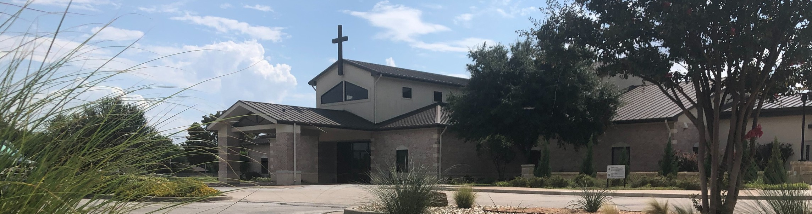

# Thank you for joining us for worship today! If you are a first-time visitor, please visit our Welcome Desk in the foyer or scan the QR code at right to complete a Guest Connect form.

U P C O M I N G E V E N T S



**Need Assistance?**

Visit the South Foyer Welcome Desk and our friendly Welcome Team will be glad to answer any questions or help you find the information you’re looking for!

**Need Coffee?**

Visit our Café in the North Foyer. Our Hospitality Team is ready to serve you!

**Need Prayer?**

If you would like someone to pray with you, our Prayer Team is available at the back of the Worship Center after each service.

Visit our website:

fellowshipwaco.org

Email us: [office@fellowshipwaco.org](mailto:office@fellowshipwaco.org)

Read and subscribe to our weekly newsletter: fellowshipwaco.org

Download our church app: fellowshipwaco.org/app

Telephone: 254.848.7200

Follow Us On Social Media

*@fellowshipwaco*

***Questions for individual study and LIFE Groups:***

1. Can you share how you started developing an awareness of God’s holiness?
2. What does it mean that God is holy?
3. Why does the holiness of God require that He judge sin? How does this make you even more grateful for Jesus Christ?
4. How does the worship in heaven as described in Revelation 15:1-4 help you grow in understanding how to worship God?
5. How could you incorporate these aspects of worship as found in Revelation 15:1-4 in your own daily delight and exaltation of God?

Sept. 1

Sept. 2

Sept. 4

Sept. 10

Sept. 11

Sept. 12

Sept. 12

Sept. 15

Sept. 21

Sept. 28

Sept. 28

Sept. 29

ForeRunners Connection Labor Day - Office Closed Student Ministry Game Night

Tues. Morning Bible Studies begin Wed. Night Activities begin MomLIFE begins

ForeRunners Event

Stephen Ministry Interest Meeting Men’s Breakfast

Share Your Faith Workshop High School Service Project Family Worship Sunday

*For complete event details and registration, visit our website: fellowshipwaco.org/events*



**Video from previous messages: youtube.com/fellowshipwaco Audio from previous messages: fellowshipwaco.org/podcasts Sermon notes online: fellowshipwaco.org/sermon-notes**

*or scan the QR code at right.*

* **the way He works vv.3-4a**

Good Morning Fellowship!

Every believer in Christ knows that God is holy, but what does that mean, and how are we to respond? In Revelation 15, we will discover the answers to

these critical questions that develop a greater devotion and expression of worship in His people.

Grant Kaul, Senior Pastor

**T h e H o l i n e s s o f G o d**

**R e v e l a t i o n 1 5**

* + **what He has revealed v. 4b**

What does every person need to know about the holiness of God?

The holiness of God:

God is the epitome of purity, justice, and

inherently separate from all that is sinful.

As such, God is distinctly majestic in all His characteristics, morally perfect, and worthy of all praise.

2. The holiness of God requires the judgment of sin on earth 14:5-8

What does every person need to know about the holiness of God?

1. **The holiness of God fuels the worship of Him in heaven 15:1-4**

God is worshipped by remembering and rejoicing in:

* + **who He is vv. 1-4**

***Those whose worship is fueled by the holiness of God will never face the wrath of God.***

4 Ways to Give

**In Service**

*Boxes in Worship Center*



**Online**

*fellowshipwaco.org/giving*

**Mail**



**App** *P.O. Box 21655*

*fellowshipwaco.org/app Waco, TX 76702*

Take Next Steps



**Membership**

*fellowshipwaco.org/membership*



**Serve**

*fellowshipwaco.org/serve*



**Small Groups**

*fellowshipwaco.org/groups*