**September 29, 2024**

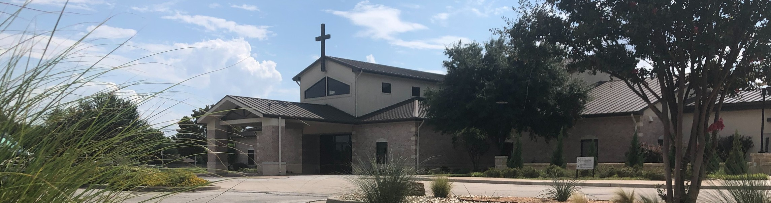

Welcome to Fellowship!

# Thank you for joining us for worship today! If you are a first-time visitor, please visit our Welcome Desk in the foyer or scan the QR code at right to complete a Guest Connect form.

U P C O M I N G E V E N T S



**Need Assistance?**

Visit the South Foyer Welcome Desk and our friendly Welcome Team will be glad to answer any questions or help you find the information you’re looking for!

**Need Coffee?**

Visit our Café in the North Foyer. Our Hospitality Team is ready to serve you!

**Need Prayer?**

If you would like someone to pray with you, our Prayer Team is available at the back of the Worship Center after each service.

Visit our website:

fellowshipwaco.org

Email us: [office@fellowshipwaco.org](mailto:office@fellowshipwaco.org)

Read and subscribe to our weekly newsletter: fellowshipwaco.org

Download our church app: fellowshipwaco.org/app

Telephone: 254.848.7200

Follow Us On Social Media

*@fellowshipwaco*

Sun. Sept. 29

Sun. Oct. 6

Thur. Oct. 10

Family Worship Sunday ForeRunners Connection Women’s Worship Night

Sat. Sat. Sat.

Oct. 12

Oct. 12

Oct. 19

Jr. High Service Project LiveWires Fall Event Men’s Breakfast

Sun. Oct. 27

Sun. Nov. 3

Tues. Nov. 5

Baptism Sunday ForeRunners Connection Election Day

Sat.

Nov. 16

Men’s Breakfast

*For complete event details and registration, visit our website: fellowshipwaco.org/events*

*or scan the QR code at right.*

Good Morning Fellowship!

Is Jesus Christ really going to return to Earth? This has been a question asked since He ascended into Heaven.This morning, we will look to what the

Scriptures declare about His second coming. This overview will help us

answer the what, when, where, why, and how! I can’t wait to worship with you.

George Ohmstede, Associate Pastor

**T h e S e c o n d C o m i n g o f C h r i s t : A n O v e r v i e w**

**A c t s 1 : 1 1**

**What is the second coming of Christ?**

**When will the second coming of Christ happen?**

**Where will the second coming of Christ take place?**

4 Ways

to Give **In Service**

*Boxes in Worship Center*

**Online**



*fellowshipwaco.org/giving*

**App**



*fellowshipwaco.org/app*

**Mail**

*P.O. Box 21655*

*Waco, TX 76702*

**Who will be involved the second coming of Christ?**

**How will the second coming of Christ unfold?**

**How are believers to prepare for the second coming of Christ?**

Take Next



Steps **Membership**

*fellowshipwaco.org/membership*



**Serve**

*fellowshipwaco.org/serve*



**Small Groups**

*fellowshipwaco.org/groups*

***My personal application of this passage:***



**Video from previous messages: youtube.com/fellowshipwaco Audio from previous messages: fellowshipwaco.org/podcasts Sermon notes online: fellowshipwaco.org/sermon-notes**

***Questions for individual study and LIFE Groups:***

1. Read Revelation 19-22 in preparation for the conclusion of our Revelation series.
2. List a few reasons as to why the Lord doesn’t provide an exact time for the second coming.
3. What is the significance of Christ returning and stepping foot on the same place from which He ascended?
4. What role will believers play in the second coming of Christ?
5. In what ways are you applying Acts 1:11 to your daily life as you watch and prepare for our Savior’s return?