**September 8, 2024**

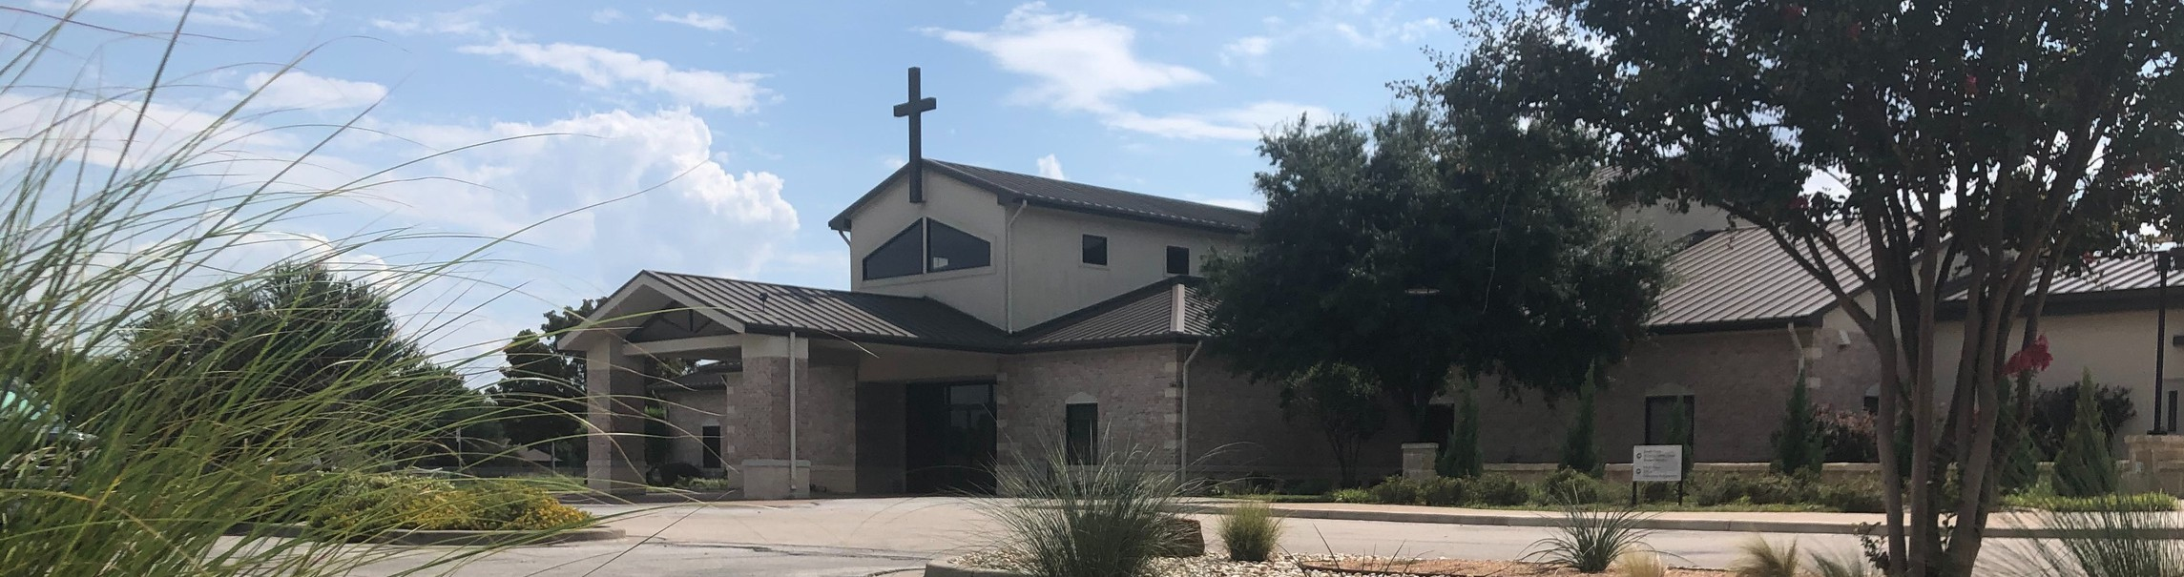

Welcome to Fellowship!

# Thank you for joining us for worship today! If you are a first-time visitor, please visit our Welcome Desk in the foyer or scan the QR code at right to complete a Guest Connect form.

U P C O M I N G E V E N T S



**Need Assistance?**

Visit the South Foyer Welcome Desk and our friendly Welcome Team will be glad to answer any questions or help you find the information you’re looking for!

**Need Coffee?**

Visit our Café in the North Foyer. Our Hospitality Team is ready to serve you!

**Need Prayer?**

If you would like someone to pray with you, our Prayer Team is available at the back of the Worship Center after each service.

Visit our website:

fellowshipwaco.org

Email us: [office@fellowshipwaco.org](mailto:office@fellowshipwaco.org)

Read and subscribe to our weekly newsletter: fellowshipwaco.org

Download our church app: fellowshipwaco.org/app

Telephone: 254.848.7200

Follow Us On Social Media

*@fellowshipwaco*

Sept. 10

Sept. 11

Sept. 12

Sept. 12

Sept. 15

Sept. 21

Sept. 28

Sept. 28

Sept. 29

Sept. 29

Oct. 10

Tues. Morning Bible Studies begin Wed. Night Activities begin MomLIFE begins

ForeRunners Event

Stephen Ministry Interest Meeting Men’s Breakfast

Share Your Faith Workshop High School Service Project Family Worship Sunday Baptism Sunday

Women’s Worship Night

*For complete event details and registration, visit our website: fellowshipwaco.org/events*

*or scan the QR code at right.*

Good Morning Fellowship!

What occurs when God brings His final end-time judgment upon a Christ-

rejecting world? Revelation 16 depicts the sobering and revealing events to come that cause us to evaluate how we live today.

Grant Kaul, Senior Pastor

**T h e F i n a l C u r t a i n f o r a C h r i s t - R e j e c t i n g W o r l d**

**R e v e l a t i o n 1 6**

*But the day of the Lord will come like a thief, in which the heavens will pass away with a roar and the elements will be destroyed with intense heat, and the earth and its works will be burned up.*

2 Peter 3:10

What occurs when God brings His final end-time judgment upon a Christ-rejecting world?

Rev. 15:1-4 The declaration of God’s holiness in heaven (review)

Rev. 15:5-16:21 The devastation of God’s holy judgment on earth

The First Bowl: Grievous Sores 16:1–2

The Second Bowl: Devastation of the Sea and its Creatures 16:3

4 Ways

to Give **In Service**

*Boxes in Worship Center*

**Online**



*fellowshipwaco.org/giving*

**App**



*fellowshipwaco.org/app*

**Mail**

*P.O. Box 21655*

*Waco, TX 76702*

The Third Bowl: Pollution of Fresh Water 16:4-7

The Fourth Bowl: Scorching Sun 16:8-9

The Fifth Bowl: Focused Darkness 16:10-11

The Sixth Bowl: The Euphrates Dried Up 16:12-16

The Seventh Bowl: Final Destruction 16:17-21

*Today if you hear His voice, do not harden your hearts.*

Hebrews 4:7b

***How one responds to a holy God***

***determines what one receives from Him in the end.***

Take Next



Steps **Membership**

*fellowshipwaco.org/membership*



**Serve**

*fellowshipwaco.org/serve*



**Small Groups**

*fellowshipwaco.org/groups*

***My personal application of this passage:***



**Video from previous messages: youtube.com/fellowshipwaco Audio from previous messages: fellowshipwaco.org/podcasts Sermon notes online: fellowshipwaco.org/sermon-notes**

***Questions for individual study and LIFE Groups:***

1. How do we see the holy character of God revealed in Revelation 15:1-4?
2. Why does God bring judgment upon the world (see 15:1-4; 16:5-7)?
3. What can we learn about the condition of the hearts of the unbelievers from the statements and actions that they take in Rev. 16 as they face God’s wrath upon sin (see 16:9, 11, 21)?
4. What are some practical ways you can apply Revelation 16:15?
5. In light of the future judgments to come, what are some practical ways we should live today?