**October 27, 2024**

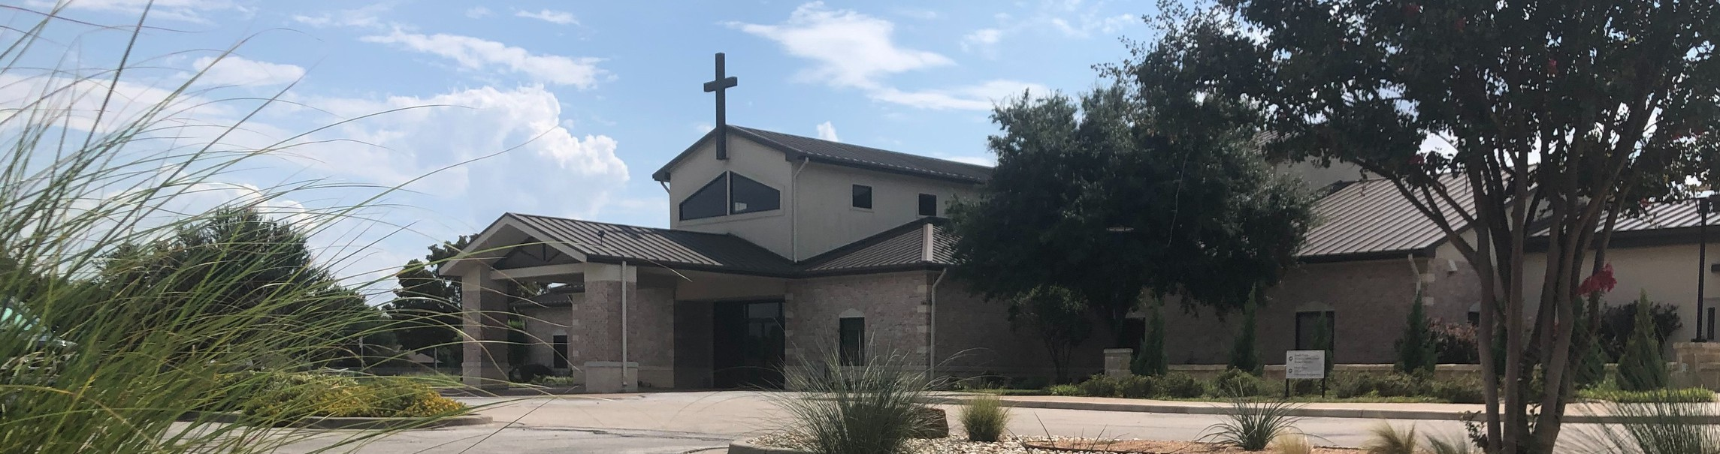

Welcome to Fellowship!

# Thank you for joining us for worship today! If you are a first-time visitor, please visit our Welcome Desk in the foyer or scan the QR code at right to complete a Guest Connect form.

U P C O M I N G E V E N T S



**Need Assistance?**

Visit the South Foyer Welcome Desk and our friendly Welcome Team will be glad to answer any questions or help you find the information you’re looking for!

**Need Coffee?**

Visit our Café in the North Foyer. Our Hospitality Team is ready to serve you!

**Need Prayer?**

If you would like someone to pray with you, our Prayer Team is available at the back of the Worship Center after each service.

Visit our website:

fellowshipwaco.org

Email us: [office@fellowshipwaco.org](mailto:office@fellowshipwaco.org)

Read and subscribe to our weekly newsletter: fellowshipwaco.org

Download our church app: fellowshipwaco.org/app

Telephone: 254.848.7200

Follow Us On Social Media

*@fellowshipwaco*

Sun. Sun. Sun. Sun.

Sun. Tues.

Oct. 27

Nov. 3

Nov. 3

Nov. 3

Nov. 3

Nov. 5

Town Hall Meeting @ 12:15 pm Daylight Saving Time Ends ForeRunners Connection

Eight Days of Hope Victory Meeting

Town Hall Meeting @ 12:15 pm Election Day

Wed. Nov. 6 Town Hall Meeting @ 5:15 pm

Sat. Nov. 9 Student Min. Movie Night

Sun. Nov. 10 Discover LIFE Membership Class

Wed. Nov. 13 Student Min. Annual Feast Night

Thur. Nov. 14 ForeRunner’s Event Sat. Nov. 16 Men’s Breakfast

*For complete event details and registration, visit our website: fellowshipwaco.org/events*

*or scan the QR code at right.*

Good Morning Fellowship!

What will eternity with God really be like? Revelation 21:1-22:5 unveils the

fascinating eternal reality for all who truly have life in Jesus Christ. The hope of heaven is to become the heartbeat of our life on earth.

Grant Kaul, Senior Pastor

**W h a t E t e r n i t y W i t h G o d i s R e a l l y L i k e**

**R e v e l a t i o n 2 1 : 1 - 2 2 : 5**

**What will eternity with God really be like?**

*No eye has seen, no ear has heard, no mind has conceived what God has prepared for those who love him...*

1 Corinthians 2:9

**If our life is in Christ, then in eternity we will experience …**

1. **Unparalleled fellowship 21:1-8**

4 Ways

to Give **In Service**

*Boxes in Worship Center*

**Online**



*fellowshipwaco.org/giving*

**App**



*fellowshipwaco.org/app*

**Mail**

*P.O. Box 21655*

*Waco, TX 76702*

1. **Unspeakable beauty 21:9-21**
2. **Unending joy 21:22-22:5**

***The hope of heaven should become the heartbeat of a Christian's life on earth.***

Take Next



Steps **Membership**

*fellowshipwaco.org/membership*



**Serve**

*fellowshipwaco.org/serve*



**Small Groups**

*fellowshipwaco.org/groups*

***My personal application of this passage:***



**Video from previous messages: youtube.com/fellowshipwaco Audio from previous messages: fellowshipwaco.org/podcasts Sermon notes online: fellowshipwaco.org/sermon-notes**

***Questions for individual study and LIFE Groups:***

* 1. **Why does God end His revelation to humanity by giving a glimpse of eternity?**
  2. **What are some aspects of eternity you are looking forward to?**
  3. **What are some hindrances to our fellowship with Christ we experience in this life that we will not face in the life to come?**
  4. **How has this passage created a desire for or given you insight into eternity?**
  5. **How can we cultivate a focus on our future home in the new heaven and earth?**