**October 6, 2024**

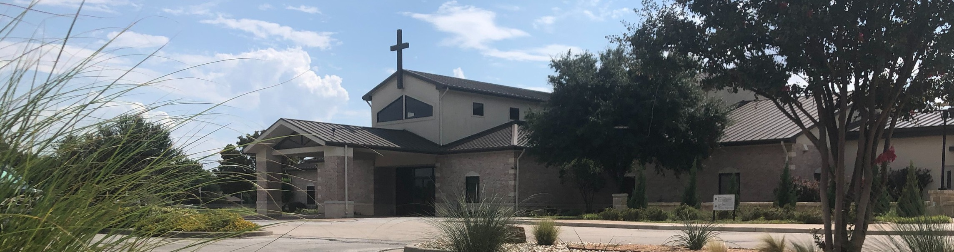

Welcome to Fellowship!

# Thank you for joining us for worship today! If you are a first-time visitor, please visit our Welcome Desk in the foyer or scan the QR code at right to complete a Guest Connect form.

U P C O M I N G E V E N T S



**Need Assistance?**

Visit the South Foyer Welcome Desk and our friendly Welcome Team will be glad to answer any questions or help you find the information you’re looking for!

**Need Coffee?**

Visit our Café in the North Foyer. Our Hospitality Team is ready to serve you!

**Need Prayer?**

If you would like someone to pray with you, our Prayer Team is available at the back of the Worship Center after each service.

Visit our website:

fellowshipwaco.org

Email us: [office@fellowshipwaco.org](mailto:office@fellowshipwaco.org)

Read and subscribe to our weekly newsletter: fellowshipwaco.org

Download our church app: fellowshipwaco.org/app

Telephone: 254.848.7200

Follow Us On Social Media

*@fellowshipwaco*

Sun. Oct. 6 ForeRunners Connection Thur. Oct. 10 Women’s Worship Night

Sat. Oct. 12 Jr. High Service Project Sat. Oct. 12 LiveWires Fall Event

Sun. Oct. 13 Stephen Ministry Interest Meeting

Sat. Oct. 19 Men’s Breakfast

Sun. Oct. 27

Sun. Nov. 3

Tues. Nov. 5

Sun. Nov. 10

Baptism Sunday ForeRunners Connection Election Day

Discover LIFE Membership Class

Sat.

Nov. 16

Men’s Breakfast

*Note: Tomorrow, Oct. 7 is the last day to register to vote.

*For complete event details and registration, visit our website: fellowshipwaco.org/events*

*or scan the QR code at right.*

Good Morning Fellowship!

Are you ready? Do you know what will occur when Jesus Christ returns to the earth and why it is important today? This morning, we will discover from

Revelation 19 the significant events that will take place with the Second Coming of Christ.

Grant Kaul, Senior Pastor

**T h e E a r t h l y R e t u r n o f J e s u s C h r i s t**

**R e v e l a t i o n 1 9**

**What will occur when Jesus Christ returns to the earth, and why is it important today?**

**When Christ shall come again …**

1. **God’s power will be revered 19:1-6**
2. **God’s people will be revealed 19:7-10**

4 Ways

to Give **In Service**

*Boxes in Worship Center*

**Online**



*fellowshipwaco.org/giving*

**App**



*fellowshipwaco.org/app*

**Mail**

*P.O. Box 21655*

*Waco, TX 76702*

1. **God’s promises will be remembered 19:11-21**
   * **a promise for Christ to return to the earth vv. 11-13**
   * **a promise for Christ to reign with His people v.14**
   * **a promise for Christ to recompense His enemies vv. 15-21**

**Are you ready?**

**We are ready for the return of Christ when we are:**

* + **Trusting Him as Savior**
  + **Following Him as Lord**
  + **Worshipping Him as God**

***The future return of Christ is to shape how He presently reigns in our lives.***

Take Next



Steps **Membership**

*fellowshipwaco.org/membership*



**Serve**

*fellowshipwaco.org/serve*



**Small Groups**

*fellowshipwaco.org/groups*

***My personal application of this passage:***



**Video from previous messages: youtube.com/fellowshipwaco Audio from previous messages: fellowshipwaco.org/podcasts Sermon notes online: fellowshipwaco.org/sermon-notes**

***Questions for individual study and LIFE Groups:***

1. What can we learn about worship from the scene in heaven found in Rev. 19:1- 6? What specific traits does God possess that earn Him praise?
2. How does knowing that “the Lord our God, the Almighty, reigns” (Rev. 19:6) affect our perspective and sense of peace amid our circumstances? What are some practical ways we can keep this truth in mind?
3. How do you think God glorifies Himself through the presentation of His people as seen in Rev. 19:7-9?
4. What can we learn about Jesus Christ from the description of His coming in Rev. 19:11-21?
5. How do you think this chapter encouraged the saints who originally received this letter? How can knowing these truths help us in our own personal growth?