**December 1, 2024**

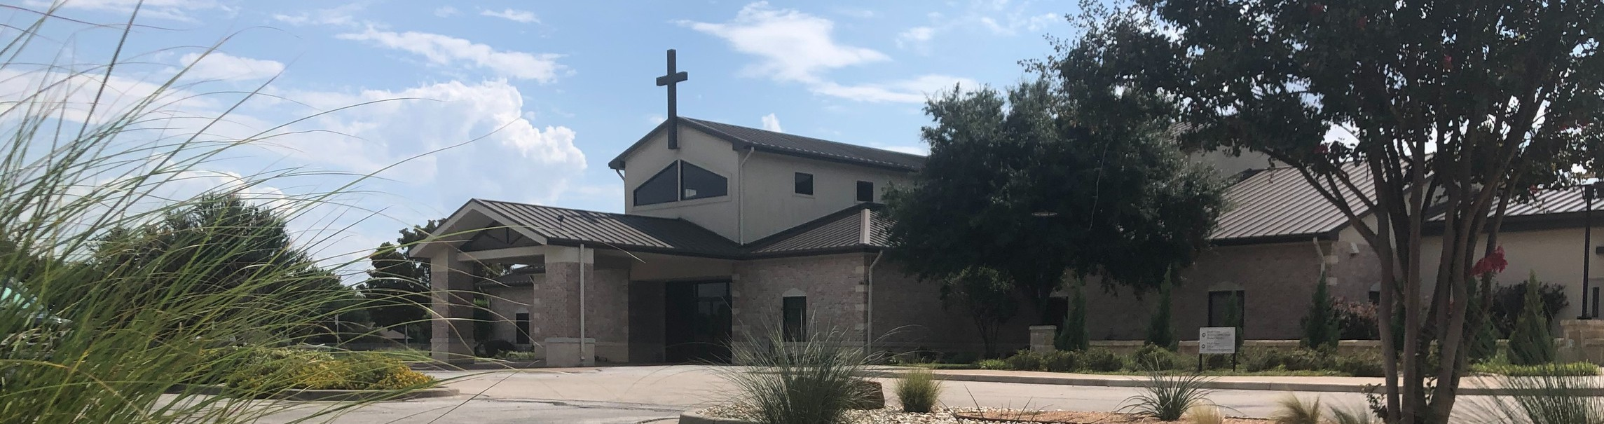

Welcome to Fellowship!

# Thank you for joining us for worship today! If you are a first-time visitor, please visit our Welcome Desk in the foyer or scan the QR code at right to complete a Guest Connect form.

U P C O M I N G E V E N T S



**Need Assistance?**

Visit the South Foyer Welcome Desk and our friendly Welcome Team will be glad to answer any questions or help you find the information you’re looking for!

**Need Coffee?**

Visit our Café in the North Foyer. Our Hospitality Team is ready to serve you!

**Need Prayer?**

If you would like someone to pray with you, our Prayer Team is available at the back of the Worship Center after each service.

Visit our website:

fellowshipwaco.org

Email us: [office@fellowshipwaco.org](mailto:office@fellowshipwaco.org)

Read and subscribe to our weekly newsletter: fellowshipwaco.org

Download our church app: fellowshipwaco.org/app

Telephone: 254.848.7200

Follow Us On Social Media

*@fellowshipwaco*

Sun. Dec. 1 Family Worship Sunday

Sun. Dec. 1 ForeRunners Connection

Sun. Dec. 1 Decorate Church for Christmas

Wed. Dec. 4 Student Ministry Parent Meeting

Thur. Dec. 5 City of Waco Public Meeting

Sat. Dec. 7 Women’s Christmas Breakfast

Wed. Dec. 11 Student Ministry Christmas Party

Fri. Dec. 13 LiveWires Christmas Party

Sat. Dec. 21 Men’s Breakfast @ Rosa’s

Tues. Dec. 24 Christmas Eve Services

Sun. Dec. 29 Family Worship Sunday

*For complete event details and registration, visit our website: fellowshipwaco.org/events*

*or scan the QR code at right.*

Good Morning Fellowship!

Proverbs tells us “pride comes before destruction” and Peter, in his first epistle, teaches us how to avoid becoming a victim to this travesty. This morning, we will learn how to grow in grace as we study what it means to “clothe ourselves in humility”. I’m excited to worship with you.

George Ohmstede, Associate Pastor

**O v e r c o m i n g P r i d e t h o u g h C h r i s t l i k e H u m i l i t y**

## 1 P e t e r 5 : 5

**We can overcome pride by ….**

* **Living out Christlike Submission (5a)**

4 Ways

to Give **In Service**

*Boxes in Worship Center*

**Online**



*fellowshipwaco.org/giving*

**App**



*fellowshipwaco.org/app*

**Mail**

*P.O. Box 21655*

*Waco, TX 76702*

* **Living out Christlike Humility (5b)**
* **Understanding the Consequence of Pride (5c)**
* **Living in the Grace God provides to the Humble (5d)**

Take Next



Steps **Membership**

*fellowshipwaco.org/membership*



**Serve**

*fellowshipwaco.org/serve*



**Small Groups**

*fellowshipwaco.org/groups*

***My personal application of this passage:***



**Video from previous messages: youtube.com/fellowshipwaco Audio from previous messages: fellowshipwaco.org/podcasts Sermon notes online: fellowshipwaco.org/sermon-notes**

## Questions for individual study and LIFE Groups:

1. What is the source of pride? Identify scripture that answers this question.
2. Who is the ultimate authority in our lives? According to scripture, who are some other authorities God has placed in our lives?
3. Using scripture, define biblical submission. What role does submission play in overcoming pride?
4. In what area of life do you most struggle with pride? What scriptural steps are you taking to overcome this?
5. Spend time discussing or write out why you are thankful for the grace of God and how His grace is helping you overcome the difficulties and struggles of life.