**November 10, 2024**

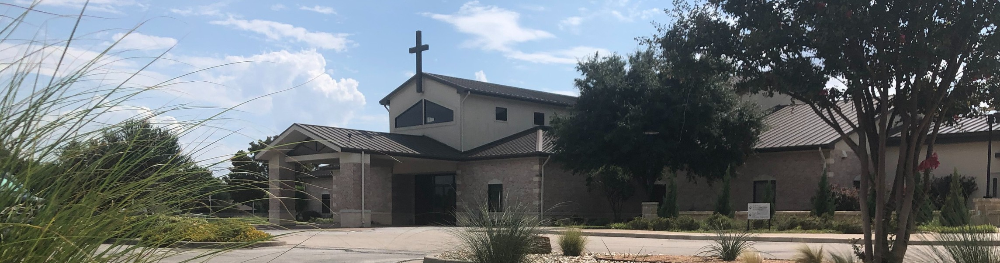

Welcome to Fellowship!

# Thank you for joining us for worship today! If you are a first-time visitor, please visit our Welcome Desk in the foyer or scan the QR code at right to complete a Guest Connect form.

U P C O M I N G E V E N T S



**Need Assistance?**

Visit the South Foyer Welcome Desk and our friendly Welcome Team will be glad to answer any questions or help you find the information you’re looking for!

**Need Coffee?**

Visit our Café in the North Foyer. Our Hospitality Team is ready to serve you!

**Need Prayer?**

If you would like someone to pray with you, our Prayer Team is available at the back of the Worship Center after each service.

Visit our website:

fellowshipwaco.org

Email us: [office@fellowshipwaco.org](mailto:office@fellowshipwaco.org)

Read and subscribe to our weekly newsletter: fellowshipwaco.org

Download our church app: fellowshipwaco.org/app

Telephone: 254.848.7200

Follow Us On Social Media

*@fellowshipwaco*

Sun. Nov. 10 Discover LIFE Membership Class

Wed. Nov. 13 Student Min. Annual Feast Night

Thur. Sat. Sun. Sun. Thur.

Nov. 14 ForeRunners Chili Fiesta Nov. 16 Men’s Breakfast

Nov. 17 Stephen Ministry Interest Meeting Nov. 17 Affirmation of Campus Planning Nov. 28 Thanksgiving

Sun. Sun. Sat.

Dec. 1

Dec. 1

Dec. 7

Family Worship Sunday Decorate church for Christmas Women’s Christmas Breakfast

Note: The church office will be closed Wednesday - Friday Nov. 27-29 for the Thanksgiving holiday.

*For complete event details and registration, visit our website: fellowshipwaco.org/events*

*or scan the QR code at right.*

**H o w t o W i n t h e W a r W i t h i n**

Good Morning Fellowship!

How are you winning the war against sin within yourself? As we will see this Sunday, 1 Peter 2:1-3 gives us the priorities to be true overcomers in Christ.

Grant Kaul, Senior Pastor

**1 P e t e r 2 : 1 - 3**

How do Christians overcome the sinful habits in their lives and grow more mature in their faith?

1. Declare war on what diminishes God’s work in you 2:1

We are “born again” to a “living hope”

*Blessed be the God and Father of our Lord Jesus Christ, who according to His great mercy has caused us to be born again to a living hope through the*

*resurrection of Jesus Christ from the dead,*

1 Peter 1:3

We are in a battle against the internal lusts of the flesh

4 Ways

to Give **In Service**

*Boxes in Worship Center*

**Online**



*fellowshipwaco.org/giving*

**App**



*fellowshipwaco.org/app*

**Mail**

*P.O. Box 21655*

*Waco, TX 76702*

1. Desire the truth of God’s word 2:2
2. Dwell in the goodness of God’s kindness 2:3

How God restores and uses broken people:

* + Be broken over your sin
  + Believe that God still loves you and forgives you
  + Begin to hope again

***Only through God’s word and a close relationship with Him can believers win the war against the sin within.***

Take Next



Steps **Membership**

*fellowshipwaco.org/membership*



**Serve**

*fellowshipwaco.org/serve*



**Small Groups**

*fellowshipwaco.org/groups*

***My personal application of this passage:***



**Video from previous messages: youtube.com/fellowshipwaco Audio from previous messages: fellowshipwaco.org/podcasts Sermon notes online: fellowshipwaco.org/sermon-notes**

***Questions for individual study and LIFE Groups:***

1. **What does Peter emphasize in verse 1, and why is this important?**
2. **What are the consequences of infants not receiving the nourishment they need? What parallels is Peter drawing in verse 2?**
3. **Why does Peter stress the importance of desiring God’s word in our lives?**
4. **What are some helpful ways to be regularly in God’s Word? Why is studying the Bible important in the life of a believer? Why is it important that the believers in our church are in God’s Word?**
5. **Why is it important for believers to live and thrive in the love of God and His kindness? How are you learning how to do this?**