**November 17, 2024**

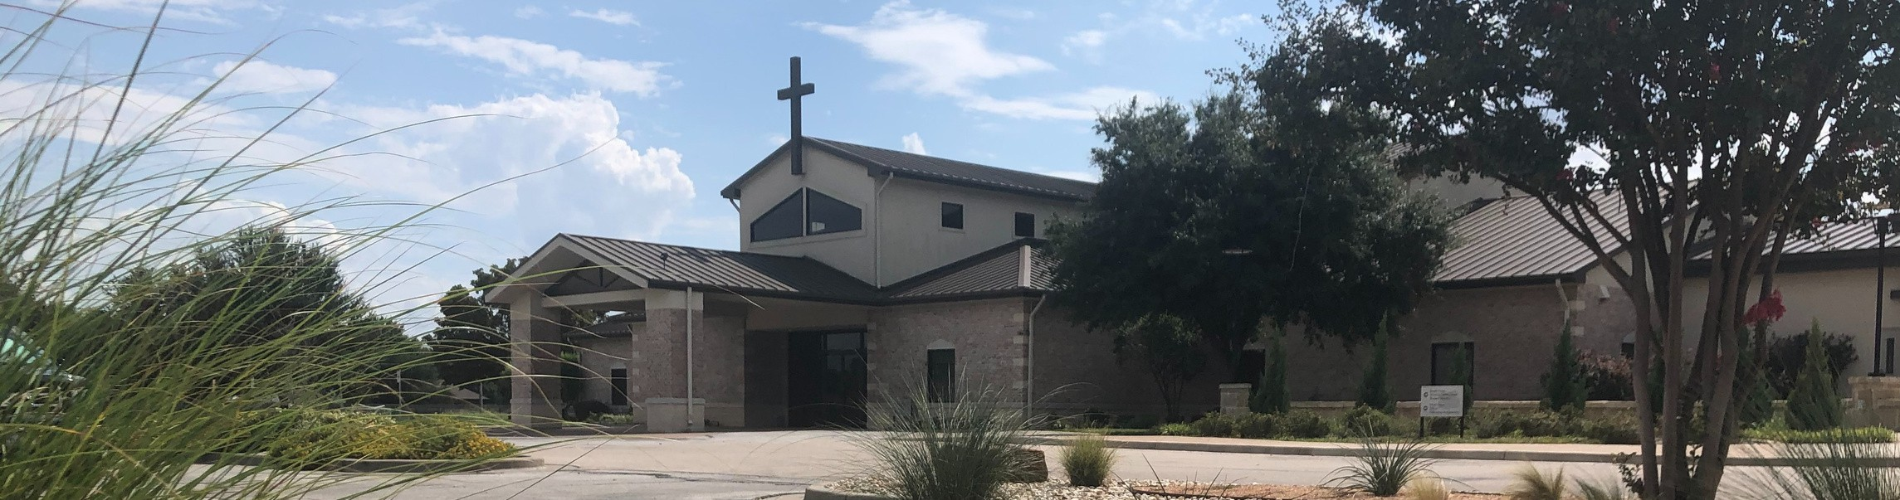

Welcome to Fellowship!

# Thank you for joining us for worship today! If you are a first-time visitor, please visit our Welcome Desk in the foyer or scan the QR code at right to complete a Guest Connect form.

U P C O M I N G E V E N T S



**Need Assistance?**

Visit the South Foyer Welcome Desk and our friendly Welcome Team will be glad to answer any questions or help you find the information you’re looking for!

**Need Coffee?**

Visit our Café in the North Foyer. Our Hospitality Team is ready to serve you!

**Need Prayer?**

If you would like someone to pray with you, our Prayer Team is available at the back of the Worship Center after each service.

Visit our website:

fellowshipwaco.org

Email us: [office@fellowshipwaco.org](mailto:office@fellowshipwaco.org)

Read and subscribe to our weekly newsletter: fellowshipwaco.org

Download our church app: fellowshipwaco.org/app

Telephone: 254.848.7200

Follow Us On Social Media

*@fellowshipwaco*

Sun. Nov. 17 Stephen Ministry Interest Meeting Sun. Nov. 17 Affirmation of Campus Planning

Wed. Nov. 20 End of Semester - Kids & Adults

Thur. Sun. Sun. Sun.

Nov. 28

Dec. 1

Dec. 1

Dec. 1

Thanksgiving

Family Worship Sunday ForeRunners Connection Decorate Church for Christmas

Wed. Dec. 4 Student Ministry Parent Meeting

Sat. Dec. 7 Women’s Christmas Breakfast Sat. Dec. 7 LiveWires Christmas Party

Wed. Dec. 11 Student Ministry Christmas Party

Tues. Dec. 24 Christmas Eve Services Sun. Dec. 29 Family Worship Sunday

Note: The church office will be closed Wednesday - Friday Nov. 27-29 for the Thanksgiving holiday.

*For complete event details and registration, visit our website: fellowshipwaco.org/events*

*or scan the QR code at right.*

Good Morning Fellowship!

All of us will suffer; the difference is how we respond to the various inflictions we face. This morning, we will see from 1 Peter 2:21-25 how to experience the overcoming presence of Christ amid our hardships.

Grant Kaul, Senior Pastor

**O v e r c o m i n g i n t h e M i d s t o f S u f f e r i n g**

**1 P e t e r 2 : 1 - 3**

***How do Christians overcome amid the suffering that they face?***

## The way we experience the overcoming presence of Christ amid suffering:

1. **Follow Jesus as the sovereign Lord of our hearts *2:21-23***

**...**that I may know Him and the power of His resurrection and the fellowship of His sufferings, being conformed to His death;...

Philippians 3:10

Never take your own revenge, beloved, but leave room for the wrath of God, for it is written, "Vengeance is Mine, I will repay," says the Lord.

Romans 12:19

## How Jesus handled suffering and temptation:

 Delighted in knowing the Father  Devoted His life to God’s will

 Depended upon Scripture

 Discerned how to respond to people and problems wisely  Demonstrated compassion and humility

4 Ways

to Give **In Service**

*Boxes in Worship Center*

**Online**



*fellowshipwaco.org/giving*

**App**



*fellowshipwaco.org/app*

**Mail**

*P.O. Box 21655*

*Waco, TX 76702*

## Know Jesus as the Savior of our lives *2:24*

For I will be merciful to their iniquities, and I will remember their sins no more.

Hebrews 8:12

...and since we have a great priest over the house of God, let us draw near with a sincere heart in full assurance of faith, having our hearts sprinkled clean from an evil conscience and our bodies washed with pure water.

Hebrews 10:21–22

## Trust Jesus as the Shepherd of our souls *2:25*

***We overcome amid the suffering in our lives***

***by trusting Jesus as the sovereign Shepherd of our souls.***

Take Next



Steps **Membership**

*fellowshipwaco.org/membership*



**Serve**

*fellowshipwaco.org/serve*



**Small Groups**

*fellowshipwaco.org/groups*

***My personal application of this passage:***



**Video from previous messages: youtube.com/fellowshipwaco Audio from previous messages: fellowshipwaco.org/podcasts Sermon notes online: fellowshipwaco.org/sermon-notes**

***Questions for individual study and LIFE Groups:***

1. **What comes to your mind when you hear the word “suffering?”**
2. **How did Jesus respond to suffering? How can we follow His example when we suffer?**
3. **What takes place in our lives when we follow in the footsteps of Jesus when we are passing through times of difficulty?**
4. **How does our response to suffering impact others? Can you share any examples?**
5. **What does it mean that Christ is our Shepherd and Guardian in life? How have you personally grown as one under His care?**