**November 24, 2024**

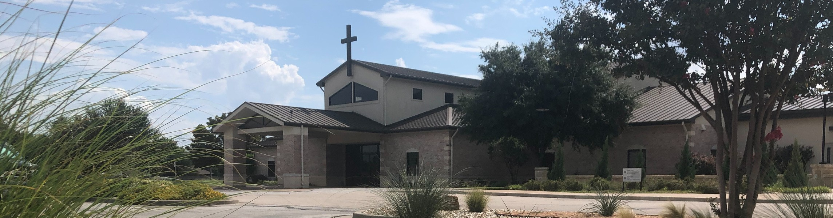

Welcome to Fellowship!

# Thank you for joining us for worship today! If you are a first-time visitor, please visit our Welcome Desk in the foyer or scan the QR code at right to complete a Guest Connect form.

U P C O M I N G E V E N T S



**Need Assistance?**

Visit the South Foyer Welcome Desk and our friendly Welcome Team will be glad to answer any questions or help you find the information you’re looking for!

**Need Coffee?**

Visit our Café in the North Foyer. Our Hospitality Team is ready to serve you!

**Need Prayer?**

If you would like someone to pray with you, our Prayer Team is available at the back of the Worship Center after each service.

Visit our website:

fellowshipwaco.org

Email us: [office@fellowshipwaco.org](mailto:office@fellowshipwaco.org)

Read and subscribe to our weekly newsletter: fellowshipwaco.org

Download our church app: fellowshipwaco.org/app

Telephone: 254.848.7200

Follow Us On Social Media

*@fellowshipwaco*

Thur. Sun. Sun. Sun.

Nov. 28

Dec. 1

Dec. 1

Dec. 1

Thanksgiving

Family Worship Sunday ForeRunners Connection Decorate Church for Christmas

Wed. Dec. 4 Student Ministry Parent Meeting

Sat.

Dec. 7

Women’s Christmas Breakfast

Wed. Dec. 11 Student Ministry Christmas Party

Fri. Sat. Tues. Sun.

Dec. 13

Dec. 21

Dec. 24

Dec. 29

LiveWires Christmas Party Men’s Breakfast @ Rosa’s Christmas Eve Services Family Worship Sunday

Note: The church office will be closed Wednesday - Friday Nov. 27-29 for the Thanksgiving holiday.

*For complete event details and registration, visit our website: fellowshipwaco.org/events*

*or scan the QR code at right.*

Good Morning Fellowship!

How can we build strong relationships, even with the most challenging people?

This morning, we will explore the mindset outlined in 1 Peter 3:8-17 that equips us, through Christ, to overcome the difficult relationships we face.

Grant Kaul, Senior Pastor

**L o v i n g W e l l : P r a c t i c a l W i s d o m f o r D i f f i c u l t R e l a t i o n s h i p s**

## 1 P e t e r 3 : 8 - 1 7

Relationships are not primarily about our happiness but about reflecting God’s holiness, experiencing His presence, and expressing His character in our lives.

**How do we build good relationships, even with the challenging people in our lives?**

1. **Resolve to love people well 3:8-9**

4 Ways

to Give **In Service**

*Boxes in Worship Center*

**Online**



*fellowshipwaco.org/giving*

**App**



*fellowshipwaco.org/app*

**Mail**

*P.O. Box 21655*

*Waco, TX 76702*

1. **Remember, we are blessed to be a blessing 3:9-12**
2. **Revere Christ as Lord in our hearts 3:13-17**

We live well when we love well.

***Affirming Christ as Lord of our hearts is the key to genuinely loving the people in our lives.***

Take Next



Steps **Membership**

*fellowshipwaco.org/membership*



**Serve**

*fellowshipwaco.org/serve*



**Small Groups**

*fellowshipwaco.org/groups*

***My personal application of this passage:***



**Video from previous messages: youtube.com/fellowshipwaco Audio from previous messages: fellowshipwaco.org/podcasts Sermon notes online: fellowshipwaco.org/sermon-notes**

## Questions for individual study and LIFE Groups:

* 1. Why is it challenging to love the “extra-grace required people” we know?
  2. Why is it important for Christians to be committed to loving others, and what are some benefits for doing so?
  3. Can you cite some specific examples of how you saw a believer practice some of the elements of Christian love that you find in verse 8 and the impressions it has made on you?
  4. In what ways do you exhibit the characteristics we find in this passage? Why does God call us to such behavior?
  5. In what practical ways can we honor Christ as Lord of our hearts? How does our attitude toward Christ affect how we live?