**November 3, 2024**

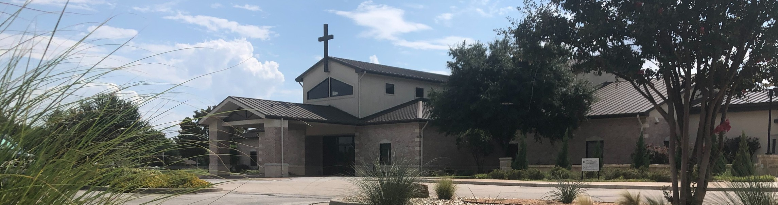

Welcome to Fellowship!

# Thank you for joining us for worship today! If you are a first-time visitor, please visit our Welcome Desk in the foyer or scan the QR code at right to complete a Guest Connect form.

U P C O M I N G E V E N T S



**Need Assistance?**

Visit the South Foyer Welcome Desk and our friendly Welcome Team will be glad to answer any questions or help you find the information you’re looking for!

**Need Coffee?**

Visit our Café in the North Foyer. Our Hospitality Team is ready to serve you!

**Need Prayer?**

If you would like someone to pray with you, our Prayer Team is available at the back of the Worship Center after each service.

Visit our website:

fellowshipwaco.org

Email us: [office@fellowshipwaco.org](mailto:office@fellowshipwaco.org)

Read and subscribe to our weekly newsletter: fellowshipwaco.org

Download our church app: fellowshipwaco.org/app

Telephone: 254.848.7200

Follow Us On Social Media

*@fellowshipwaco*

Sun. Sun.

Sun. Tues.

Nov. 3

Nov. 3

Nov. 3

Nov. 5

ForeRunners Connection Eight Days of Hope Victory Meeting

Town Hall Meeting @ 12:15 pm Election Day

Wed. Nov. 6 Town Hall Meeting @ 5:15 pm

Sat. Nov. 9 Student Min. Movie Night

Sun. Nov. 10 Discover LIFE Membership Class

Wed. Nov. 13 Student Min. Annual Feast Night

Thur. Sat. Thur.

Nov. 14 ForeRunner’s Chili Fiesta Nov. 16 Men’s Breakfast

Nov. 28 Thanksgiving

Note: The church office will be close Wednesday - Friday Nov. 27-29 for the Thanksgiving holiday.

*For complete event details and registration, visit our website: fellowshipwaco.org/events*

*or scan the QR code at right.*

**H o w t o K n o w i f Y o u a r e R e a d y f o r C h r i s t ’ s R e t u r n**

Good Morning Fellowship!

The Book of Revelation culminates with Jesus Christ declaring He is coming back to this earth and giving all humanity a specific call and warning. This

passage will reveal if you are really ready for Christ’s return.

Grant Kaul, Senior Pastor

**R e v e l a t i o n 2 2 : 6 - 2 1**

**How do you know that you are ready for the return of Jesus Christ?**

1. **You are ready if you are committed to Christ’s word 22:6-10**

4 Ways

to Give **In Service**

*Boxes in Worship Center*

**Online**



*fellowshipwaco.org/giving*

**App**



*fellowshipwaco.org/app*

**Mail**

*P.O. Box 21655*

*Waco, TX 76702*

1. **You are ready if you have come to Christ for eternal life**

**22:11-21**

***We are ready for Christ’s return when we are responding with faith in Christ and His word.***

Take Next



Steps **Membership**

*fellowshipwaco.org/membership*



**Serve**

*fellowshipwaco.org/serve*



**Small Groups**

*fellowshipwaco.org/groups*

***My personal application of this passage:***



**Video from previous messages: youtube.com/fellowshipwaco Audio from previous messages: fellowshipwaco.org/podcasts Sermon notes online: fellowshipwaco.org/sermon-notes**

***Questions for individual study and LIFE Groups:***

* 1. **Why do people begin to think very seriously about eternity when they understand their life on earth will end? Have you ever seen examples of this?**
  2. **Why do you think God gave us the Book of Revelation (v.6)? To whom is this book specifically addressed and why (1:1; 22:6)?**
  3. **Why do you think Jesus Christ stresses that He will return to the earth? How is His earthly return emphasized in other books of the Bible? (For example, look at the end of each chapter of 1 Thessalonians.)**
  4. **Why does God give a warning at the close of Revelation 22:18-19 and what are ways in which it is not heeded?**
  5. **How have you responded to the invitation to experience eternal life in Christ? How have you seen His life transforming your own life?**