**December 15, 2024**

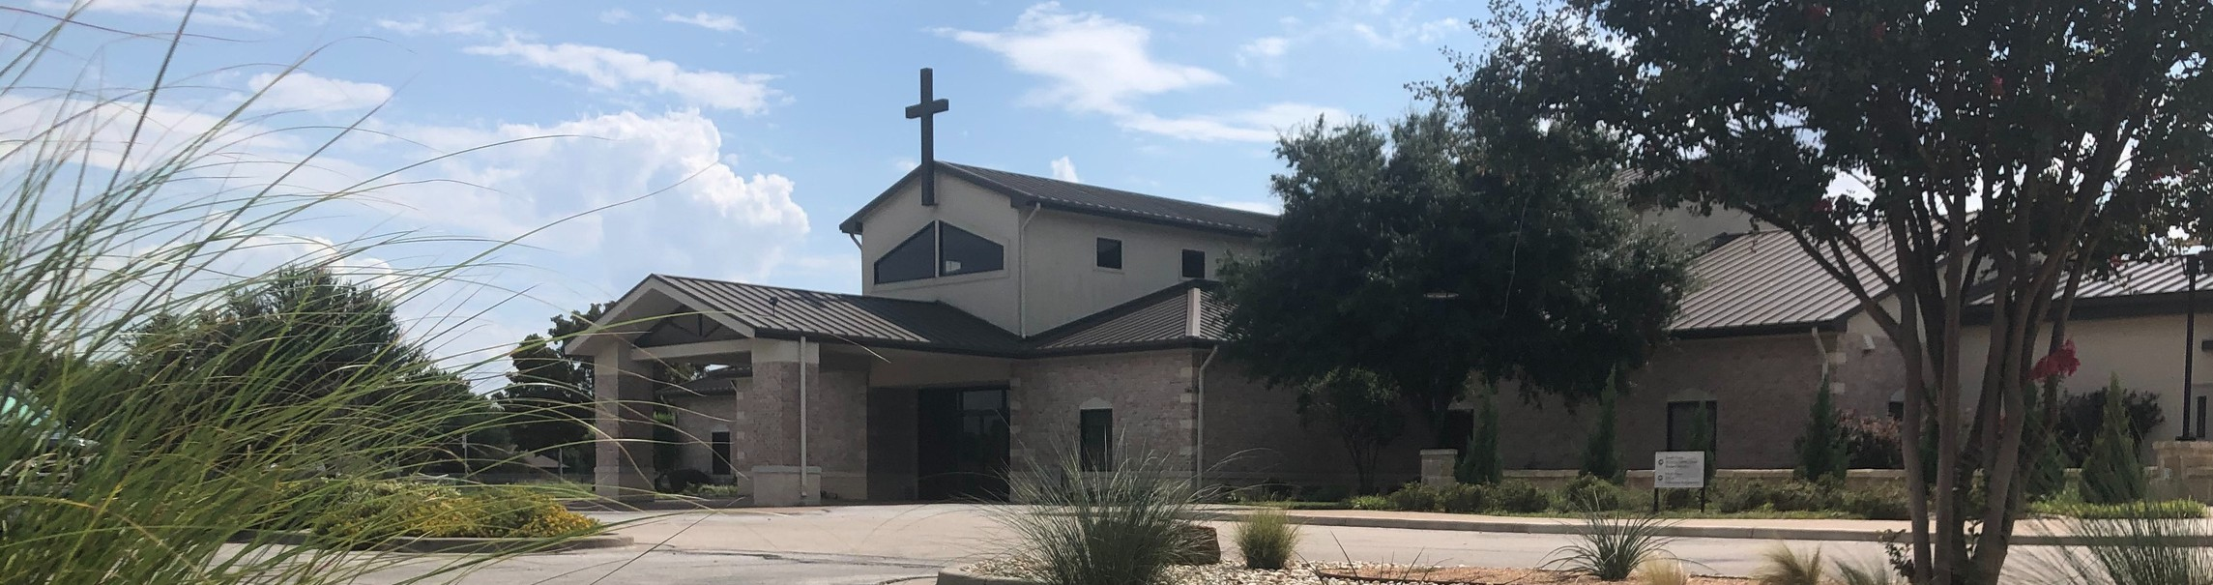

Welcome to Fellowship!

# Thank you for joining us for worship today! If you are a first-time visitor, please visit our Welcome Desk in the foyer or scan the QR code at right to complete a Guest Connect form.

Follow Us On Social Media

*@fellowshipwaco*

## Need Assistance?

Sat. Tues. Sun. Tues.

U P C O M I N G E V E N T S

Dec. 21

Dec. 24

Dec. 29

Dec. 31

Men’s Breakfast @ Rosa’s Christmas Eve Services Family Worship Sunday New Year’s Eve

Visit the South Foyer Welcome Desk and our friendly Welcome Team will be glad to answer any questions or help you find the information you’re looking for!

## Need Coffee?

Wed. Jan. 1

Sun. Jan. 5

New Year’s Day ForeRunners Connection

Visit our Café in the North Foyer. Our Hospitality Team is ready to serve you!

*The church office will be closed for the Christmas holiday from December 24 through January 1.



*Year-end gifts sent by mail must be postmarked by December 31.

*For complete event details and registration, visit our website: fellowshipwaco.org/events*

*or scan the QR code at right.*

## Need Prayer?

If you would like someone to pray with you, our Prayer Team is available at the back of the Worship Center after each service.

Visit our website:

fellowshipwaco.org

Email us: [office@fellowshipwaco.org](mailto:office@fellowshipwaco.org)

Read and subscribe to our weekly newsletter: fellowshipwaco.org

Download our church app: fellowshipwaco.org/app

Telephone: 254.848.7200

Good Morning Fellowship!

What does every person need to know about Christmas? We must begin with the beginning. This is exactly what we will do this morning as we discover

Christmas' surprising and rarely referenced origins as unveiled in John 1:1-18.

Grant Kaul, Senior Pastor

**B e f o r e B e t h l e h e m : T h e E t e r n a l S t o r y B e h i n d C h r i s t m a s**

**J o h n 1 : 1 - 1 8**

**What does every person need to know about Christmas?**

1. **Christmas begins in the eternal purposes of God 1:1-3**
2. **Christmas broadcasts the eternal life and light of Christ 1:4-8**

4 Ways

to Give **In Service**

*Boxes in Worship Center*

**Online**



*fellowshipwaco.org/giving*

**App**



*fellowshipwaco.org/app*

**Mail**

*P.O. Box 21655*

*Waco, TX 76702*

1. **Christmas brings eternal relationship with God 1:9-18**

**The three responses to the earthly entrance of God’s eternal Son:**

* + **Unable to really see Him 1:10**
  + **Unwilling to believe in Him 1:11**
  + **Unfathomable joy to receive Him 1:12-13**

*For God so loved the world that he gave his one and only Son that whoever believes in him shall not perish but have eternal life.*

John 3:16

The most profound joy of Christmas comes when we are in awe of the journey of the Son of God.

***The journey to Christmas begins with the eternal purposes of God to bring us eternal life in Christ.***

Take Next



Steps **Membership**

*fellowshipwaco.org/membership*



**Serve**

*fellowshipwaco.org/serve*



**Small Groups**

*fellowshipwaco.org/groups*

***My personal application of this passage:***



**Video from previous messages: youtube.com/fellowshipwaco Audio from previous messages: fellowshipwaco.org/podcasts Sermon notes online: fellowshipwaco.org/sermon-notes**

**Questions for individual study and LIFE Groups:**

1. Have you ever had the experience of walking into the middle of a movie and not understanding what was happening on the screen? Why is it important that you know the beginning if you are going to make sense of the movie?
2. Why is it important that people understand the origins of Christmas?
3. What do we learn about the Word from John 1:1-18? How do we see the deity of the Word on display in these verses?
4. What is the amazing significance of John 1:14? What is the name of the eternal Word who has entered humanity (John 1:17)? When did you first understand the truth of these verses?
5. How could this passage bring you greater delight and devotion to Christ this Christmas season?