**December 29, 2024**

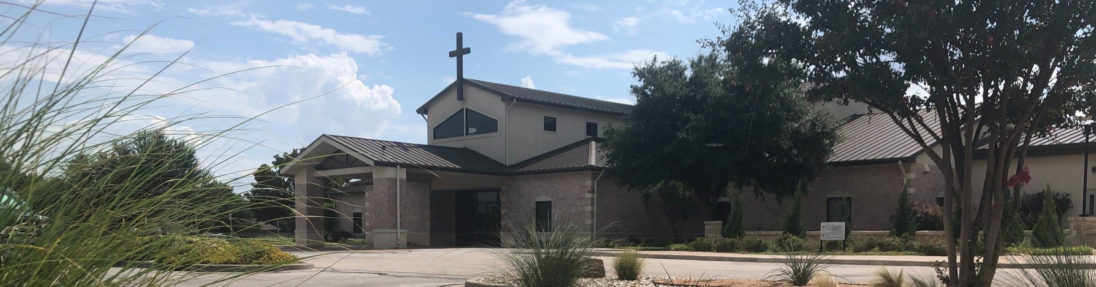

Welcome to Fellowship!

# Thank you for joining us for worship today! If you are a first-time visitor, please visit our Welcome Desk in the foyer or scan the QR code at right to complete a Guest Connect form.

Follow Us On Social Media

*@fellowshipwaco*

U P C O M I N G E V E N T S

Sun. Tues. Wed. Sun.

Sun.

Dec. 29

Dec. 31

Jan. 1

Jan. 5

Jan. 5

Family Worship Sunday New Year’s Eve

New Year’s Day



**Need Assistance?**

Visit the South Foyer Welcome Desk and our friendly Welcome Team will be glad to answer any questions or help you find the information you’re looking for!

**Need Coffee?**

Visit our Café in the North Foyer. Our Hospitality Team is ready to serve you!

**Need Prayer?**

If you would like someone to pray with you, our Prayer Team is available at the back of the Worship Center after each service.

Visit our website:

fellowshipwaco.org

Email us: [office@fellowshipwaco.org](mailto:office@fellowshipwaco.org)

Read and subscribe to our weekly newsletter: fellowshipwaco.org

Download our church app: fellowshipwaco.org/app

Telephone: 254.848.7200

New Sermon Series in Colossians- Better Together

ForeRunners Connection

*The church office will be closed through January 1.

*Year-end gifts sent by mail must be postmarked by December 31.

*For complete event details and registration, visit our website: fellowshipwaco.org/events*

*or scan the QR code at right.*

Good Morning Fellowship!

How many times have you heard a story and simply thought, this just isn’t

possible? How did you eventually understand that it was not only possible, but that it truly happened? You listened to the facts. This morning we will

investigate Jesus’ journey to Bethlehem and look to the prophets who foretold of His coming. I can’t wait to worship with you as we realize, “For nothing is

impossible with God.”

George Ohmstede, Associate Pastor

**T h e J o u r n e y t o B e t h l e h e m : T h e P a t h R e v e a l e d i n H i s P r o p h e t s**

## L u k e 1 : 2 6 - 3 8

### The Prophecy of the Virgin

**(Is 7:11-16, Luke 1:26-30, 34-35)**

***Her dwelling, her name, her situation, her encounter, her perplexion, her question***

### The Prophecy of J esus

**(Gen 3:14-15, Is 7:14, Mic 5:2, 2 Sam 7:12-13, Is 9:6, Jn 1:1, Luke 1:31-33)**

***His announcement, His arrival, His name, His lineage, His authority, His eternality***

4 Ways

to Give **In Service**

*Boxes in Worship Center*

**Online**



*fellowshipwaco.org/giving*

**App**



*fellowshipwaco.org/app*

**Mail**

*P.O. Box 21655*

*Waco, TX 76702*

### The Prophecy of the Barren Woman (Luke 1:11-20, Luke 1:36)

***Her husband, her situation, her pregnancy confirmed***

### The Promise of the Angel (Luke 1:37)

***For nothing is impossible with God***

### The Peace of the Virgin (Luke 1:38)

***Her response as a willing and trusting servant.***

Take Next



Steps **Membership**

*fellowshipwaco.org/membership*



**Serve**

*fellowshipwaco.org/serve*



**Small Groups**

*fellowshipwaco.org/groups*

***My personal application of this passage:***



**Video from previous messages: youtube.com/fellowshipwaco Audio from previous messages: fellowshipwaco.org/podcasts Sermon notes online: fellowshipwaco.org/sermon-notes**

## Questions for individual study and LIFE Groups:

1. Explain in your own words why prophecy in God’s Word is vital to one’s overall faith.
2. Write out/discuss how you would use the prophecies mentioned in today’s sermon to explain to others the story of Jesus as fact and not fiction.
3. Explore why Gabriel felt it necessary to let Mary know Elizabeth was pregnant.
4. Write out/discuss a “For nothing is impossible with God” moment you have experienced. Use this as a time to thank God for all He has done for you.
5. How will you apply the example of Mary’s response as a willing and trusting servant to your everyday life? What makes this difficult at times for you? What plan will you put into practice to help you grow and mature so you, too, may respond in this way more consistently?