**December 8, 2024**

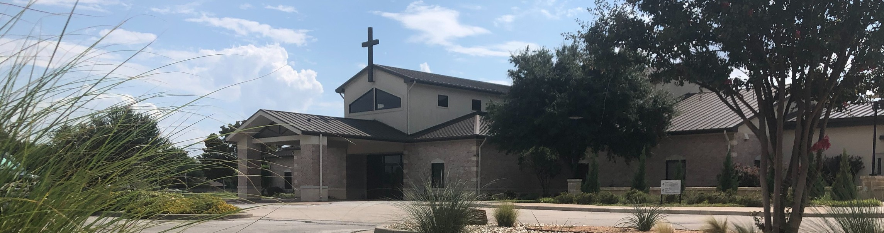

Welcome to Fellowship!

# Thank you for joining us for worship today! If you are a first-time visitor, please visit our Welcome Desk in the foyer or scan the QR code at right to complete a Guest Connect form.

Follow Us On Social Media

*@fellowshipwaco*

## Need Assistance?

Wed. Dec. 11

U P C O M I N G E V E N T S

Student Ministry Christmas Party

Visit the South Foyer Welcome Desk and our friendly Welcome

Fri. Sat. Tues. Sun.

Dec. 13

Dec. 21

Dec. 24

Dec. 29

LiveWires Christmas Party Men’s Breakfast @ Rosa’s Christmas Eve Services Family Worship Sunday

Team will be glad to answer any questions or help you find the information you’re looking for!

## Need Coffee?

Visit our Café in the North Foyer. Our Hospitality Team is ready to serve you!

*The church office will be closed for the Christmas holiday from December 24 through January 1.



*Year-end gifts sent by mail must be postmarked by December 31.

*For complete event details and registration, visit our website: fellowshipwaco.org/events*

*or scan the QR code at right.*

## Need Prayer?

If you would like someone to pray with you, our Prayer Team is available at the back of the Worship Center after each service.

Visit our website:

fellowshipwaco.org

Email us: [office@fellowshipwaco.org](mailto:office@fellowshipwaco.org)

Read and subscribe to our weekly newsletter: fellowshipwaco.org

Download our church app: fellowshipwaco.org/app

Telephone: 254.848.7200

Good Morning Fellowship!

Anxiety. Even the word can stress you out. This morning, we will discover how to overcome when anxiety attacks by applying the powerful principles highlighted in 1 Peter 5:6-11.

Grant Kaul, Senior Pastor

**H o w t o O v e r c o m e W h e n A n x i e t y A t t a c k s**

**1 P e t e r 5 : 6 - 1 1**

**How do you overcome when anxiety attacks?**

**The keys to overcoming when anxiety attacks:**

1. **Humble yourself in God’s presence 5:6-7**

*Come to Me, all who are weary and heavy-laden, and I will give you rest. Take My yoke upon you and learn from Me, for I am gentle and humble in heart,*

*and you will find rest for your souls.*

Matthew 11:28-29

4 Ways

to Give **In Service**

*Boxes in Worship Center*

**Online**



*fellowshipwaco.org/giving*

**App**



*fellowshipwaco.org/app*

**Mail**

*P.O. Box 21655*

*Waco, TX 76702*

1. **Hold fast to your faith in God’s power 5:8-9**

*No temptation has overtaken you but such as is common to man; and God is faithful, who will not allow you to be tempted beyond what you are able, but with the temptation will provide the way of escape also, so that you will be*

*able to endure it.*

1 Corinthians 10:13

*Finally, be strong in the Lord and in the strength of His might. Put on the full armor of God, so that you will be able to stand firm against the schemes of*

*the devil.*

Ephesians 6:10-11

1. **Hope in God’s promises 5:10-11**

***We live in the peace of God when we actively trust in God.***

Take Next



Steps **Membership**

*fellowshipwaco.org/membership*



**Serve**

*fellowshipwaco.org/serve*



**Small Groups**

*fellowshipwaco.org/groups*

***My personal application of this passage:***



**Video from previous messages: youtube.com/fellowshipwaco Audio from previous messages: fellowshipwaco.org/podcasts Sermon notes online: fellowshipwaco.org/sermon-notes**

**Questions for individual study and LIFE Groups:**

* 1. How do believers humble themselves and place their lives under God’s “mighty hand”? Why are we, at times, resistant to this?
  2. How do you “cast your anxiety upon Him”? Why is this so necessary in our lives? What happens to us when we do not do this?
  3. In what ways does God express His love and care for you? How have you experienced God’s care in this past year?
  4. How are we to resist the attacks of the devil? How does a believer develop spiritual health to do this?
  5. What is our source of hope amid life’s difficult circumstances? How does our perspective of what God will do in the future affect how we live in the present?