**February 2, 2025**

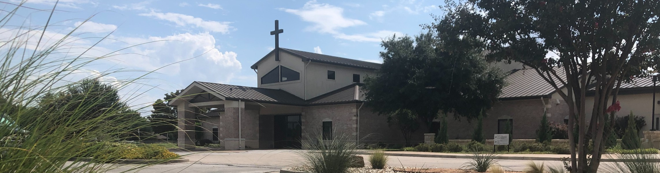

Welcome to Fellowship!

# Thank you for joining us for worship today! If you are a first-time visitor, please visit our Welcome Desk in the foyer or scan the QR code at right to complete a Guest Connect form.

U P C O M I N G E V E N T S

Follow Us On Social Media

*@fellowshipwaco*

Sun. Sun. Tues. Wed. Thur. Sat. Sat. Thur. Fri.

Sun.

Feb. 2

Feb. 2

Feb. 4

Feb. 5

Feb. 6

Feb. 8

Feb. 8

Feb. 13

Feb. 14

Feb. 16

Baptism Sunday ForeRunners Connection

Tuesday Adult Bible Studies begin Wednesday Night Kickoff MomLIFE Begins



**Need Assistance?**

Visit the South Foyer Welcome Desk and our friendly Welcome Team will be glad to answer any questions or help you find the information you’re looking for!

**Need Coffee?**

Visit our Café in the North Foyer. Our Hospitality Team is ready to serve you!

**Need Prayer?**

If you would like someone to pray with you, our Prayer Team is available at the back of the Worship Center after each service.

Visit our website:

fellowshipwaco.org

Email us: [office@fellowshipwaco.org](mailto:office@fellowshipwaco.org)

Read and subscribe to our weekly newsletter: fellowshipwaco.org

Download our church app: fellowshipwaco.org/app

Telephone: 254.848.7200

Men’s Breakfast

LiveWires Parent Valentine Dinner ForeRunners Lunch

Valentine Dinner & Date Night Discover LIFE Membership Class

*For complete event details and registration, visit our website: fellowshipwaco.org/events*

*or scan the QR code at right.*

Good Morning Fellowship!

For the church to be Better Together, we must be Resolved to mature in our faith through creating holy and healthy spiritual practices. This morning, we will look in the book of Colossians to help us understand how to create,

manage, and commit to daily spiritual practices that will move us forward in our personal maturity in Christ!

George Ohmstede, Associate Pastor

**P e r s o n a l R e s o l v e i n H o l y a n d H e a l t h y S p i r i t u a l P r a c t i c e s**

**C o l o s s i a n s 2 : 6 - 7**

**Comprehension**

 Walk in Him

Firmly Rooted

Built up in Him

Established in your Faith

 As you were instructed

**Comprehension**

The believer becomes rooted and established through being resolved to mature in spiritual practices.

4 Ways

to Give **In Service**

*Boxes in Worship Center*

**Online**



*fellowshipwaco.org/giving*

**App**



*fellowshipwaco.org/app*

**Mail**

*P.O. Box 21655*

*Waco, TX 76702*

**Conduct**

What is my prayer plan for 2025?

What is my Bible study plan for 2025?

What is my accountability plan for 2025?

What is my community involvement plan for 2025?

***For the church to be Better Together, I must personally be resolved to mature in my faith through the spiritual practices of prayer, Bible study,***

***accountability, and community!***

Take Next



Steps **Membership**

*fellowshipwaco.org/membership*



**Serve**

*fellowshipwaco.org/serve*



**Small Groups**

*fellowshipwaco.org/groups*

***My personal application of this passage:***



**Video from previous messages: youtube.com/fellowshipwaco Audio from previous messages: fellowshipwaco.org/podcasts Sermon notes online: fellowshipwaco.org/sermon-notes**

**Questions for individual study and LIFE Groups:**

1. Develop and begin your personal prayer plan for 2025.
2. Develop and begin your personal Bible study plan for 2025.
3. Develop and begin your personal accountability plan for 2025.
4. Develop and begin your personal community plan for 2025.
5. Reach out to the staff, or fellow believers, to help in these areas as we would love to provide guidance.