**January 12, 2025**

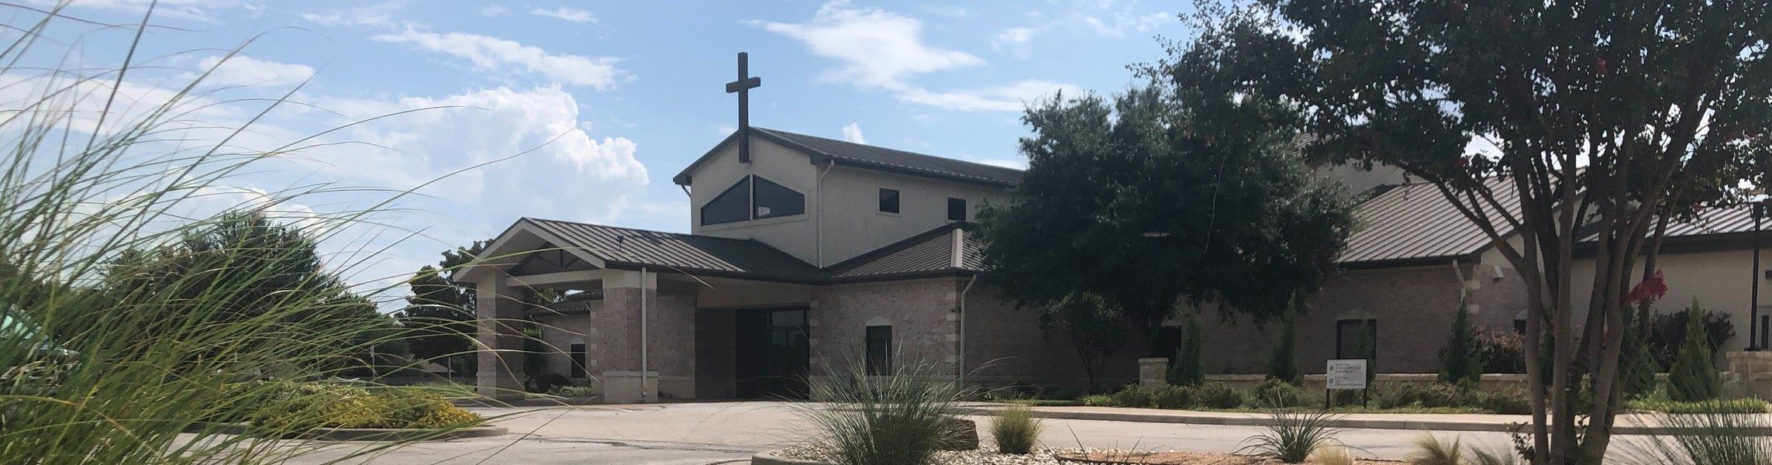

Welcome to Fellowship!

# Thank you for joining us for worship today! If you are a first-time visitor, please visit our Welcome Desk in the foyer or scan the QR code at right to complete a Guest Connect form.

U P C O M I N G E V E N T S

Follow Us On Social Media

*@fellowshipwaco*

Sun. Sun. Wed. Fri.

Sun. Sun. Sat. Sun. Sun. Tues. Wed. Thur. Sun.

Jan. 12

Jan. 12

Jan. 15

Jan. 17

Jan. 19

Jan. 19

Jan. 25

Jan. 26

Feb. 2

Feb. 4

Feb. 5

Feb. 6

Feb. 16

Budget Affirmation

1824 Young Adults - 10:45 - Loft Student Ministry Silent Disco Student Ministry Catalyst begins Stephen Ministry Interest Meeting 1824 Young Adults -10:45 - Loft Women’s Worship Breakfast 1824 Young Adults - 10:45 - Loft Baptism Sunday



**Need Assistance?**

Visit the South Foyer Welcome Desk and our friendly Welcome Team will be glad to answer any questions or help you find the information you’re looking for!

**Need Coffee?**

Visit our Café in the North Foyer. Our Hospitality Team is ready to serve you!

**Need Prayer?**

If you would like someone to pray with you, our Prayer Team is available at the back of the Worship Center after each service.

Visit our website:

fellowshipwaco.org

Email us: [office@fellowshipwaco.org](mailto:office@fellowshipwaco.org)

Read and subscribe to our weekly newsletter: fellowshipwaco.org

Download our church app: fellowshipwaco.org/app

Telephone: 254.848.7200

Tuesday Adult Bible Studies begin Wednesday Night Kickoff MomLIFE Begins

Discover LIFE Membership Class

*For complete event details and registration, visit our website: fellowshipwaco.org/events*

*or scan the QR code at right.*

Good Morning!

Fellowship is on mission to glorify God by living out the LIFE we have in Christ, and it is our aim to carry out this mission through the **Vision** of

**Growing Deep** and **Reaching Out**. It is our prayer that each of us will be

**ALL-IN** in 2025 as we understand that His church is **BETTER TOGETHER!**

George Ohmstede, Associate Pastor

**A l l - I n : T h e V i s i o n f o r G o d ’ s**

**L o c a l C h u r c h @ F e l l o w s h i p B i b l e**

## C o l o s s i a n s 1 : 2 8 - 2 9

### Comprehension

* We are to Jesus
* We are to Wisdom
* We are to every man !
* We are to with !

### Conviction

* Any labor or striving I carry out for Jesus is for Him and only powered by Him.
* It is no longer I who live, but who lives in me! (Galatians 2:20)
* I am encouraged to know and empowered to strive because Jesus works within me!

4 Ways

to Give **In Service**

*Boxes in Worship Center*

**Online**



*fellowshipwaco.org/giving*

**App**



*fellowshipwaco.org/app*

**Mail**

*P.O. Box 21655*

*Waco, TX 76702*

### Conduct

* We are to be through the local church here @ Fellowship Bible
  + We are to privately and corporately
  + We are to others and alongside others
  + We are to the time, talent, treasure, and tribe God has provided
* We are to together through prayer, accountability, and encouragement!
* We are !

### Carrying out the Vision of Fellowship Bible Church

* [**https://fellowshipwaco.org/vision/**](https://fellowshipwaco.org/vision/) **Psalms 1:1-3**
* [**https://fellowshipwaco.org/churchvisionplan/**](https://fellowshipwaco.org/churchvisionplan/)
  + Vision Values
  + Vision Goals
  + Vision Plan
* [**https://fellowshipwaco.org/serve/**](https://fellowshipwaco.org/serve/)
  + Serve
  + Serve

### How will you be ALL-IN at Fellowship Bible in 2025 and beyond?

**We are BETTER TOGETHER!**

Take Next



Steps **Membership**

*fellowshipwaco.org/membership*



**Serve**

*fellowshipwaco.org/serve*



**Small Groups**

*fellowshipwaco.org/groups*

***My personal application of this passage:***



**Video from previous messages: youtube.com/fellowshipwaco Audio from previous messages: fellowshipwaco.org/podcasts Sermon notes online: fellowshipwaco.org/sermon-notes**

## Questions for individual study and LIFE Groups:

1. Take time to visit the church website and explore and pray through the pages listed in the sermon outline.
2. In what ways are you currently proclaiming Jesus and pursuing wisdom?
3. Explain Galatians 2:20 in your own words and apply it to striving to purpose with power.
4. Read Matthew 16:24-26 and apply it to being ALL-IN for Jesus. Focus on the aspect of surrender.
5. What are your next steps to be ALL-IN for Jesus at Fellowship Bible Church 2025?