**January 19, 2025**

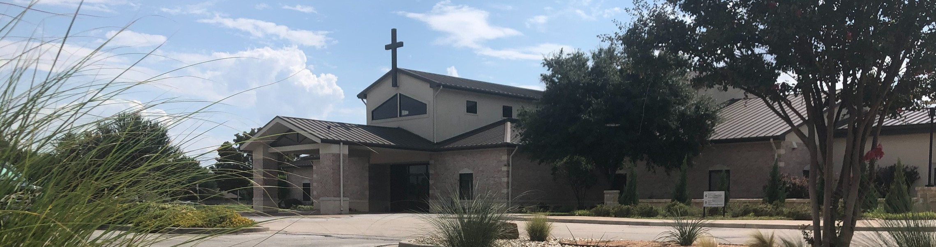

Welcome to Fellowship!

# Thank you for joining us for worship today! If you are a first-time visitor, please visit our Welcome Desk in the foyer or scan the QR code at right to complete a Guest Connect form.

U P C O M I N G E V E N T S

Follow Us On Social Media

*@fellowshipwaco*

Sun. Sun. Mon. Wed. Sat. Sun. Sun. Tues. Wed. Thur. Sun.

Jan. 19

Jan. 19

Jan. 20

Jan. 22

Jan. 25

Jan. 26

Feb. 2

Feb. 4

Feb. 5

Feb. 6

Feb. 16

Stephen Ministry Interest Meeting 1824 Young Adults -10:45 - Loft Office Closed

Student Ministry



**Need Assistance?**

Visit the South Foyer Welcome Desk and our friendly Welcome Team will be glad to answer any questions or help you find the information you’re looking for!

**Need Coffee?**

Visit our Café in the North Foyer. Our Hospitality Team is ready to serve you!

**Need Prayer?**

If you would like someone to pray with you, our Prayer Team is available at the back of the Worship Center after each service.

Visit our website:

fellowshipwaco.org

Email us: [office@fellowshipwaco.org](mailto:office@fellowshipwaco.org)

Read and subscribe to our weekly newsletter: fellowshipwaco.org

Download our church app: fellowshipwaco.org/app

Telephone: 254.848.7200

Women’s Worship Breakfast 1824 Young Adults - 10:45 - Loft Baptism Sunday

Tuesday Adult Bible Studies begin Wednesday Night Kickoff MomLIFE Begins

Discover LIFE Membership Class

*For complete event details and registration, visit our website: fellowshipwaco.org/events*

*or scan the QR code at right.*

Good Morning Fellowship!

How does a believer in Christ grow in the grace of God? The answer to this key question is at the heart of the New Testament and is the passion of our church. We thrive in Christ when we take the pursuits outlined in Colossians 3:12-17 to heart.

Grant Kaul, Senior Pastor

**B e t t e r T o g e t h e r : U n i t e d i n O u r P a s s i o n o f G r o w i n g i n G r a c e**

## C o l o s s i a n s 3 : 1 2 - 1 7

**How do followers of Jesus Christ grow in the grace of God?**

1. **Believe who you are in Christ 3:12a**

*For He rescued us from the domain of darkness, and transferred us to the*

*kingdom of His beloved Son, in whom we have redemption, the forgiveness of sins.*

Colossians 1:13-14

4 Ways

to Give **In Service**

*Boxes in Worship Center*

**Online**



*fellowshipwaco.org/giving*

**App**



*fellowshipwaco.org/app*

**Mail**

*P.O. Box 21655*

*Waco, TX 76702*

1. **Receive all that you have in Christ 3:12b-17**

**Pathway of Growing in Grace:**

**Begin ** **Establish ** **Serve ** **Multiply**

***Who we are in Christ shapes how we live our life.***

Take Next



Steps **Membership**

*fellowshipwaco.org/membership*



**Serve**

*fellowshipwaco.org/serve*



**Small Groups**

*fellowshipwaco.org/groups*

***My personal application of this passage:***



**Video from previous messages: youtube.com/fellowshipwaco Audio from previous messages: fellowshipwaco.org/podcasts Sermon notes online: fellowshipwaco.org/sermon-notes**

## Questions for individual study and LIFE Groups:

* 1. Why do you think Paul reminds believers of their position in Christ in the first part of verse 12? How does our standing with God affect our fellowship with Him and our relationship with others?
  2. In what ways have you witnessed in others any of the characteristics we have available through our relationship with Jesus Christ highlighted in Colossians 3:12- 17 in the lives of other believers?
  3. Why is it so important for Christians to clothe themselves with these qualities? How does a believer specifically do that? How should we respond when we fall short?
  4. If a friend came to you for help and told you they were having a difficult time forgiving someone, what would you say to them?
  5. How have you seen the Lord develop some of these attributes in your life? Are there any current situations spurring this growth that you could share?