**January 26, 2025**

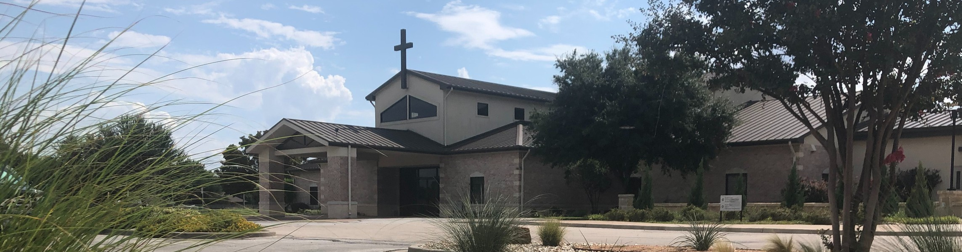

Welcome to Fellowship!

# Thank you for joining us for worship today! If you are a first-time visitor, please visit our Welcome Desk in the foyer or scan the QR code at right to complete a Guest Connect form.

U P C O M I N G E V E N T S

Follow Us On Social Media

*@fellowshipwaco*

Sun. Sun. Sat. Sun. Sun. Tues. Wed. Thur. Sat. Sat. Thur. Fri.

Sun.

Jan. 26

Jan. 26

Feb. 1

Feb. 2

Feb. 2

Feb. 4

Feb. 5

Feb. 6

Feb. 8

Feb. 8

Feb. 13

Feb. 14

Feb. 16

1824 Young Adults - 10:45 - Loft Partnering w/Parents-9:00 & 10:45 Volunteer Work Day

Baptism Sunday



**Need Assistance?**

Visit the South Foyer Welcome Desk and our friendly Welcome Team will be glad to answer any questions or help you find the information you’re looking for!

**Need Coffee?**

Visit our Café in the North Foyer. Our Hospitality Team is ready to serve you!

**Need Prayer?**

If you would like someone to pray with you, our Prayer Team is available at the back of the Worship Center after each service.

Visit our website:

fellowshipwaco.org

Email us: [office@fellowshipwaco.org](mailto:office@fellowshipwaco.org)

Read and subscribe to our weekly newsletter: fellowshipwaco.org

Download our church app: fellowshipwaco.org/app

Telephone: 254.848.7200

ForeRunner’s Connection

Tuesday Adult Bible Studies begin Wednesday Night Kickoff MomLIFE Begins

Men’s Breakfast

LiveWires Parent Valentine Dinner ForeRunner’s Lunch

Valetine Dinner & Date Night Discover LIFE Membership Class

*For complete event details and registration, visit our website: fellowshipwaco.org/events*

*or scan the QR code at right.*

Good Morning Fellowship!

BETTER TOGETHER. ALL IN. RESOLVED. INTENTIONAL. This is His

CHURCH! Colossians 3:1-4 will challenge us to respond with resolve as we

strive to be the church God has called us to be. I’m excited to worship with you this morning!

George Ohmstede, Associate Pastor

**R e s p o n d i n g w i t h R e s o l v e**

## C o l o s s i a n s 3 : 1 - 4 & P s a l m 1 1 9 : 1 1 2

This is for the - The

The Church on (LIFE)

The Church on (Growing Deep, Reaching Out)

The Church with (Pathway of Growing in Grace)

The church is Better Together when we are ALL IN, striving to live out the mission, carry out the vision and passionately dedicated to growing in

grace through the teaching, hearing, and applying of scripture.

The Church is to be

Resolved to the things

Resolved to Set on the things

The church is Better Together when we are ALL IN, seeking and setting our minds on the things above.

4 Ways

to Give **In Service**

*Boxes in Worship Center*

**Online**



*fellowshipwaco.org/giving*

**App**



*fellowshipwaco.org/app*

**Mail**

*P.O. Box 21655*

*Waco, TX 76702*

The saved are and

Set apart from the to

Set apart to be in

Secured as for all

The church is Better Together when we are intentional about living in the hope and promise of our new life in Jesus! Life for the believer isn’t about Jesus, it IS Jesus!

When Jesus is , the Church, too, will be revealed with Him in !

Jesus will and himself here on earth again

Jesus will his church and the saved will be with Jesus in

The church is Better Together when we are intentional in working for and serving Jesus while we await His promised return!

Fellowship Bible Church will be Better Together when we respond with resolve to seek and set our minds on the things above!

Take Next



Steps **Membership**

*fellowshipwaco.org/membership*



**Serve**

*fellowshipwaco.org/serve*



**Small Groups**

*fellowshipwaco.org/groups*

***My personal application of this passage:***



**Video from previous messages: youtube.com/fellowshipwaco Audio from previous messages: fellowshipwaco.org/podcasts Sermon notes online: fellowshipwaco.org/sermon-notes**

## Questions for individual study and LIFE Groups:

1. Are you ALL IN with Jesus and His church? List the ways in which you are currently living this out or how you are planning to do so in 2025.
2. In 2025, which area(s) of spiritual growth do you desire to focus on:

Mission (LIFE), Vision (Growing Deep, Reaching out), Passion (Pathway of Growing in Grace)? Pray and put together an intentional plan.

1. In your own words and/or with scripture describe what it means to seek and set your mind on the things above.
2. After answering the questions above and putting together a plan for 2025, write out your Resolved statement: I am resolved to…