**January 5, 2025**

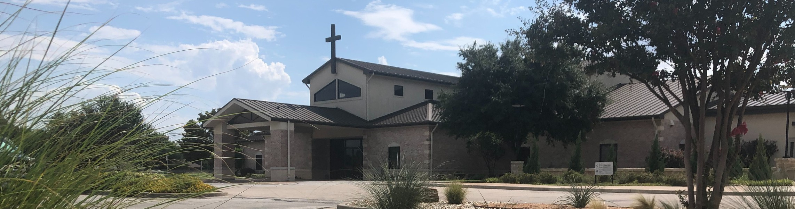

Welcome to Fellowship!

# Thank you for joining us for worship today! If you are a first-time visitor, please visit our Welcome Desk in the foyer or scan the QR code at right to complete a Guest Connect form.

Follow Us On Social Media

*@fellowshipwaco*

U P C O M I N G E V E N T S



**Need Assistance?**

Visit the South Foyer Welcome Desk and our friendly Welcome Team will be glad to answer any questions or help you find the information you’re looking for!

**Need Coffee?**

Visit our Café in the North Foyer. Our Hospitality Team is ready to serve you!

**Need Prayer?**

If you would like someone to pray with you, our Prayer Team is available at the back of the Worship Center after each service.

Visit our website:

fellowshipwaco.org

Email us: [office@fellowshipwaco.org](mailto:office@fellowshipwaco.org)

Read and subscribe to our weekly newsletter: fellowshipwaco.org

Download our church app: fellowshipwaco.org/app

Telephone: 254.848.7200

Sun. Jan. 5 New Sermon Series in Colossians-

Better Together

Sun. Jan. 5 ForeRunners Connection

Thur. Jan. 9 ForeRunners Lunch

Sun. Jan. 12 Budget Affirmation

Wed. Jan. 15 Student Ministry Silent Disco

Fri.

Jan. 17

Student Ministry Catalyst begins

Sun. Jan. 19 Stephen Ministry Interest Meeting

Sat. Jan. 25 Women’s Worship Breakfast

Sun. Feb. 2 Baptism Sunday

Tues. Feb. 4 Tuesday Adult Bible Studies begin

Wed. Feb. 5 Wednesday Night Kickoff

Thur. Feb. 6 MomLIFE Begins

Sun. Feb. 16 Discover LIFE Membership Class

*For complete event details and registration, visit our website: fellowshipwaco.org/events*

*or scan the QR code at right.*

Happy New Year Fellowship!

What does it look like for Christians and churches to "live on mission?"

Each of us needs the clarity and conviction that come from understanding the church's mission which are modeled and described in Colossians 1:24-27.

We are "better together" when we are united in our mission!

Grant Kaul, Senior Pastor

**B e t t e r T o g e t h e r : U n i t e d i n O u r M i s s i o n**

## C o l o s s i a n s 1 : 2 4 - 2 7

**How does our identity in Christ shape our mission in life?**

**Our mission is highlighted by four priorities that flow from our LIFE in Christ:**

1. **Loving God** **1:24**

**Four reasons for how suffering brings joy:**

·Richer relationship

·Reassurance

·Reward

·Relating to and reaching others

*For the love of Christ controls us, having concluded this, that one died for all, therefore all died; and He died for all, so that they who live might no longer*

*live for themselves, but for Him who died and rose again on their behalf.*

2 Corinthians 5:14–15

4 Ways

to Give **In Service**

*Boxes in Worship Center*

**Online**



*fellowshipwaco.org/giving*

**App**



*fellowshipwaco.org/app*

**Mail**

*P.O. Box 21655*

*Waco, TX 76702*

1. **Investing in Others 1:24-25**
2. **Following His Word 1:25-27**

*All Scripture is inspired by God and profitable for teaching, for reproof, for correction, for training in righteousness; so that the man of God may be*

*adequate, equipped for every good work.*

2 Timothy 3:16-17

1. **Engaging our World** **1:27**

**Fellowship’s mission statement:**

**To glorify God by living out the LIFE we have in Christ.**

**(L**oving God, **I**nvesting in others, **F**ollowing His word, **E**ngaging our world**)**

***Our identity in Christ shapes our mission in life.***

Take Next



Steps **Membership**

*fellowshipwaco.org/membership*



**Serve**

*fellowshipwaco.org/serve*



**Small Groups**

*fellowshipwaco.org/groups*

***My personal application of this passage:***



**Video from previous messages: youtube.com/fellowshipwaco Audio from previous messages: fellowshipwaco.org/podcasts Sermon notes online: fellowshipwaco.org/sermon-notes**

## Questions for individual study and LIFE Groups:

* 1. Why is "Christ in you, the hope of glory," at the heart of what it means to be a Christian, and how does this reality shape your life?
  2. Why is it critical that believers in Christ have clarity and conviction about the mission of the church?
  3. In Colossians 1:24-27, how do you see the Apostle Paul modeling and encouraging the four priorities that flow from our LIFE in Christ (Loving God, Investing in others, Following His word, and Engaging our world)?
  4. How can Christians share Paul’s perspective to “rejoice in my sufferings for your sake,” as he stated in Colossians 1:24?
  5. Can you share one way you see God developing your faith and priorities as highlighted in this passage?