**February 16, 2025**

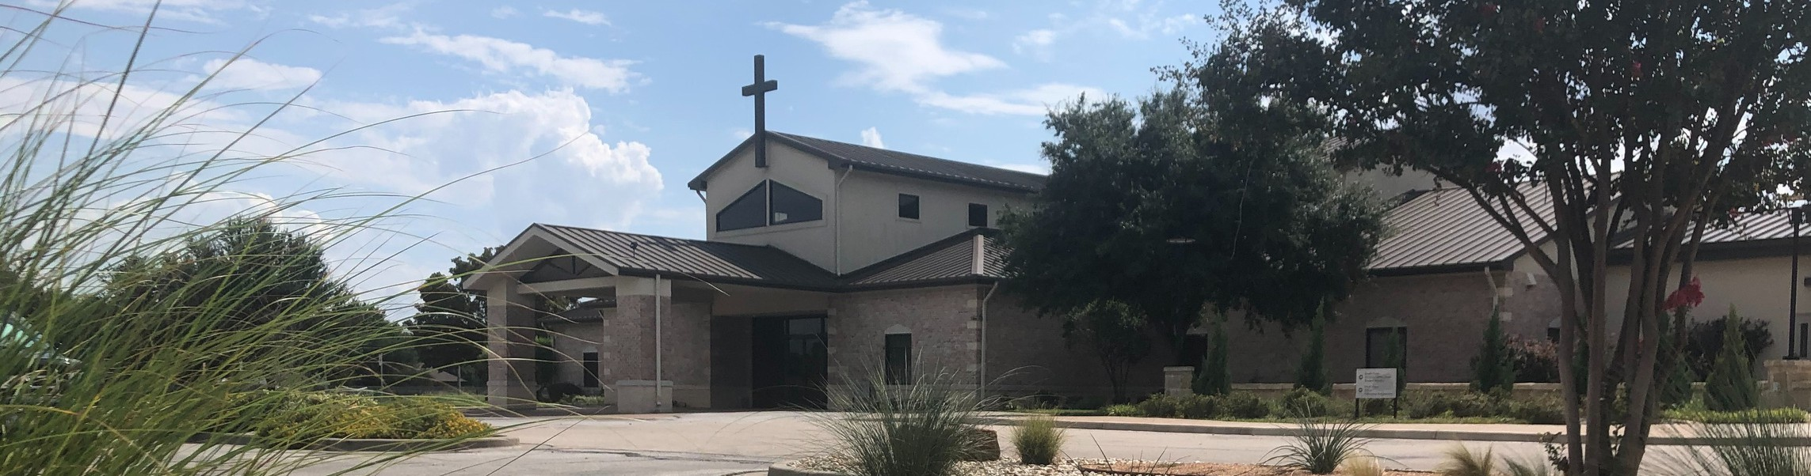

Welcome to Fellowship!

# Thank you for joining us for worship today! If you are a first-time visitor, please visit our Welcome Desk in the foyer or scan the QR code at right to complete a Guest Connect form.

Follow Us On Social Media

*@fellowshipwaco*

U P C O M I N G E V E N T S

Sun. Fri. Sat.

Sun.

Feb. 16

Feb. 21

Feb. 22

Mar. 2

Discover LIFE Membership Class EFCA Conference begins

EFCA Conference concludes True Girl Crazy Hair Tour



**Need Assistance?**

Visit the South Foyer Welcome Desk and our friendly Welcome Team will be glad to answer any questions or help you find the information you’re looking for!

**Need Coffee?**

Visit our Café in the North Foyer. Our Hospitality Team is ready to serve you!

**Need Prayer?**

If you would like someone to pray with you, our Prayer Team is available at the back of the Worship Center after each service.

Visit our website:

fellowshipwaco.org

Email us: [office@fellowshipwaco.org](mailto:office@fellowshipwaco.org)

Read and subscribe to our weekly newsletter: fellowshipwaco.org

Download our church app: fellowshipwaco.org/app

Telephone: 254.848.7200

2025 FX Camp In-House Registration begins TODAY! This is for families and volunteers who attend Fellowship. Community-wide registration will open at a later date.

Registration has begun for our Women’s Conference on Friday, May 2nd, and Saturday, May 3rd! Visit our website, fellowshipwaco.org, to register and get more details.

*For complete event details and registration, visit our website: fellowshipwaco.org/events*

*or scan the QR code at right.*

**H o w a C h u r c h F l o u r i s h e s i n G o d ’ s L o v e**

Good Morning Fellowship!

How does a church flourish in God's love? Three particular pursuits as highlighted in 1 Timothy 1:5-11 make all the difference.

Grant Kaul, Senior Pastor

**I n t e n t i o n a l C h u r c h :**

**T h e T r a i t s o f a C h u r c h i n L o v e w i t h C h r i s t**

**1 T i m o t h y 1 : 5 - 1 1**

How does a church flourish in God’s love?

1. **Stay focused on the goal of growing in God’s love** **1:5**

The Holy Spirit develops a lifestyle of growing in Christ’s love in the following ways:

 Developing a pure heart

Developing a good conscience

 Developing a sincere faith

What does it look like to love well in this situation, relationship, conflict, or interaction?

4 Ways  to Give **In Service**

*Boxes in Worship Center*



**Online**

*fellowshipwaco.org/giving*



**App**

*fellowshipwaco.org/app*

**Mail**

*P.O. Box 21655*

*Waco, TX 76702*

1. **Steer clear of prideful teachers who deviate from the truth 1:6-7**

How can you recognize false teaching?

* + **It promotes controversies instead of helping people come to Jesus and grow mature in Him (1:4).**
  + **It is often initiated by those whose motivation is to make a name for themselves (1:7).**
  + **It will be contrary to the true teaching of the Scriptures (1:6–7; 4:1–3).**

1. **Stand strong in the truth of the gospel of grace 1:8-11**

**the gospel:** the “good news” that by grace God forgives and redeems all

who are broken over their sin and who believe in the perfect life, substitutionary death, and resurrection of Jesus Christ, and gives them eternal life as disciples in His kingdom

***A church flourishes in God’s love when it***

***stays focused on the gospel of God’s grace.***

Take Next



Steps **Membership**

*fellowshipwaco.org/membership*



**Serve**

*fellowshipwaco.org/serve*



**Small Groups**

*fellowshipwaco.org/groups*

***My personal application of this passage:***



**Video from previous messages: youtube.com/fellowshipwaco Audio from previous messages: fellowshipwaco.org/podcasts Sermon notes online: fellowshipwaco.org/sermon-notes**

**Questions for individual study and LIFE Groups:**

1. What is the goal of biblical instruction, and how do you see this developing in your life?
2. Why is it important for believers in Christ to develop discernment and steer clear of prideful teachers who deviate from the truth? How do you practice this?
3. What is the Law, and what role does it have? (see also Rom. 3:19-26; Gal. 3:23- 26
4. How would you explain the main points of the gospel?
5. As a believer, how do you see youself and our church flourishing in God’s love?