**February 23, 2025**

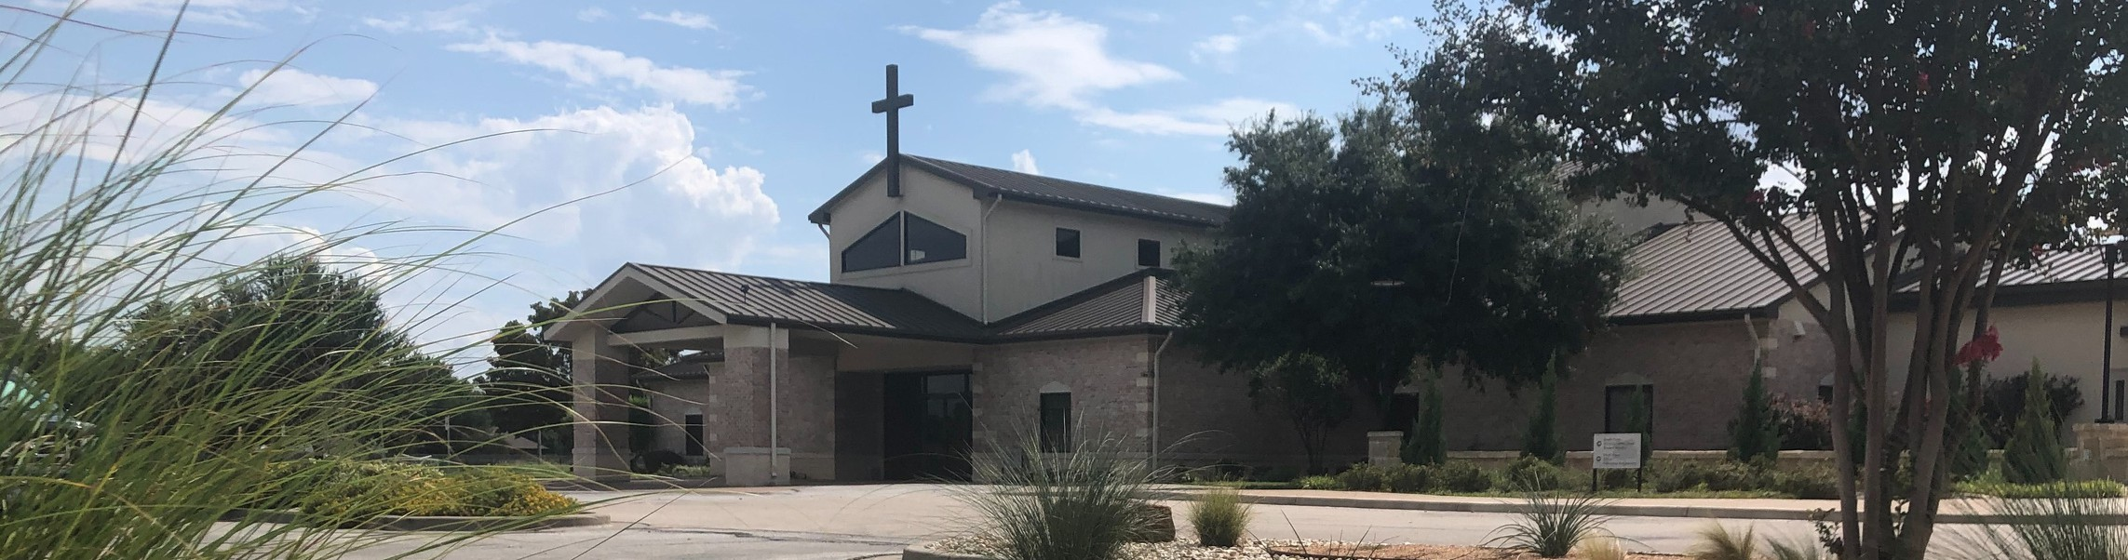

Welcome to Fellowship!

# Thank you for joining us for worship today! If you are a first-time visitor, please visit our Welcome Desk in the foyer or scan the QR code at right to complete a Guest Connect form.

Follow Us On Social Media

*@fellowshipwaco*

U P C O M I N G E V E N T S

Mon.

Sun. Sun. Sun. Sat.

Feb. 24

Mar. 2

Mar. 2

Mar. 9 Mar.15

Church Office Closed

ForeRunners Connection True Girl Crazy Hair Tour All Family Worship Services Men’s Breakfast



**Need Assistance?**

Visit the South Foyer Welcome Desk and our friendly Welcome Team will be glad to answer any questions or help you find the information you’re looking for!

**Need Coffee?**

Visit our Café in the North Foyer. Our Hospitality Team is ready to serve you!

**Need Prayer?**

If you would like someone to pray with you, our Prayer Team is available at the back of the Worship Center after each service.

Visit our website:

fellowshipwaco.org

Email us: [office@fellowshipwaco.org](mailto:office@fellowshipwaco.org)

Read and subscribe to our weekly newsletter: fellowshipwaco.org

Download our church app: fellowshipwaco.org/app

Telephone: 254.848.7200

2025 FX Camp In-House Registration TODAY!

This is for families and volunteers

who attend Fellowship. Community-wide registration will open at a later date.

Registration has begun for our Women’s Conference on Friday, May 2nd, and Saturday, May 3rd! Visit our website, fellowshipwaco.org, to register and get more details.

*For complete event details and registration, visit our website: fellowshipwaco.org/events*

*or scan the QR code at right.*

Good Morning Fellowship!

How does the gospel of Christ change lives? Every person, whether they are a believer or not, needs to know the answer to this fundamental question, as

unforgettably revealed in 1 Timothy 1:12-17.

Grant Kaul, Senior Pastor

**H o w t h e G o s p e l o f C h r i s t C h a n g e s L i v e s**

**I n t e n t i o n a l C h u r c h :**

**T h e T r a i t s o f a C h u r c h i n L o v e w i t h C h r i s t**

**1 T i m o t h y 1 : 1 2 - 1 7**

## the gospel:

the “good news” that by grace God forgives and redeems all who are broken over their sin and who believe in the perfect life, substitutionary death, and resurrection of Jesus Christ, and gives them eternal life as disciples in His kingdom

## How does the gospel of Christ change lives?

1. **Christ strengthens us for His service** **1:12**

4 Ways  to Give **In Service**

*Boxes in Worship Center*



**Online**

*fellowshipwaco.org/giving*



**App**

*fellowshipwaco.org/app*

**Mail**

*P.O. Box 21655*

*Waco, TX 76702*

## Christ saves us from our sinfulness 1:13-15

1. **Christ sets us apart for His purposes 1:16-17**

**What is your salvation story?** (This passage shows the pattern)

* + Life before knowing Christ (1:12-13)
  + How you trusted Christ as Savior and Lord (1:14-15)
  + How you are growing in your relationship with Christ (1:16-17)

***We live in the life-changing reality of the gospel by***

***focusing on Christ, His cross, and His calling upon our lives.***

Take Next



Steps **Membership**

*fellowshipwaco.org/membership*



**Serve**

*fellowshipwaco.org/serve*



**Small Groups**

*fellowshipwaco.org/groups*

***My personal application of this passage:***



**Video from previous messages: youtube.com/fellowshipwaco Audio from previous messages: fellowshipwaco.org/podcasts Sermon notes online: fellowshipwaco.org/sermon-notes**

**Questions for individual study and LIFE Groups:**

1. Explain the gospel and how God has used it to bring you into a relationship with Jesus Christ.
2. How have you seen Jesus Christ develop you for His kingdom service as He did in Paul’s life (see 1:12)?
3. How do Christians become conduits of God’s blessing?
4. What do we learn about salvation from 1 Timothy 1:13-15, and can you share one truth that is especially meaningful to you?
5. In what ways does Jesus Christ set His people apart for His purposes, as seen in 1 Timothy 1:16-17, and how is this shaping how you live?