**February 9, 2025**

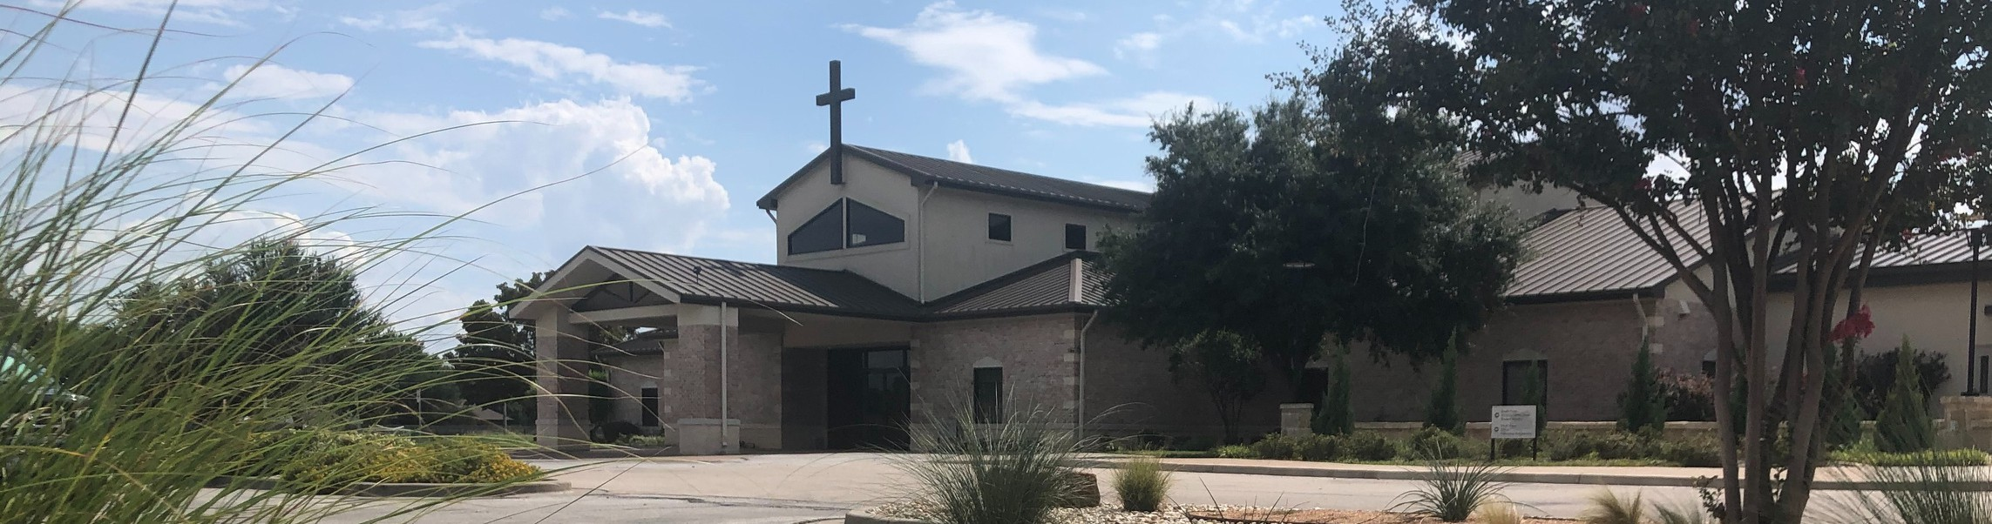

Welcome to Fellowship!

# Thank you for joining us for worship today! If you are a first-time visitor, please visit our Welcome Desk in the foyer or scan the QR code at right to complete a Guest Connect form.

Follow Us On Social Media

*@fellowshipwaco*

U P C O M I N G E V E N T S

Thur. Fri. Sun.

Sun.

Feb. 13

Feb. 14

Feb. 16

Mar. 2

ForeRunners Lunch

Valentine Dinner & Date Night Discover LIFE Membership Class



**Need Assistance?**

Visit the South Foyer Welcome Desk and our friendly Welcome Team will be glad to answer any questions or help you find the information you’re looking for!

**Need Coffee?**

Visit our Café in the North Foyer. Our Hospitality Team is ready to serve you!

**Need Prayer?**

If you would like someone to pray with you, our Prayer Team is available at the back of the Worship Center after each service.

Visit our website:

fellowshipwaco.org

Email us: [office@fellowshipwaco.org](mailto:office@fellowshipwaco.org)

Read and subscribe to our weekly newsletter: fellowshipwaco.org

Download our church app: fellowshipwaco.org/app

Telephone: 254.848.7200

True Girl Crazy Hair Tour

2025 FX Camp In-House Registration begins Sunday, February 16th. This is for families and volunteers that attend Fellowship. Community- wide registration will open on a later date.

Registration for our Women’s Conference in May will begin on February 14th. Visit our website for more details.

*For complete event details and registration, visit our website: fellowshipwaco.org/events*

*or scan the QR code at right.*

Good Morning Fellowship!

Jesus Christ declared, “I will build my church,” but what will that look like? God reveals what every church needs to know and pursue in the timeless truth of

1 Timothy. This morning, we will look at the introduction of this fascinating letter and identify the keys to a thriving church.

Grant Kaul, Senior Pastor

**T h e K e y s t o a T h r i v i n g C h u r c h**

**I n t e n t i o n a l C h u r c h : T h e T r a i t s o f a C h u r c h i n L o v e w i t h C h r i s t**

## 1 T i m o t h y 1 : 1 - 5

Jesus said, “I will build my church”. (Matthew 16:18)

*but in case I am delayed, I write so that you will know how one ought to*

*conduct himself in the household of God, which is the church of the living God, the pillar and support of the truth.*

1 Timothy 3:15

What does Christ really intend for His church?

Overview outline of 1 Timothy

Six Traits Cultivated in a Church in Love with Christ:

Ch. 1 Compelled by truth and the love of Christ Ch. 2 Consecrated to holiness

Ch. 3 Characterized by godly leaders Ch. 4 Committed to maturity

Ch. 5 Concerned about honorable relationships Ch. 6 Convinced of the all-sufficiency of Christ

How can I fulfill my role in our church as Christ intends?

4 Ways

to Give **In Service**

*Boxes in Worship Center*

**Online**



*fellowshipwaco.org/giving*

**App**



*fellowshipwaco.org/app*

**Mail**

*P.O. Box 21655*

*Waco, TX 76702*

Introduction to the Letter 1:1-2

The two primary priorities for a thriving church:

1. **Protect the purity of God’s work which grows by faith 1:3-4**
2. **Promote the goal of God’s word which is to grow in love** **1:5**

We develop a lifestyle in growing in Christ’s love in the following ways:

·Developing a pure heart

·Developing a good conscience

·Developing a sincere faith

What does it look like to love well in this situation, relationship, conflict, or interaction?

***A church thrives in Christ’s love when it***

***protects the work of God and promotes the word of God.***

Take Next



Steps **Membership**

*fellowshipwaco.org/membership*



**Serve**

*fellowshipwaco.org/serve*



**Small Groups**

*fellowshipwaco.org/groups*

***My personal application of this passage:***



**Video from previous messages: youtube.com/fellowshipwaco Audio from previous messages: fellowshipwaco.org/podcasts Sermon notes online: fellowshipwaco.org/sermon-notes**

## Questions for individual study and LIFE Groups:

1. When Jesus said, “I will build my church,” in Matthew 16:18, what do you think He meant? What is “the church,” and what role does Jesus Christ have in it?
2. Why is there a need for churches today to have a clear understanding of what Christ intends for His church? What happens when Christians lose sight of God’s instruction for His church?
3. Why is it important that believers in Christ grow in hope, grace, mercy, and peace (see 1:1-2)? How do we learn to experience these on a daily basis?
4. Why was Timothy urged to continue investing himself in the ministry at Ephesus? What made this difficult?
5. What is the goal of the church’s ministry according to 1 Timothy 1:5, and how is it developed?