**March 2, 2025**

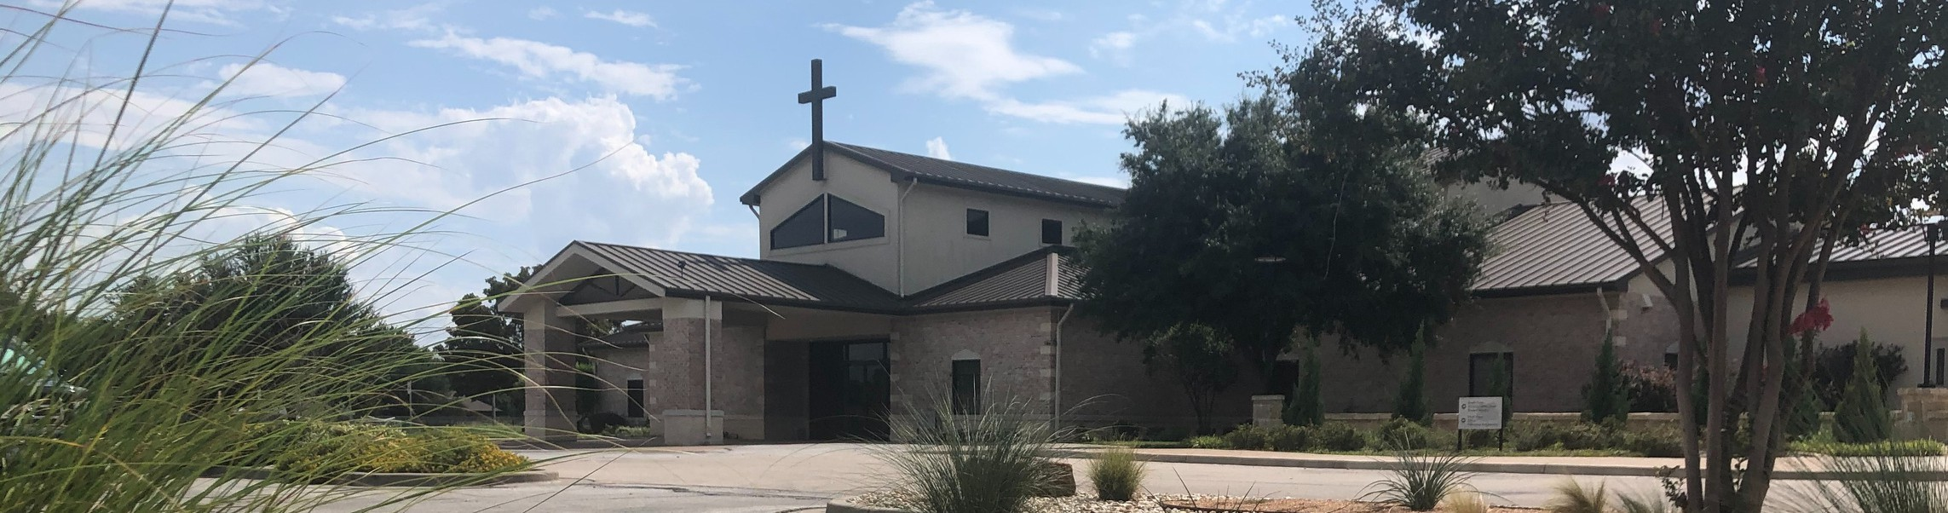

Welcome to Fellowship!

# Thank you for joining us for worship today! If you are a first-time visitor, please visit our Welcome Desk in the foyer or scan the QR code at right to complete a Guest Connect form.

Follow Us On Social Media

*@fellowshipwaco*

U P C O M I N G E V E N T S

|  |  |  |
| --- | --- | --- |
| Sun. | Mar. 2 | ForeRunners Connection |
| Sun. | Mar. 2 | True Girl Crazy Hair Tour |
| Sun. | Mar. 9 | All Family Worship Services |
| Sat. | Mar.15 | Men’s Breakfast |

Due to the Spring break holiday, our usual weekly ministries will be canceled for the week of March 10-14.

2025 FX Camp In-House Registration TODAY!



**Need Assistance?**

Visit the South Foyer Welcome Desk and our friendly Welcome Team will be glad to answer any questions or help you find the information you’re looking for!

**Need Coffee?**

Visit our Café in the North Foyer. Our Hospitality Team is ready to serve you!

**Need Prayer?**

If you would like someone to pray with you, our Prayer Team is available at the back of the Worship Center after each service.

Visit our website:

fellowshipwaco.org

Email us: [office@fellowshipwaco.org](mailto:office@fellowshipwaco.org)

Read and subscribe to our weekly newsletter: fellowshipwaco.org

Download our church app: fellowshipwaco.org/app

Telephone: 254.848.7200

This is for families and volunteers

who attend Fellowship. Community-wide registration will open at a later date.

*For complete event details and registration, visit our website: fellowshipwaco.org/events*

*or scan the QR code at right.*

**H o w t o F i g h t t h e G o o d F i g h t o f F a i t h**

Good Morning Fellowship!

How do you fight the good fight of faith? As we will discover this morning in 1 Timothy 1:18-20, there are two lifetime practices every Christian must

cultivate. A failure to follow these can be catastrophic.

Grant Kaul, Senior Pastor

**I n t e n t i o n a l C h u r c h :**

**T h e T r a i t s o f a C h u r c h i n L o v e w i t h C h r i s t**

**1 T i m o t h y 1 : 1 8 - 2 0**

**Our relationship with Christ empowers us to fight the good fight of faith.**

**How do you fight the good fight of faith?**

1. **Keep your calling sure** **1:18**

What has God called you to do in this season of your life?

4 Ways

to Give **In Service**

*Boxes in Worship Center*

**Online**



*fellowshipwaco.org/giving*

**App**



*fellowshipwaco.org/app*

**Mail**

*P.O. Box 21655*

*Waco, TX 76702*

1. **Keep your walk pure 1:19-20**

***We fight the good fight of faith by keeping our calling clear and our walk pure.***

Take Next



Steps **Membership**

*fellowshipwaco.org/membership*



**Serve**

*fellowshipwaco.org/serve*



**Small Groups**

*fellowshipwaco.org/groups*

***My personal application of this passage:***



**Video from previous messages: youtube.com/fellowshipwaco Audio from previous messages: fellowshipwaco.org/podcasts Sermon notes online: fellowshipwaco.org/sermon-notes**

**Questions for individual study and LIFE Groups:**

* 1. Why is it important to have a sense of calling in your particular season of life?
  2. How would you describe your calling?
  3. What are some of the obstacles you face in fighting the good fight of faith? How do you cultivate a strong faith in Christ and recharge your batteries?
  4. What is a good conscience, and how do you keep it that way?
  5. What can potentially happen when you fail to give attention to these key components of a faithful life (see 1:20)? Have you ever known someone who failed to put these verses into practice?