**March 16, 2025**

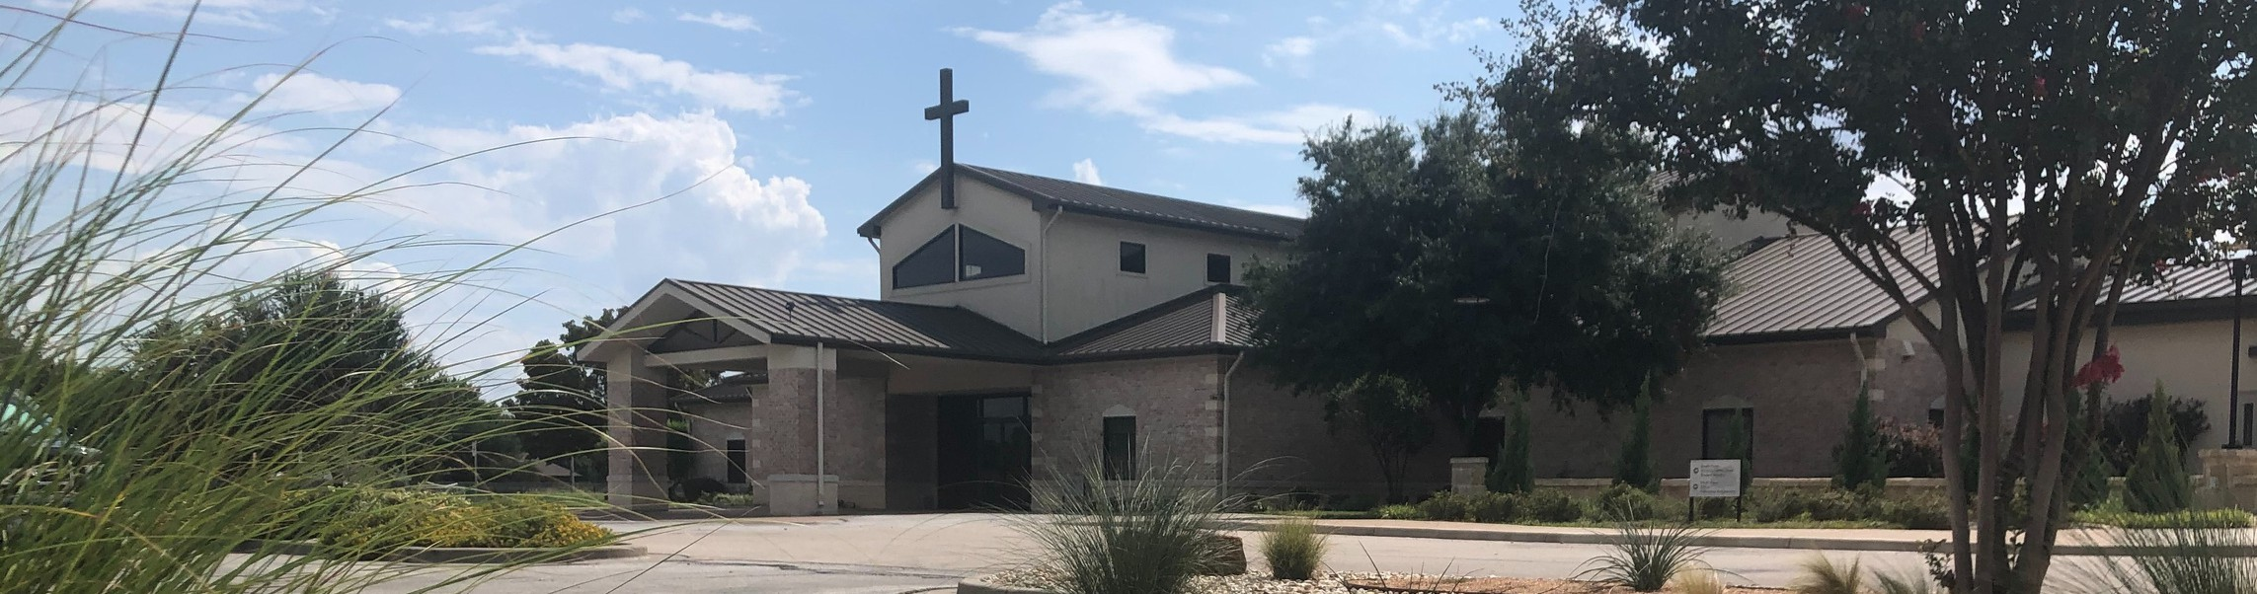

Welcome to Fellowship!

# Thank you for joining us for worship today! If you are a first-time visitor, please visit our Welcome Desk in the foyer or scan the QR code at right to complete a Guest Connect form.

U P C O M I N G E V E N T S

Follow Us On Social Media

*@fellowshipwaco*

Sun. Mar 30 Stephen Ministry Interest Meeting



**Need Assistance?**

Visit the South Foyer Welcome Desk and our friendly Welcome Team will be glad to answer any questions or help you find the information you’re looking for!

**Need Coffee?**

Visit our Café in the North Foyer. Our Hospitality Team is ready to serve you!

**Need Prayer?**

If you would like someone to pray with you, our Prayer Team is available at the back of the Worship Center after each service.

Visit our website:

fellowshipwaco.org

Email us: [office@fellowshipwaco.org](mailto:office@fellowshipwaco.org)

Read and subscribe to our weekly newsletter: fellowshipwaco.org

Download our church app: fellowshipwaco.org/app

Telephone: 254.848.7200

Sun. April 6 ForeRunners Connection

Thur. April 10 ForeRunners Event Thur. April 10 LiveWires Event

Sat. Fri. Sun.

April 12

April 18

April 20

Men’s Breakfast

Good Friday Service 6:30 p.m. Easter Service Times:

7:30 a.m., 9:00 a.m., 10:45 a.m.

*For complete event details and registration, visit our website: fellowshipwaco.org/events*

*or scan the QR code at right.*

Good Morning Fellowship!

What does holiness look like in action? In 1 Timothy 2:8-15, the Apostle Paul highlights how believers in Christ’s church manifest lives that are set apart for His purposes.

Grant Kaul, Senior Pastor

**H o l i n e s s i n A c t i o n**

**I n t e n t i o n a l C h u r c h :**

**T h e T r a i t s o f a C h u r c h i n L o v e w i t h C h r i s t**

**1 T i m o t h y 2 : 8 - 1 5**

***A holy life flows from living in and loving the presence of a holy God.***

**God desires and develops followers, not fans.**

**How do men and women after God’s own heart live God-honoring lives?**

**Holiness in action in a man’s heart:**

1. **Dedicated to prayer** **2:8**

*If I regard wickedness in my heart, the Lord will not hear;*

Psalm 66:18

1. **Dignified in his behavior** **2:8**

4 Ways  to Give **In Service**

*Boxes in Worship Center*



**Online**

*fellowshipwaco.org/giving*



**App**

*fellowshipwaco.org/app*

**Mail**

*P.O. Box 21655*

*Waco, TX 76702*

**Holiness in action in a woman’s heart:**

1. **Discerning in how she dresses** **2:9**
2. **Delighting in good works** **2:10**
3. **Developing in faith** **2:11**
4. **Deferring to Elders/Pastors 2:12-15**

*but in case I am delayed, I write so that you will know how one ought to*

*conduct himself in the household of God, which is the church of the living God, the pillar and support of the truth.*

1 Timothy 3:15

**How are we responding to the holiness of God?**

***A holy life flows from living in and loving the presence of a holy God.***

Take Next



Steps **Membership**

*fellowshipwaco.org/membership*



**Serve**

*fellowshipwaco.org/serve*



**Small Groups**

*fellowshipwaco.org/groups*

***My personal application of this passage:***



**Video from previous messages: youtube.com/fellowshipwaco Audio from previous messages: fellowshipwaco.org/podcasts Sermon notes online: fellowshipwaco.org/sermon-notes**

**Questions for individual study and LIFE Groups:**

1. How would you define the word “holiness?” Why does Christ seek to cultivate holiness in the lives of His people, and how does He do this?
2. What do we learn about holiness in action in the lives of men who are followers of Christ, and why is this important?
3. How do Christian ladies learn to exercise discernment in what they wear and why is this important in our culture?
4. What are good works, and how are they produced?
5. How is holiness displayed by Christ-centered women who defer to their elders and pastors when it comes to preaching and teaching the Scriptures during corporate worship gatherings and leading in the local church?