**March 23, 2025**

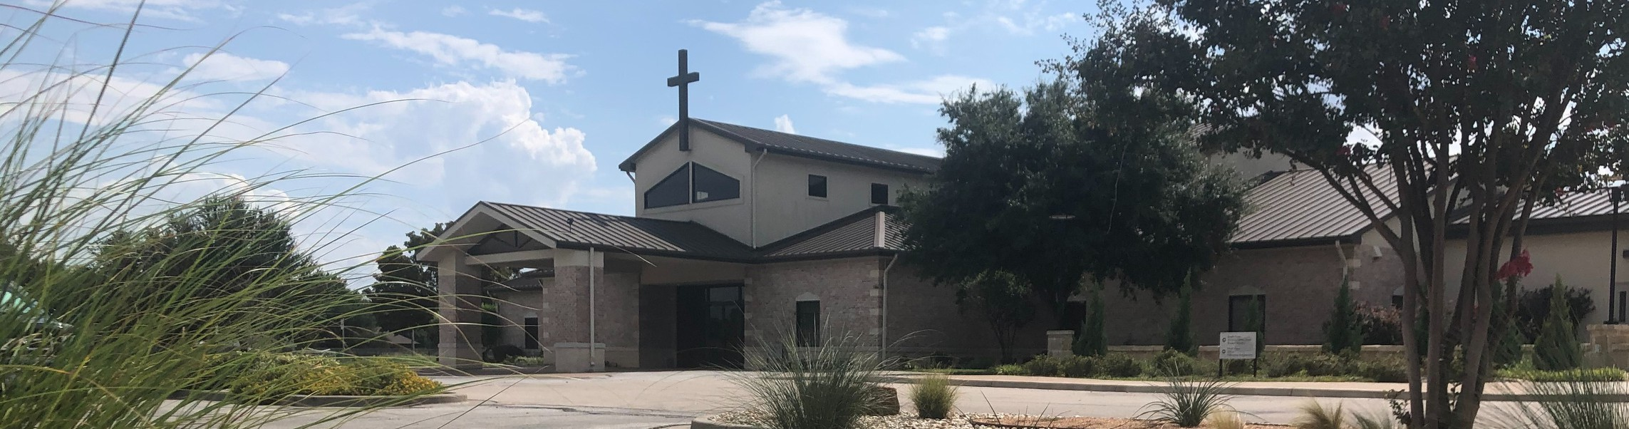

Welcome to Fellowship!

# Thank you for joining us for worship today! If you are a first-time visitor, please visit our Welcome Desk in the foyer or scan the QR code at right to complete a Guest Connect form.

U P C O M I N G E V E N T S

Follow Us On Social Media

*@fellowshipwaco*

Sun. Mar 30 Stephen Ministry Interest Meeting Sun. April 6 ForeRunners Connection



**Need Assistance?**

Visit the South Foyer Welcome Desk and our friendly Welcome Team will be glad to answer any questions or help you find the information you’re looking for!

**Need Coffee?**

Visit our Café in the North Foyer. Our Hospitality Team is ready to serve you!

**Need Prayer?**

If you would like someone to pray with you, our Prayer Team is available at the back of the Worship Center after each service.

Visit our website:

fellowshipwaco.org

Email us: [office@fellowshipwaco.org](mailto:office@fellowshipwaco.org)

Read and subscribe to our weekly newsletter: fellowshipwaco.org

Download our church app: fellowshipwaco.org/app

Telephone: 254.848.7200

Thur. April 10 ForeRunners Event Thur. April 10 LiveWires Event

Sat. Fri. Sun.

April 12

April 18

April 20

Men’s Breakfast

Good Friday Service 6:30 p.m. Easter Service Times:

7:30 a.m., 9:00 a.m., 10:45 a.m.

Fr-Sa May 2-3 Women’s Conference

Sun. May 11 Child Dedication Services

Sun. May 18 Discover LIFE Membership Class

*For complete event details and registration, visit our website: fellowshipwaco.org/events*

*or scan the QR code at right.*

Good Morning Fellowship!

Do you know God’s divine design for church leadership and why it is

important? In 1 Timothy 3:1-7, the Apostle Paul highlights the qualities God develops in overseers of His local churches. As go the leaders, so go the

people.

Grant Kaul, Senior Pastor

**T h e D i v i n e D e s i g n f o r S p i r i t u a l L e a d e r s h i p**

**I n t e n t i o n a l C h u r c h :**

**T h e T r a i t s o f a C h u r c h i n L o v e w i t h C h r i s t**

**1 T i m o t h y 3 : 1 - 7**

***What is God’s divine design for spiritual leaders?***

## Three qualities God develops in healthy church overseers:

1. **Desire for the work** **3:1**

**Elder:** emphasizes dignity and maturity

**Pastor / Shepherd:** emphasizes leadership, caring and teaching

**Overseer / Bishop:** emphasizes the function of giving guidance and exercising authority

4 Ways  to Give **In Service**

*Boxes in Worship Center*



**Online**

*fellowshipwaco.org/giving*



**App**

*fellowshipwaco.org/app*

**Mail**

*P.O. Box 21655*

*Waco, TX 76702*

## Depth of maturity and skill 3:2-6

1. **Demonstrated testimony to the world** **3:7**

*"But speaking the truth in love, we are to grow up in all aspects into Him who is the head, that is, Christ, from whom the whole body, being fitted and held*

*together by what every joint supplies, according to the proper working of each individual part, causes the growth of the body for the building up of itself in*

*love."*

Ephesians 4:15-16

## At the heart of spiritual leadership is love-based shepherding.

***Growing believers need shepherding leaders.***

Take Next



Steps **Membership**

*fellowshipwaco.org/membership*



**Serve**

*fellowshipwaco.org/serve*



**Small Groups**

*fellowshipwaco.org/groups*

***My personal application of this passage:***



**Video from previous messages: youtube.com/fellowshipwaco Audio from previous messages: fellowshipwaco.org/podcasts Sermon notes online: fellowshipwaco.org/sermon-notes**

**Questions for individual study and LIFE Groups:**

1. How would you define “leadership”? Why must Christians follow Scripture rather than look elsewhere when it comes to the topic of church leadership?
2. What are some of the different character qualities that elders must possess? Why are these character qualities important?
3. What are some of the skills that an elder must possess? What does this look like in a local church setting, and why is this important?
4. Why must overseers have a strong testimony to those outside of the church?
5. What are ways we can support and encourage our fellow believers who serve us as elders?