**March 30, 2025**

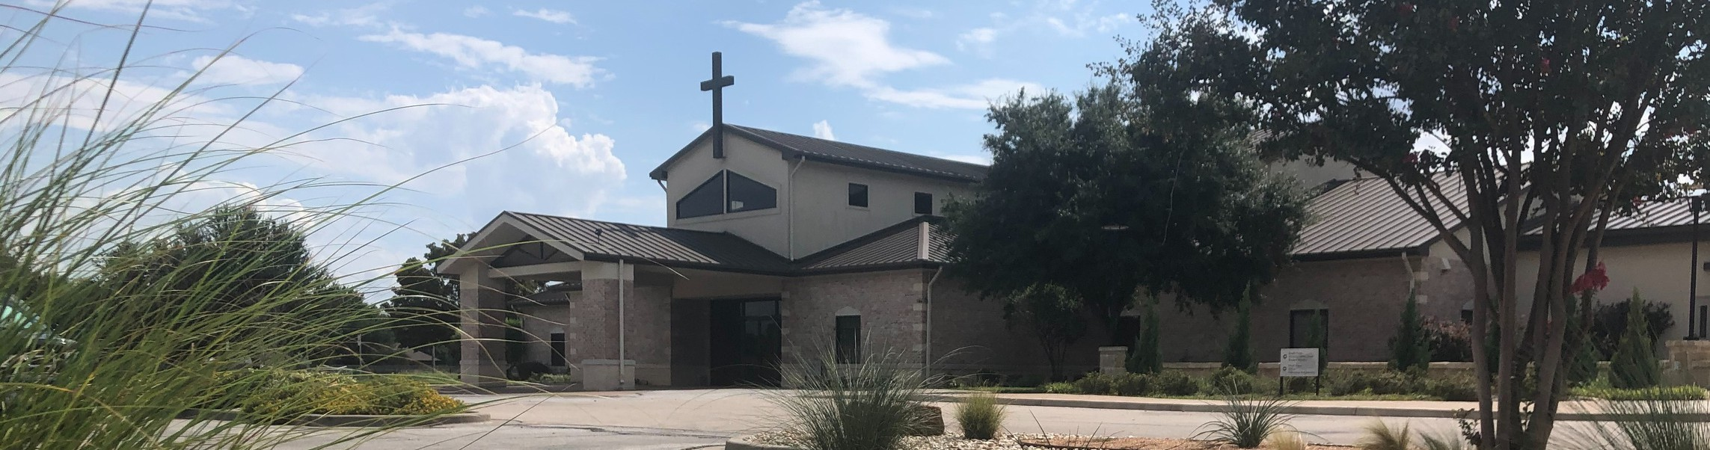

Welcome to Fellowship!

# Thank you for joining us for worship today! If you are a first-time visitor, please visit our Welcome Desk in the foyer or scan the QR code at right to complete a Guest Connect form.

U P C O M I N G E V E N T S

Follow Us On Social Media

*@fellowshipwaco*

Sun. Mar 30 Stephen Ministry Interest Meeting



**Need Assistance?**

Visit the South Foyer Welcome Desk and our friendly Welcome Team will be glad to answer any questions or help you find the information you’re looking for!

**Need Coffee?**

Visit our Café in the North Foyer. Our Hospitality Team is ready to serve you!

**Need Prayer?**

If you would like someone to pray with you, our Prayer Team is available at the back of the Worship Center after each service.

Visit our website:

fellowshipwaco.org

Email us: [office@fellowshipwaco.org](mailto:office@fellowshipwaco.org)

Read and subscribe to our weekly newsletter: fellowshipwaco.org

Download our church app: fellowshipwaco.org/app

Telephone: 254.848.7200

Sun. April 6 ForeRunners Connection

Thur. April 10 ForeRunners Event Thur. April 10 LiveWires Event

Sat. Fri. Sun.

April 12

April 18

April 20

Men’s Breakfast

Good Friday Service 6:30 p.m. Easter Service Times:

7:30 a.m., 9:00 a.m., 10:45 a.m.

Fr-Sa May 2-3 Women’s Conference

Sun. May 11 Child Dedication Services

Sun. May 18 Discover LIFE Membership Class

*For complete event details and registration, visit our website: fellowshipwaco.org/events*

*or scan the QR code at right.*

Good Morning Fellowship!

Serving others is imperative to a healthy church. It is so vital God instituted an office within the church for this role to be carried out. This morning, we will

explore how deacons function within the body as well as look to how each believer is called to serve God and serve others!

George Ohmstede, Associate Pastor

**T h e O f f i c e o f D e a c o n : L e a d i n g w i t h a S e r v a n t ’ s H e a r t !**

**I n t e n t i o n a l C h u r c h :**

**T h e T r a i t s o f a C h u r c h i n L o v e w i t h C h r i s t**

**1 T i m o t h y 3 : 8 - 1 3**

***The Definition of the Deacon v. 8***

***The Character of the Deacon vs. 8-10, 12***

***Personal Character v. 8***

***Spiritual Character v. 9-10,12***

4 Ways

to Give **In Service**

*Boxes in Worship Center*

**Online**



*fellowshipwaco.org/giving*

**App**



*fellowshipwaco.org/app*

**Mail**

*P.O. Box 21655*

*Waco, TX 76702*

***The Role of the Deacon vs. 8,11***

***The Reward for the Deacon v. 13***

***The office of deacon is to be occupied by those who are setting the***

***example in serving God and serving others with a heart of faithfulness, availability, and encouragement.***

Take Next



Steps **Membership**

*fellowshipwaco.org/membership*



**Serve**

*fellowshipwaco.org/serve*



**Small Groups**

*fellowshipwaco.org/groups*

***My personal application of this passage:***



**Video from previous messages: youtube.com/fellowshipwaco Audio from previous messages: fellowshipwaco.org/podcasts Sermon notes online: fellowshipwaco.org/sermon-notes**

**Questions for individual study and LIFE Groups:**

1. What are the differences between the office of elder and deacon?
2. Why is there a need within the church for both elders and deacons (ministry leaders)?
3. Elders and deacons are not the only members of the church called to serve. Explain why serving God and serving others is a call to all believers, not just these specific offices.
4. Looking at the characteristics of a deacon, choose one in which you have seen yourself mature or identify one in which you would like to mature. Then write out how the Lord helped you mature or how you plan to take steps to mature.
5. How are you using your gifts and talents to serve the Lord and others through your local church?