**April 13, 2025**

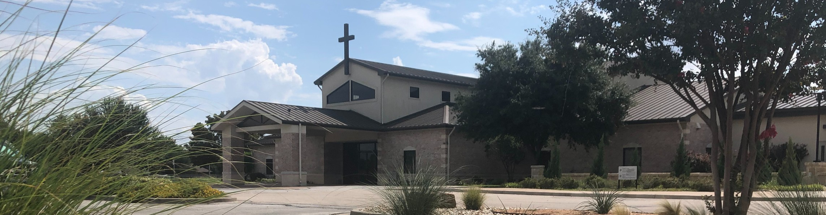

Welcome to Fellowship!

# Thank you for joining us for worship today! If you are a first-time visitor, please visit our Welcome Desk in the foyer or scan the QR code at right to complete a Guest Connect form.

U P C O M I N G E V E N T S

Follow Us On Social Media

*@fellowshipwaco*

Fri. Sun.

April 18

April 20

Good Friday Service 6:30 p.m. Easter Service Times:

7:30 a.m., 9:00 a.m., 10:45 a.m.



**Need Assistance?**

Visit the South Foyer Welcome Desk and our friendly Welcome Team will be glad to answer any questions or help you find the information you’re looking for!

**Need Coffee?**

Visit our Café in the North Foyer. Our Hospitality Team is ready to serve you!

**Need Prayer?**

If you would like someone to pray with you, our Prayer Team is available at the back of the Worship Center after each service.

Visit our website:

fellowshipwaco.org

Email us: [office@fellowshipwaco.org](mailto:office@fellowshipwaco.org)

Read and subscribe to our weekly newsletter: fellowshipwaco.org

Download our church app: fellowshipwaco.org/app

Telephone: 254.848.7200

Fr-Sa May 2-3 Women’s Conference

Sun. May 11 Child Dedication Services

Sun. May 18 Discover LIFE Membership Class

*For complete event details and registration, visit our website: fellowshipwaco.org/events*

*or scan the QR code at right.*

Good Morning Fellowship!

In one of the great crossroad texts of the Bible, Jesus presents the most important decision in a person's life in Matthew 7:13-14. Our response to Christ determines our direction in both life and eternity.

Grant Kaul, Senior Pastor

**T h e R o a d Y o u A r e O n**

## M a t t h e w 7 : 1 3 - 1 4

**Which way are you going in this life?**

**Traveling on the broad way that leads to destruction** **7:13**

**Trusting in Christ on the narrow way that leads to life** **7:14**

4 Ways

to Give **In Service**

*Boxes in Worship Center*

**Online**



*fellowshipwaco.org/giving*

**App**



*fellowshipwaco.org/app*

**Mail**

*P.O. Box 21655*

*Waco, TX 76702*

*I am the door; if anyone enters through Me, he will be saved, and will go in and out and find pasture.*

### John 10:9

*Jesus said to Him, “I am the way, and the truth, and the life; no one comes to the Father but through Me.”*

### John 14:6

*Do not love the world nor the things in the world. If anyone loves the world,*

*the love of the Father is not in him. For all that is in the world, the lust of the flesh and the lust of the eyes and the boastful pride of life, is not from the*

*Father, but is from the world. The world is passing away, and also its lusts; but the one who does the will of God lives forever.*

### 1 John 2:15–17

*And He said to them, “Follow Me, and I will make you fishers of men.”*

### Matthew 4:19

***Our response to Christ determines our direction in both life and eternity.***

Take Next



Steps **Membership**

*fellowshipwaco.org/membership*



**Serve**

*fellowshipwaco.org/serve*



**Small Groups**

*fellowshipwaco.org/groups*

***My personal application of this passage:***



**Video from previous messages: youtube.com/fellowshipwaco Audio from previous messages: fellowshipwaco.org/podcasts Sermon notes online: fellowshipwaco.org/sermon-notes**

## Questions for individual study and LIFE Groups:

1. What can we learn from Jesus’ words in Matthew 7:13-14 about the entrance into God’s kingdom and genuine spiritual life ?
2. How would you describe the wide gate and broad way that Jesus speaks of in Matthew 7:13? Why does Jesus state that many are in this category?
3. What are some of the philosophies and beliefs that are part of the wide gate and broad way approach? Where does this way lead, and what does this mean for individuals traveling this way?
4. Why is the gate small and the way narrow that lead to life (see Matt. 7:14)? Can you describe this gate and way according to Jesus and the Scriptures?
5. What is the life that Jesus is speaking of in Matthew 7:14? What are the features of trusting Jesus Christ in this way of life?