**April 6, 2025**

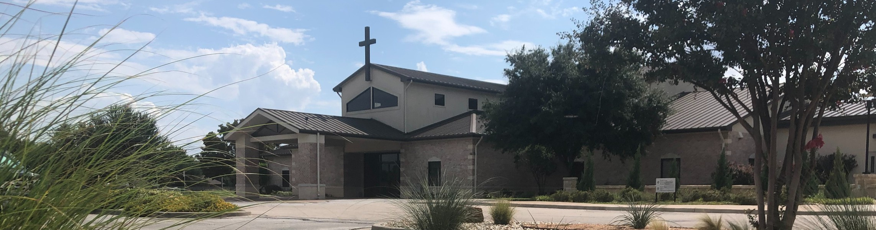

Welcome to Fellowship!

# Thank you for joining us for worship today! If you are a first-time visitor, please visit our Welcome Desk in the foyer or scan the QR code at right to complete a Guest Connect form.

U P C O M I N G E V E N T S

Follow Us On Social Media

*@fellowshipwaco*

Sun. April 6 ForeRunners Connection



**Need Assistance?**

Visit the South Foyer Welcome Desk and our friendly Welcome Team will be glad to answer any questions or help you find the information you’re looking for!

**Need Coffee?**

Visit our Café in the North Foyer. Our Hospitality Team is ready to serve you!

**Need Prayer?**

If you would like someone to pray with you, our Prayer Team is available at the back of the Worship Center after each service.

Visit our website:

fellowshipwaco.org

Email us: [office@fellowshipwaco.org](mailto:office@fellowshipwaco.org)

Read and subscribe to our weekly newsletter: fellowshipwaco.org

Download our church app: fellowshipwaco.org/app

Telephone: 254.848.7200

Thur. April 10 ForeRunners Event Thur. April 10 LiveWires Event

Sat. Fri. Sun.

April 12

April 18

April 20

Men’s Breakfast

Good Friday Service 6:30 p.m. Easter Service Times:

7:30 a.m., 9:00 a.m., 10:45 a.m.

Fr-Sa May 2-3 Women’s Conference

Sun. May 11 Child Dedication Services

Sun. May 18 Discover LIFE Membership Class

*For complete event details and registration, visit our website: fellowshipwaco.org/events*

*or scan the QR code at right.*

Good Morning Fellowship!

Do you know how significant the local church is in God’s kingdom plan? In 1 Timothy 3:14-16, we discover how every church of Jesus Christ is to fulfill its role in this world.

Grant Kaul, Senior Pastor

**T h e E t e r n a l S i g n i f i c a n c e o f t h e L o c a l C h u r c h**

**I n t e n t i o n a l C h u r c h :**

**T h e T r a i t s o f a C h u r c h i n L o v e w i t h C h r i s t**

**1 T i m o t h y 3 : 1 4 - 1 6**

**Why is the church of Jesus Christ so significant?**

**The significance of the local church is revealed in two distinct and impactful ways:**

1. **The church is the living expression of God’s truth 3:14-15**

4 Ways

to Give **In Service**

*Boxes in Worship Center*

**Online**



*fellowshipwaco.org/giving*

**App**



*fellowshipwaco.org/app*

**Mail**

*P.O. Box 21655*

*Waco, TX 76702*

**Ways in which we are the living expression of God’s truth:**

**personalizing God’s word**

**practicing God’s word**

**preserving God’s word**

**proclaiming God’s word**

1. **The church is for the loving exaltation of Christ’s life** **3:16**

***The local church is a manifestation of the family of God that expresses His truth and exalts Christ’s life.***

Take Next



Steps **Membership**

*fellowshipwaco.org/membership*



**Serve**

*fellowshipwaco.org/serve*



**Small Groups**

*fellowshipwaco.org/groups*

***My personal application of this passage:***



**Video from previous messages: youtube.com/fellowshipwaco Audio from previous messages: fellowshipwaco.org/podcasts Sermon notes online: fellowshipwaco.org/sermon-notes**

**Questions for individual study and LIFE Groups:**

1. Why is the Apostle Paul writing this letter according to 1 Timothy 3:14-15?
2. What does 1 Timothy 3:15 reveal about the church’s role in this world?
3. What practical ways do you and our church manifest the distinctive role highlighted in 1 Timothy 3:15?
4. How does 1 Timothy 3:16 help you better understand Jesus Christ and His gospel?
5. Can you share one way you have grown in your relationship with Jesus Christ as a part of Fellowship Bible Church?