**Good Friday April 18, 2025**

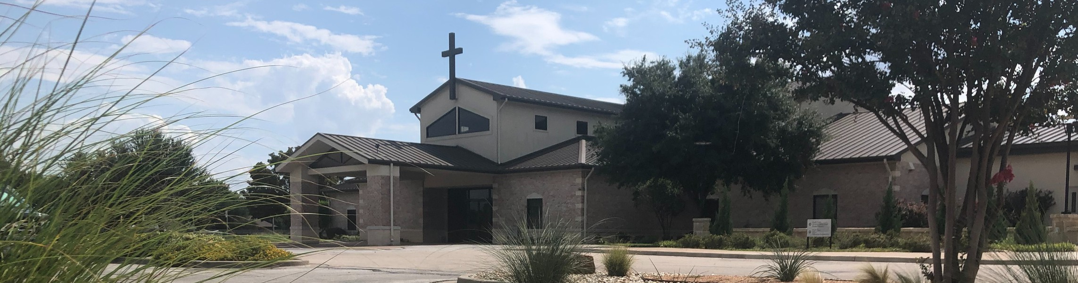

Welcome to Fellowship!

# Thank you for joining us for worship today! If you are a first-time visitor, please visit our Welcome Desk in the foyer or scan the QR code at right to complete a Guest Connect form.

U P C O M I N G E V E N T S

Follow Us On Social Media

*@fellowshipwaco*

Sun.

Sun.

April 20

April 27

Easter Service Times:

7:30 a.m., 9:00 a.m., 10:45 a.m.



**Need Assistance?**

Visit the South Foyer Welcome Desk and our friendly Welcome Team will be glad to answer any questions or help you find the information you’re looking for!

**Need Coffee?**

Visit our Café in the North Foyer. Our Hospitality Team is ready to serve you!

**Need Prayer?**

If you would like someone to pray with you, our Prayer Team is available at the back of the Worship Center after each service.

Visit our website:

fellowshipwaco.org

Email us: [office@fellowshipwaco.org](mailto:office@fellowshipwaco.org)

Read and subscribe to our weekly newsletter: fellowshipwaco.org

Download our church app: fellowshipwaco.org/app

Telephone: 254.848.7200

Student Ministry Bake Sale

Fr-Sa May 2-3 Women’s Conference

Sun Sun. Sun. Sun.

May 4

May 11

May 18

May 25

ForeRunners Connection Child Dedication Services

Discover LIFE Membership Class Graduation Sunday for Seniors

*For complete event details and registration, visit our website: fellowshipwaco.org/events*

*or scan the QR code at right.*

Good Evening Fellowship!

Tonight, we will journey through Scripture and witness how the cross of Jesus Christ began changing lives from the very beginning. We will meet some of the first individuals whose hearts and stories were changed by the cross and

reflect on how Jesus continues to transform our lives today.

Grant Kaul, Senior Pastor

**C h a n g e d b y H i s C r o s s :**

**T h e R o a d T o R e d e m p t i o n**

**L u k e 2 3 : 2 0 - 4 9**

Have you been changed by His cross?

Setting the Scene: 23:20-25

People that were changed by His cross…

A Country Traveler 23:26 A Changed Direction

A Collection of Women 23:27-31 A Changed Perspective

4 Ways

to Give **In Service**

*Boxes in Worship Center*

**Online**



*fellowshipwaco.org/giving*

**App**



*fellowshipwaco.org/app*

**Mail**

*P.O. Box 21655*

*Waco, TX 76702*

A Condemned Criminal 23:32-43 A Changed Eternity

A Commanding Centurion 23:44-49 A Changed Heart

Have you been changed by His cross?

redemption:

The act of buying back or rescuing something or someone that was lost, enslaved, or in a state of bondage.

*In Him we have redemption through His blood, the forgiveness of our trespasses, according to the riches of His grace.*

Ephesians 1:7

***To be redeemed by Christ is to be forever changed by His cross.***

Take Next



Steps **Membership**

*fellowshipwaco.org/membership*



**Serve**

*fellowshipwaco.org/serve*



**Small Groups**

*fellowshipwaco.org/groups*

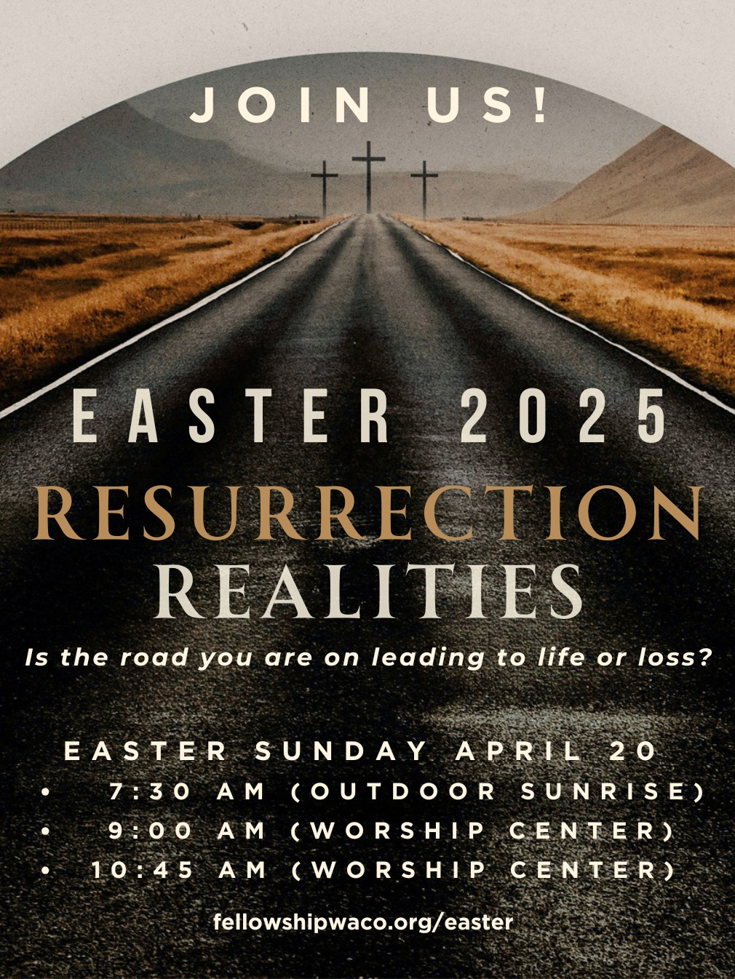

**Video from previous messages: youtube.com/fellowshipwaco Audio from previous messages: fellowshipwaco.org/podcasts Sermon notes online: fellowshipwaco.org/sermon-notes**