**Easter Sunday April 20, 2025**

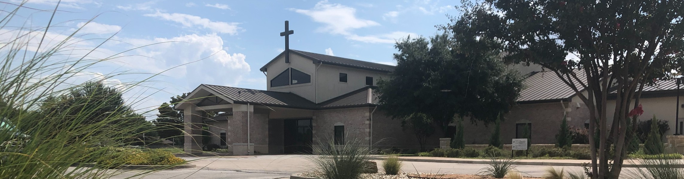

Welcome to Fellowship!

# Thank you for joining us for worship today! If you are a first-time visitor, please visit our Welcome Desk in the foyer or scan the QR code at right to complete a Guest Connect form.

U P C O M I N G E V E N T S



**Need Assistance?**

Visit the South Foyer Welcome Desk and our friendly Welcome Team will be glad to answer any questions or help you find the information you’re looking for!

**Need Coffee?**

Visit our Café in the North Foyer. Our Hospitality Team is ready to serve you!

**Need Prayer?**

If you would like someone to pray with you, our Prayer Team is available at the back of the Worship Center after each service.

Visit our website:

fellowshipwaco.org

Email us: [office@fellowshipwaco.org](mailto:office@fellowshipwaco.org)

Read and subscribe to our weekly newsletter: fellowshipwaco.org

Download our church app: fellowshipwaco.org/app

Telephone: 254.848.7200

Follow Us On Social Media

*@fellowshipwaco*

Sun.

April 27

Student Ministry Bake Sale

Fr-Sa May 2-3 Women’s Conference

Sun. Sun. Sun. Sun.

May 4

May 11

May 18

May 25

ForeRunners Connection Child Dedication Services

Discover LIFE Membership Class Graduation Sunday for Seniors

*For complete event details and registration, visit our website: fellowshipwaco.org/events*

*or scan the QR code at right.*

Happy Resurrection Day Fellowship –

We are joyfully gathering this morning to celebrate the Easter morning reality that Jesus Christ has risen from the grave. Today, we will journey through

Luke 24:13-35 and discover how the events of that first Resurrection evening show us the path to personally knowing Jesus today.

Grant Kaul, Senior Pastor

**W h e n J e s u s i s H i d d e n i n P l a i n S i g h t**

## L u k e 2 4 : 1 3 - 3 5

**Is Jesus truly alive and resurrected from the dead?**

4 Ways

to Give **In Service**

*Boxes in Worship Center*

**Online**



*fellowshipwaco.org/giving*

**App**



*fellowshipwaco.org/app*

**Mail**

*P.O. Box 21655*

*Waco, TX 76702*

*So faith comes from hearing, and hearing by the word of Christ.*

Romans 10:17

***It is through believing the truth of Scripture that we come to truly know the risen Savior.***

Take Next



Steps **Membership**

*fellowshipwaco.org/membership*



**Serve**

*fellowshipwaco.org/serve*



**Small Groups**

*fellowshipwaco.org/groups*

***My personal application of this passage:***



**Video from previous messages: youtube.com/fellowshipwaco Audio from previous messages: fellowshipwaco.org/podcasts Sermon notes online: fellowshipwaco.org/sermon-notes**

## Questions for individual study and LIFE Groups:

1. What did the disciples feel and discuss as they walked, and how does this mirror our responses to disappointment or unanswered prayers?
2. Why do you think the disciples didn’t recognize Jesus initially, and what might keep us from recognizing His presence in our everyday lives?
3. As we see Jesus explaining the Scriptures to them before revealing Himself, what does this tell us about the role of God’s word in personally knowing Him and building a deeper relationship with Him?
4. How does believing the Scripture and knowing the resurrected Son of God stir us to action and witness?
5. When did you believe in the resurrection of Jesus Christ? How does knowing that He is alive affect the way you live?