**Sunday June 1, 2025**

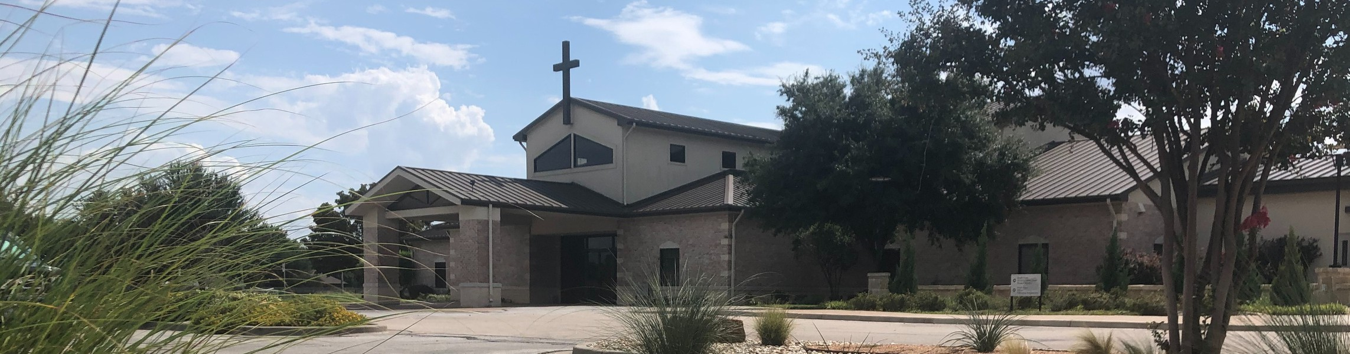

Welcome to Fellowship!

# Thank you for joining us for worship today! If you are a first-time visitor, please visit our Welcome Desk in the foyer or scan the QR code at right to complete a Guest Connect form.

U P C O M I N G E V E N T S

Follow Us On Social Media

*@fellowshipwaco*

Sun. Sun. Sun. Sun. Wed. Sat. Sun. Mon. Sat. Sun. Sun. Sun. Sun. Wed. Sat.

June 1

June 1

June 1

June 1

June 4

June 7

June 8

June 9

June 14

June 15

June 15

June 15

June 15

June 18

June 21

Coffee & Connection ForeRunners Connection

FX Camp Volunteer Training E3 Event - Faith



**Need Assistance?**

Visit the South Foyer Welcome Desk and our friendly Welcome Team will be glad to answer any questions or help you find the information you’re looking for!

**Need Coffee?**

Visit our Café in the North Foyer. Our Hospitality Team is ready to serve you!

**Need Prayer?**

If you would like someone to pray with you, our Prayer Team is available at the back of the Worship Center after each service.

Visit our website:

fellowshipwaco.org

Email us: [office@fellowshipwaco.org](mailto:office@fellowshipwaco.org)

Read and subscribe to our weekly newsletter: fellowshipwaco.org

Download our church app: fellowshipwaco.org/app

Telephone: 254.848.7200

FX Camp Volunteer Training Student Ministry Pizza Night Coffee & Connection

FX Camp begins MomLIFE Breakfast Coffee & Connection Father’s Day

Child Dedication Family Sunday

Summer Bible Studies begin Men’s Breakfast

*For complete event details and registration, visit our website: fellowshipwaco.org/events*

*or scan the QR code at right.*

Good Morning Fellowship!

What are the priorities of healthy, Christ-centered leaders? In 1 Timothy 4:10- 16, the Apostle Paul highlights what every church should desire and every

spiritual leader should pursue.

Grant Kaul, Senior Pastor

**P r i o r i t i e s o f H e a l t h y**

**C h r i s t - C e n t e r e d L e a d e r s**

## I n t e n t i o n a l C h u r c h :

**T h e T r a i t s o f a C h u r c h i n L o v e w i t h C h r i s t**

**1 T i m o t h y 4 : 1 0 - 1 6**

**What are the priorities of healthy, Christ-centered leaders?**

1. **Focus on Jesus 4:10-11**

*Who you follow determines how you lead.*

4 Ways

to Give **In Service**

*Boxes in Worship Center*

**Online**



*fellowshipwaco.org/giving*

**App**



*fellowshipwaco.org/app*

**Mail**

*P.O. Box 21655*

*Waco, TX 76702*

1. **Lead by example** **4:12**

*The most powerful message you will ever give is the life you live.*

1. **Establish believers in the truth** **4:13**
2. **Make personal maturity a priority 4:14-16**

**How to identify** **y our spiritual gifts**

*Start serving, then ask these three questions: * *What do I like to do?*

*What do I sense I am called to do?*

*What is God blessing?*

***Your ministry is not a job that you do but a lifestyle that you live.***

Take Next



Steps **Membership**

*fellowshipwaco.org/membership*



**Serve**

*fellowshipwaco.org/serve*



**Small Groups**

*fellowshipwaco.org/groups*

***My personal application of this passage:***



**Video from previous messages: youtube.com/fellowshipwaco Audio from previous messages: fellowshipwaco.org/podcasts Sermon notes online: fellowshipwaco.org/sermon-notes**

## Questions for individual study and LIFE Groups:

* 1. Why is it important that we learn to develop a daily focus on Jesus (see 1 Tim. 4:10)? How do you do this?
  2. How have you seen the power of an exemplary life in a fellow believer benefit your development as a Christian? How has 1 Timothy 4:12 caused you to think differently about how you live?
  3. What do we learn about the role of Scripture in the ministry of a spiritual leader? Why is this to be emphasized?
  4. In what ways do spiritual leaders develop? Why is it important they continue to make progress in their skills and maturity?
  5. Why is it important Christian leaders learn to care for their souls (see 1 Tim. 4:16)? What can potentially happen when we do not do this? What is one way you try to do this?