**Sunday May 11, 2025**

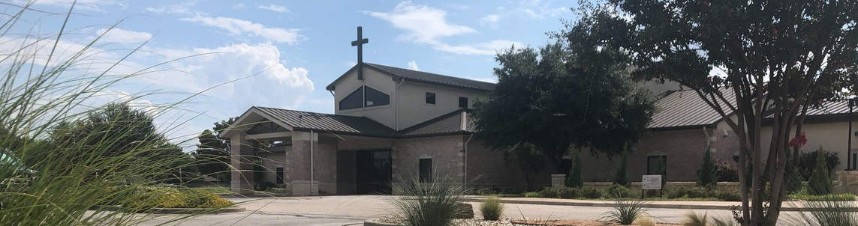

Welcome to Fellowship!

# Thank you for joining us for worship today! If you are a first-time visitor, please visit our Welcome Desk in the foyer or scan the QR code at right to complete a Guest Connect form.

U P C O M I N G E V E N T S

Follow Us On Social Media

*@fellowshipwaco*

Sun. Sat. Sun. Sun. Sun. Thur. Fri.

May 11 Child Dedication Services May 17 Men’s Breakfast

May 18 Discover LIFE Membership Class May 18 Stephen Ministry Interest Meeting May 25 Graduation Sunday for Seniors May 29 LiveWires Pool Party



**Need Assistance?**

Visit the South Foyer Welcome Desk and our friendly Welcome Team will be glad to answer any questions or help you find the information you’re looking for!

**Need Coffee?**

Visit our Café in the North Foyer. Our Hospitality Team is ready to serve you!

**Need Prayer?**

If you would like someone to pray with you, our Prayer Team is available at the back of the Worship Center after each service.

Visit our website:

fellowshipwaco.org

Email us: [office@fellowshipwaco.org](mailto:office@fellowshipwaco.org)

Read and subscribe to our weekly newsletter: fellowshipwaco.org

Download our church app: fellowshipwaco.org/app

Telephone: 254.848.7200

May 30 FCA Lunch

Sun. Sun. Sat.

June 1

June 1

June 7

Coffee & Connection E3 Event - Faith Student Ministry Event

*For complete event details and registration, visit our website: fellowshipwaco.org/events*

*or scan the QR code at right.*

Good Morning Fellowship!

Without hope, despair grows, motivation dwindles, and resilience fades. This morning, we will discover from 1 Timothy 4:9-11 how to experience lasting

hope through our relationship with the living God.

Grant Kaul, Senior Pastor

**H o w t o L i v e i n H o p e**

**I n t e n t i o n a l C h u r c h :**

**T h e T r a i t s o f a C h u r c h i n L o v e w i t h C h r i s t**

**1 T i m o t h y 4 : 9 - 1 1**

## How do we experience hope through our relationship with the living God?

1. **Trust in Christ as the living hope in our lives 4:9-10**

*Blessed be the God and Father of our Lord Jesus Christ, who according to His great mercy has caused us to be born again to a living hope through the*

*resurrection of Jesus Christ from the dead,*

1 Peter 1:3

4 Ways

to Give **In Service**

*Boxes in Worship Center*

**Online**



*fellowshipwaco.org/giving*

**App**



*fellowshipwaco.org/app*

**Mail**

*P.O. Box 21655*

*Waco, TX 76702*

## How to practically trust Christ as our Living Hope

**·**Start your day by giving it to God

**·**Trust God’s truth over your emotions

**·**Make eternal choices in temporary situations

**·**Feed your hope with God’s word

**·**Have hopeful believers in your life

**·**Keep an eternal perspective

**·**Let hope in the risen Savior move you to action

## Know that Christ is the only hope for our world 4:10-11

***We grow strong in our faith when we fix our hope on the risen Lord of our lives.***

Take Next



Steps **Membership**

*fellowshipwaco.org/membership*



**Serve**

*fellowshipwaco.org/serve*



**Small Groups**

*fellowshipwaco.org/groups*

***My personal application of this passage:***



**Video from previous messages: youtube.com/fellowshipwaco Audio from previous messages: fellowshipwaco.org/podcasts Sermon notes online: fellowshipwaco.org/sermon-notes**

**Questions for individual study and LIFE Groups:**

* 1. What does it mean we have fixed our hope on “the living God”? How is this different from hoping in temporary things?
  2. How does the title “Savior of all people” shape your understanding of Jesus as the ultimate source of hope? How does the phrase, “You are what you eat,” have meaning not just in our physical lives but also in our spiritual and emotional health?
  3. Why is it essential that Jesus is living, not just a historical figure, for our hope to be real and enduring?
  4. According to verse 10, why do we labor and strive? How does trusting in Christ empower us to keep going when life is hard?
  5. How can trusting in the living Christ reshape your daily outlook, especially in situations that feel uncertain or overwhelming?