**Sunday May 18, 2025**

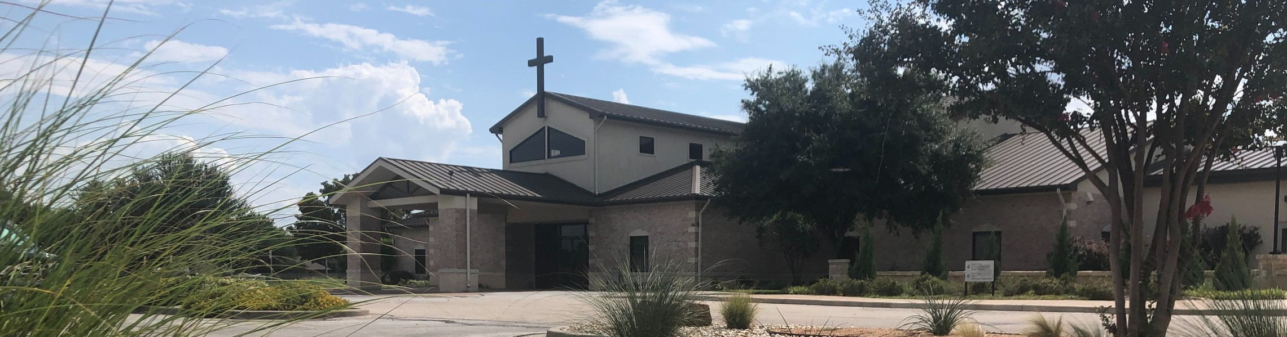

Welcome to Fellowship!

# Thank you for joining us for worship today! If you are a first-time visitor, please visit our Welcome Desk in the foyer or scan the QR code at right to complete a Guest Connect form.

Follow Us On Social Media

*@fellowshipwaco*

U P C O M I N G E V E N T S



**Need Assistance?**

Visit the South Foyer Welcome Desk and our friendly Welcome Team will be glad to answer any questions or help you find the information you’re looking for!

**Need Coffee?**

Visit our Café in the North Foyer. Our Hospitality Team is ready to serve you!

**Need Prayer?**

If you would like someone to pray with you, our Prayer Team is available at the back of the Worship Center after each service.

Visit our website:

fellowshipwaco.org

Email us: [office@fellowshipwaco.org](mailto:office@fellowshipwaco.org)

Read and subscribe to our weekly newsletter: fellowshipwaco.org

Download our church app: fellowshipwaco.org/app

Telephone: 254.848.7200

Sun. Sun. Thur. Fri.

May 18 Stephen Ministry Interest Meeting May 25 Graduation Sunday for Seniors May 29 LiveWires Pool Party

May 30 Fellowship of Christian Ath. Lunch

|  |  |  |
| --- | --- | --- |
| Sun. | June 1 | Coffee & Connection |
| Sun. | June 1 | E3 Event - Faith |
| Sat. | June 7 | Student Ministry Event |
| Sun. | June 8 | Coffee & Connection |
| Sun. | June 15 | Child Dedication |

Sunday morning, May 25th, we will have a guest speaker, Curtis Fahrlender. That evening, he will lead “Can I Ask That?”, a seminar on

suffering. Come join us from 4:00-5:30pm.

*For complete event details and registration, visit our website: fellowshipwaco.org/events*

*or scan the QR code at right.*

Good Morning Fellowship!

The most powerful message you will ever give is the life that you live.

In 1 Timothy 4:12, the Apostle Paul highlights the specific ways we are to manifest our faith in Christ, as he challenges the youthful Timothy to rise to the high calling we have in Christ.

Grant Kaul, Senior Pastor

**T h e M e s s a g e o f Y o u r L i f e**

## I n t e n t i o n a l C h u r c h :

**T h e T r a i t s o f a C h u r c h i n L o v e w i t h C h r i s t**

**1 T i m o t h y 4 : 1 2**

**What are the specific ways we are to manifest our faith in Christ?**

1. **Speech**

For the mouth speaks out of that which fills the heart. The good man brings out of his good treasure what is good; and the evil man brings out of his evil treasure what is evil.

Matthew 12:34b-35

1. **Conduct**

4 Ways

to Give **In Service**

*Boxes in Worship Center*

**Online**



*fellowshipwaco.org/giving*

**App**



*fellowshipwaco.org/app*

**Mail**

*P.O. Box 21655*

*Waco, TX 76702*

1. **Love**

We love because He first loved us.

1 John 4:19

1. **Faith**
2. **Purity**

**Practices for developing**  **purity and overcoming the dangers of temptation:**

* + Develop a deep awareness of God’s truth and His continual presence
  + Have convictions before the crisis
  + Know that love involves loyalty
  + Do not become callous to sin

No temptation has overtaken you but such as is common to man; and God is faithful, who will not allow you to be tempted beyond what you are able, but with the temptation will provide the way of escape also, so that you will be

*able to endure it.* 1 Corinthians 10:13

If we confess our sins, He is faithful and righteous to forgive us our sins and to cleanse us from all unrighteousness. 1 John 1:9

The seeds that you sow will be the ones that will grow.

***The most powerful message you will ever give is the life you live.***

Take Next



Steps **Membership**

*fellowshipwaco.org/membership*



**Serve**

*fellowshipwaco.org/serve*



**Small Groups**

*fellowshipwaco.org/groups*

***My personal application of this passage:***



**Video from previous messages: youtube.com/fellowshipwaco Audio from previous messages: fellowshipwaco.org/podcasts Sermon notes online: fellowshipwaco.org/sermon-notes**

## Questions for individual study and LIFE Groups:

1. What are some different ways our speech can reveal maturity in our relationship with Christ?
2. How do Christians develop conduct in keeping with Christ’s character?
3. How would you describe “love” as found in 1 Timothy 4:12? How do people know that we love them?
4. What is “faith,” and how is it cultivated?
5. How does purity manifest itself in a Christian’s life? How can we develop patterns of purity in our lives?
6. Can you describe how Christ develops the traits highlighted in this verse in the lives of His followers?