**Sunday May 25, 2025**

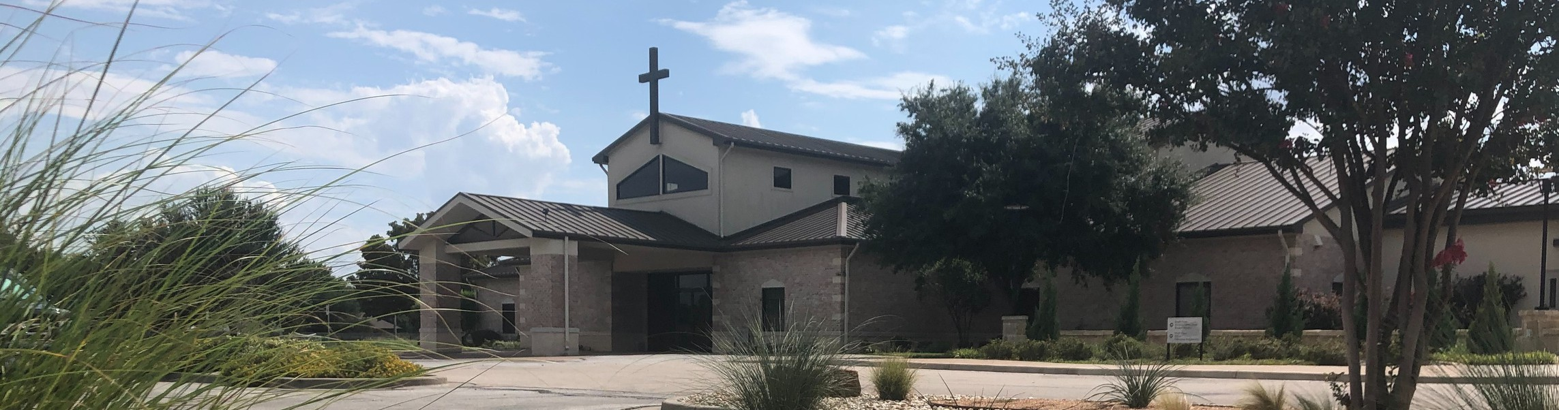

Welcome to Fellowship!

# Thank you for joining us for worship today! If you are a first-time visitor, please visit our Welcome Desk in the foyer or scan the QR code at right to complete a Guest Connect form.

U P C O M I N G E V E N T S

Follow Us On Social Media

*@fellowshipwaco*

Sun. Thur. Fri.

May 25 Seminar on Suffering May 29 LiveWires Pool Party

May 30 Fellowship of Christian Ath. Lunch



**Need Assistance?**

Visit the South Foyer Welcome Desk and our friendly Welcome Team will be glad to answer any questions or help you find the information you’re looking for!

**Need Coffee?**

Visit our Café in the North Foyer. Our Hospitality Team is ready to serve you!

**Need Prayer?**

If you would like someone to pray with you, our Prayer Team is available at the back of the Worship Center after each service.

Visit our website:

fellowshipwaco.org

Email us: [office@fellowshipwaco.org](mailto:office@fellowshipwaco.org)

Read and subscribe to our weekly newsletter: fellowshipwaco.org

Download our church app: fellowshipwaco.org/app

Telephone: 254.848.7200

|  |  |  |
| --- | --- | --- |
| Sun. | June 1 | Coffee & Connection |
| Sun. | June 1 | E3 Event - Faith |
| Sat. | June 7 | Student Ministry Event |
| Sun. | June 8 | Coffee & Connection |
| Sun. | June 15 | Child Dedication |

This evening, Curtis Fahrlender will lead “Can I Ask That?”, a seminar on suffering.

Come join us from 4:00-5:30pm.

*For complete event details and registration, visit our website: fellowshipwaco.org/events*

*or scan the QR code at right.*

Good Morning Fellowship!

Are you facing trials or feeling overwhelmed by life’s challenges? This

morning, we explore James 1:1-5 and discover how God uses our struggles to strengthen our faith and develop Christ-like character.

Curtis Fahrlender, Guest Speaker

**A F a i t h T h a t W o r k s**

**I n T h e M i d s t o f T r i a l s**

**J a m e s 1 : 1 - 5**

Introduction: A Man Named J ames 1:1

1. **The** **of Trials 1:2**

*As an example, brethren, of suffering and patience, take the prophets who spoke in the name of the Lord. We count those blessed who endured. You*

*have heard of the endurance of Job and have seen the outcome of the Lord’s dealings, that the Lord is full of compassion and is merciful.*

James 5:10-11

4 Ways

to Give **In Service**

*Boxes in Worship Center*

**Online**



*fellowshipwaco.org/giving*

**App**



*fellowshipwaco.org/app*

**Mail**

*P.O. Box 21655*

*Waco, TX 76702*

1. **The**  **of Trials 1:3-4**
2. **The**  **of**  **in Trials** **1:5**

Key Takeaways:

1. **When facing difficulties, remember God is at work.**
2. **Trials refine our faith and develop endurance.**
3. **Allow endurance to shape our character, reflecting Christ.**
4. **God’s wisdom is available in confusing and painful times.**
5. **Our fellowship community is God’s gift to help us endure, grow, and find wisdom.**

Take Next



Steps **Membership**

*fellowshipwaco.org/membership*



**Serve**

*fellowshipwaco.org/serve*



**Small Groups**

*fellowshipwaco.org/groups*

***My personal application of this passage:***



**Video from previous messages: youtube.com/fellowshipwaco Audio from previous messages: fellowshipwaco.org/podcasts Sermon notes online: fellowshipwaco.org/sermon-notes**

**Questions for individual study and LIFE Groups:**

* 1. What does it mean to “count it all joy” when you face trials? (Verse 1-2)
  2. How do trials test our faith and produce endurance (Verse 3)?
  3. According to verse 4, what is God’s purpose in allowing us to go through trials?
  4. Why do you think James connects wisdom with facing trials (verse 5)?
  5. What does this passage teach us about God’s character, especially in verse 5?